Name: Darshan Prajapati
Roll no: 24
MCA 3

P1

Q1. Read an image using OpenCV and display its width, height, and number of channels
import matplotlib.pyplot as plt
# %pip install opencv-python
import cv2

# read the image
img = cv2.imread("image.jpg")

if img is None:
print("Image not found")
else:
print("Image loaded successfully")

Image loaded successfully

# Get height, width, and number of channels
height,width,channels = img.shape

# Display information
print("Width:", width)
print("Height:", height)
print("Number of Channels:", channels)

Width: 4702
Height: 3394
Number of Channels: 3

# Display image
plt.imshow(cv2.cvtColor(img,cv2.COLOR_BGR2RGB))
plt.axis("off")
plt.show()

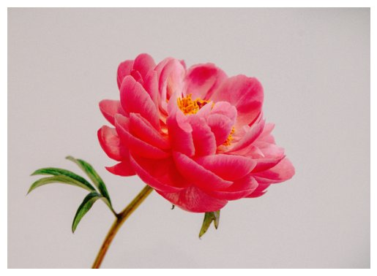

Q2. Read an image and save it in another image format
import cv2
import matplotlib.pyplot as plt

# Read the image
img = cv2.imread("image.jpg")
if img is None:
print("Image not found!")
else:
print("Image Loaded Successfully")

Image Loaded Successfully

# Save the image in PNG format
cv2.imwrite("image.png", img)

print("Image saved successfully")

Image saved successfully

Q3. Resize an image to 224 x 224 pixels and display the original and resized images
import cv2
import matplotlib.pyplot as plt

# Read the image
img = cv2.imread("image.jpg")

if img is None:
print("Image not found!")
else:
print("Image Loaded Successfully")

Image Loaded Successfully

# Resize the image
resized_img = cv2.resize(img, (224, 224))

# Display original and resized images
plt.figure(figsize=(8, 4))

# Original image
plt.subplot(1, 2, 1)
plt.imshow(cv2.cvtColor(img, cv2.COLOR_BGR2RGB))
plt.title("Original Image")
plt.axis("off")

# Resized image
plt.subplot(1, 2, 2)
plt.imshow(cv2.cvtColor(resized_img, cv2.COLOR_BGR2RGB))
plt.title("Resized Image")
plt.axis("off")

plt.show()

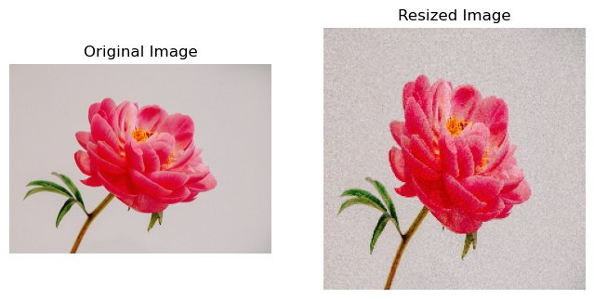

Q4. Resize an image to 50% of its original dimensions
import cv2
import matplotlib.pyplot as plt

# Read the image
img = cv2.imread("image.jpg")

# Get original dimensions
height, width = img.shape[:2]

# Calculate 50% dimensions
new_width = int(width * 0.5)
new_height = int(height * 0.5)

# Resize the image
resized_img = cv2.resize(img, (new_width, new_height))

# Display original and resized images
plt.figure(figsize=(8, 4))

plt.subplot(1, 2, 1)
plt.imshow(cv2.cvtColor(img, cv2.COLOR_BGR2RGB))
plt.title("Original Image")
plt.axis("off")

plt.subplot(1, 2, 2)
plt.imshow(cv2.cvtColor(resized_img, cv2.COLOR_BGR2RGB))
plt.title("50% Resized")
plt.axis("off")

plt.show()

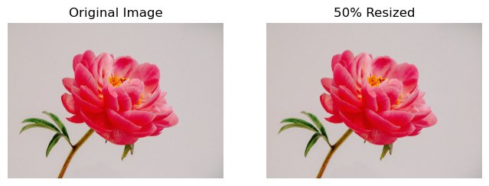

Q5. Crop a rectangular region from an image using specified starting and ending coordinates
import cv2
import matplotlib.pyplot as plt

# Read the image
img = cv2.imread("image.jpg")

# Starting and ending coordinates
x1, y1 = 100, 50
x2, y2 = 400, 300

# Crop the image
cropped = img[y1:y2, x1:x2]

# Display original image
plt.subplot(1, 2, 1)
plt.imshow(cv2.cvtColor(img, cv2.COLOR_BGR2RGB))
plt.title("Original Image")
plt.axis("off")

# Display cropped image
plt.subplot(1, 2, 2)
plt.imshow(cv2.cvtColor(cropped, cv2.COLOR_BGR2RGB))
plt.title("Cropped Image")
plt.axis("off")

plt.show()

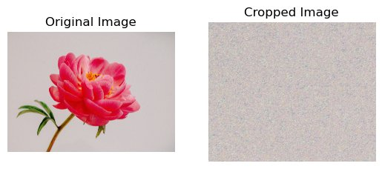

Q.6 Extract the central region of an image using cropping
import cv2
import matplotlib.pyplot as plt

# Read the image
img = cv2.imread("image.jpg")

# Get image dimensions
height, width = img.shape[:2]

# Size of central region
crop_width = 1000
crop_height = 1000

# Find starting coordinates
x1 = (width - crop_width) // 2
y1 = (height - crop_height) // 2

# Find ending coordinates
x2 = x1 + crop_width
y2 = y1 + crop_height

# Crop the central region
cropped = img[y1:y2, x1:x2]

# Display images
plt.subplot(1, 2, 1)
plt.imshow(cv2.cvtColor(img, cv2.COLOR_BGR2RGB))
plt.title("Original")
plt.axis("off")

plt.subplot(1, 2, 2)
plt.imshow(cv2.cvtColor(cropped, cv2.COLOR_BGR2RGB))
plt.title("Central Region")
plt.axis("off")

plt.show()

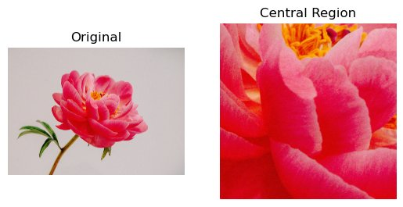

Q.7 Convert a color image from BGR/RGB to grayscale
import cv2
import matplotlib.pyplot as plt

# Read the color image
img = cv2.imread("image.jpg")

# Convert BGR image to grayscale
gray = cv2.cvtColor(img, cv2.COLOR_BGR2GRAY)

# Display original image
plt.subplot(1, 2, 1)
plt.imshow(cv2.cvtColor(img, cv2.COLOR_BGR2RGB))
plt.title("Color Image")
plt.axis("off")

# Display grayscale image
plt.subplot(1, 2, 2)
plt.imshow(gray, cmap="gray")
plt.title("Grayscale Image")
plt.axis("off")

plt.show()

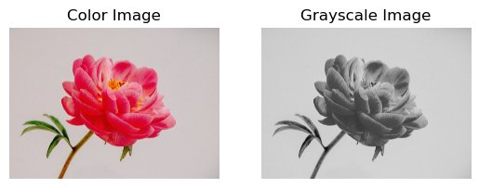

Q.8 Convert an image from BGR/RGB to HSV color space and display the result
import cv2
import matplotlib.pyplot as plt

# Read the image (OpenCV reads it in BGR format)
img = cv2.imread("image.jpg")

# Convert BGR to HSV
hsv_img = cv2.cvtColor(img, cv2.COLOR_BGR2HSV)

# Display original image
plt.subplot(1, 2, 1)
plt.imshow(cv2.cvtColor(img, cv2.COLOR_BGR2RGB))
plt.title("Original Image")
plt.axis("off")

# Display HSV image
plt.subplot(1, 2, 2)
plt.imshow(hsv_img)
plt.title("HSV Image")
plt.axis("off")

plt.show()

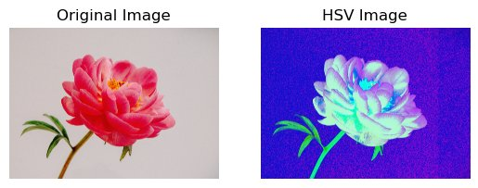

Q.9 Convert an image from BGR/RGB to LAB color space and display the result
import cv2
import matplotlib.pyplot as plt

# Read the image
img = cv2.imread("image.jpg")

# Convert BGR to LAB
lab_img = cv2.cvtColor(img, cv2.COLOR_BGR2LAB)

# Display original image
plt.subplot(1, 2, 1)
plt.imshow(cv2.cvtColor(img, cv2.COLOR_BGR2RGB))
plt.title("Original Image")
plt.axis("off")

# # Convert LAB back to RGB for proper display
# lab_display = cv2.cvtColor(lab_img, cv2.COLOR_LAB2RGB)

# Display LAB image
plt.subplot(1, 2, 2)
plt.imshow(lab_img)
plt.title("LAB Image")
plt.axis("off")

plt.show()

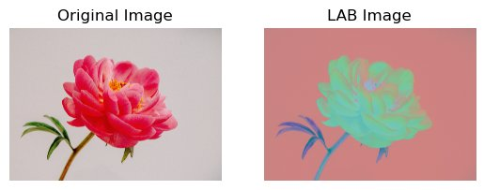

Q.10 Add salt-and-pepper noise to an image and remove the noise using a median filter
import cv2
import numpy as np
import matplotlib.pyplot as plt

# Read the image
img = cv2.imread("Test.jpg",cv2.IMREAD_GRAYSCALE)

# Convert BGR to RGB for processing/display
img_rgb = cv2.cvtColor(img, cv2.COLOR_GRAY2RGB)

# Create a copy of the image
noisy_img = img_rgb.copy()

# Number of noisy pixels
num_pixels = 5000

# Get image height and width
height, width = img_rgb.shape[:2]

# Add salt noise (white pixels)
for i in range(num_pixels // 2):
x = np.random.randint(0, width)
y = np.random.randint(0, height)
noisy_img[y, x] = [255, 255, 255]

# Add pepper noise (black pixels)
for i in range(num_pixels // 2):
x = np.random.randint(0, width)
y = np.random.randint(0, height)
noisy_img[y, x] = [0, 0, 0]

# Remove noise using median filter
denoised_img = cv2.medianBlur(noisy_img, 5)

# Display images
plt.figure(figsize=(12, 4))

plt.subplot(1, 3, 1)
plt.imshow(img_rgb)
plt.title("Original Image")
plt.axis("off")

plt.subplot(1, 3, 2)
plt.imshow(noisy_img)
plt.title("Salt and Pepper Noise")
plt.axis("off")

plt.subplot(1, 3, 3)
plt.imshow(denoised_img)
plt.title("Median Filter Result")
plt.axis("off")

plt.show()

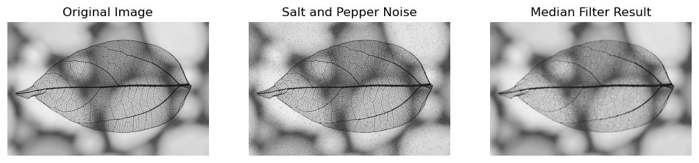
import cv2
import random

# Read image in grayscale
image = cv2.imread("Test.jpg", cv2.IMREAD_GRAYSCALE)

if image is None:
raise ValueError("Could not load image")

# Add salt and pepper noise
def add_salt_and_pepper_noise(image, noise_prob):
noisy_image = image.copy()
height, width = noisy_image.shape

for i in range(height):
for j in range(width):
r = random.random()

if r < noise_prob / 2:
noisy_image[i, j] = 255 # Salt
elif r < noise_prob:
noisy_image[i, j] = 0 # Pepper

return noisy_image

# Add 5% noise
noisy_image = add_salt_and_pepper_noise(image, 0.05)

# Remove noise using median filter
filtered_image = cv2.medianBlur(noisy_image, 5)

# Display
cv2.imshow("Original Image", image)
cv2.imshow("Noisy Image", noisy_image)
cv2.imshow("Filtered Image", filtered_image)

cv2.waitKey(0)
cv2.destroyAllWindows()

Q.11 Apply a mean filter to an image and observe its effect on image quality
import cv2
import matplotlib.pyplot as plt

# Read image
img = cv2.imread("Test.jpg")

# Convert BGR to RGB
img_rgb = cv2.cvtColor(img, cv2.COLOR_BGR2RGB)

# Apply mean filter
mean_filtered = cv2.blur(img_rgb, (5, 5))

# Display images
plt.figure(figsize=(10, 4))

plt.subplot(1, 2, 1)
plt.imshow(img_rgb)
plt.title("Original Image")
plt.axis("off")

plt.subplot(1, 2, 2)
plt.imshow(mean_filtered)
plt.title("Mean Filter")
plt.axis("off")

plt.show()

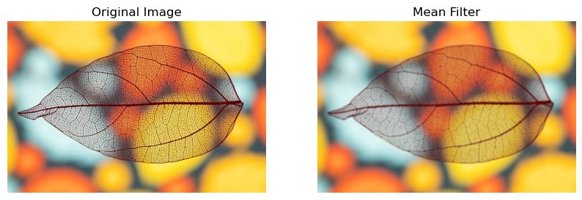

Q.12 Apply Gaussian smoothing using 3x3, 5x5, and 7x7 kernels and compare the results
import cv2
import matplotlib.pyplot as plt

# Read the image
img = cv2.imread("Test.jpg")

# Convert BGR to RGB for displaying
img_rgb = cv2.cvtColor(img, cv2.COLOR_BGR2RGB)

# Apply Gaussian smoothing with different kernel sizes
gaussian_3 = cv2.GaussianBlur(img_rgb, (3, 3), 0)
gaussian_5 = cv2.GaussianBlur(img_rgb, (5, 5), 0)
gaussian_7 = cv2.GaussianBlur(img_rgb, (7, 7), 0)

# Display the images
plt.figure(figsize=(12, 8))

# Original image
plt.subplot(1, 4, 1)
plt.imshow(img_rgb)
plt.title("Original Image")
plt.axis("off")

# 3x3 Gaussian filter
plt.subplot(1, 4, 2)
plt.imshow(gaussian_3)
plt.title("Gaussian Blur - 3x3")
plt.axis("off")

# 5x5 Gaussian filter
plt.subplot(1, 4, 3)
plt.imshow(gaussian_5)
plt.title("Gaussian Blur - 5x5")
plt.axis("off")

# 7x7 Gaussian filter
plt.subplot(1, 4, 4)
plt.imshow(gaussian_7)
plt.title("Gaussian Blur - 7x7")
plt.axis("off")

plt.show()

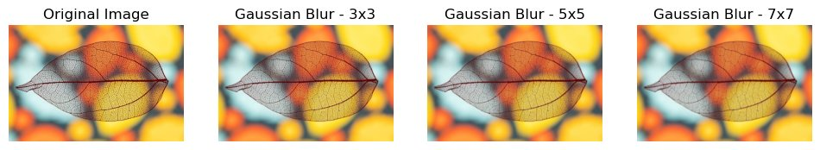

Q.13 Apply bilateral filtering to an image and observe how it affects noise and edges
import cv2
import matplotlib.pyplot as plt

# Read the image
img = cv2.imread("Dog.jpg")

# Convert BGR to RGB for display
img_rgb = cv2.cvtColor(img, cv2.COLOR_BGR2RGB)

# Apply bilateral filter
bilateral_img = cv2.bilateralFilter(img_rgb, 9, 75, 75)

# Display original and filtered images
plt.figure(figsize=(10, 5))

# Original image
plt.subplot(1, 2, 1)
plt.imshow(img_rgb)
plt.title("Original Image")
plt.axis("off")

# Bilateral filtered image
plt.subplot(1, 2, 2)
plt.imshow(bilateral_img)
plt.title("Bilateral Filter")
plt.axis("off")

plt.show()

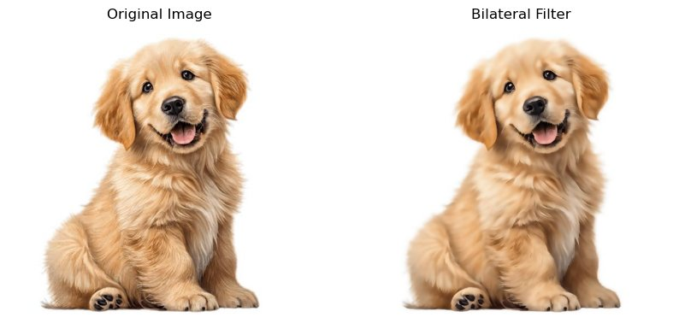

Q.14 Apply Gaussian, median, and bilateral filters to the same noisy image and compare their results
import cv2
import numpy as np
import matplotlib.pyplot as plt

# Read the image
img = cv2.imread("test.jpg")

# Convert BGR to RGB for display
img_rgb = cv2.cvtColor(img, cv2.COLOR_BGR2RGB)

# Create a copy to add noise
noisy_img = img_rgb.copy()

# Get image dimensions
height, width = noisy_img.shape[:2]

# Number of noisy pixels
num_pixels = 5000

# Add salt-and-pepper noise
for i in range(num_pixels):

# Generate random coordinates
x = np.random.randint(0, width)
y = np.random.randint(0, height)

# Add salt or pepper noise
if i % 2 == 0:
noisy_img[y, x] = [255, 255, 255] # Salt (White)
else:
noisy_img[y, x] = [0, 0, 0] # Pepper (Black)

# Apply Gaussian filter
gaussian = cv2.GaussianBlur(noisy_img, (5, 5), 0)

# Apply Median filter
median = cv2.medianBlur(noisy_img, 5)

# Apply Bilateral filter
bilateral = cv2.bilateralFilter(noisy_img, 9, 75, 75)

# Display all images
plt.figure(figsize=(15, 10))

# Original image
plt.subplot(2, 3, 1)
plt.imshow(img_rgb)
plt.title("Original Image")
plt.axis("off")

# Noisy image
plt.subplot(2, 3, 2)
plt.imshow(noisy_img)
plt.title("Noisy Image")
plt.axis("off")

# Gaussian filter
plt.subplot(2, 3, 3)
plt.imshow(gaussian)
plt.title("Gaussian Filter")
plt.axis("off")

# Median filter
plt.subplot(2, 3, 4)
plt.imshow(median)
plt.title("Median Filter")
plt.axis("off")

# Bilateral filter
plt.subplot(2, 3, 5)
plt.imshow(bilateral)
plt.title("Bilateral Filter")
plt.axis("off")

plt.show()

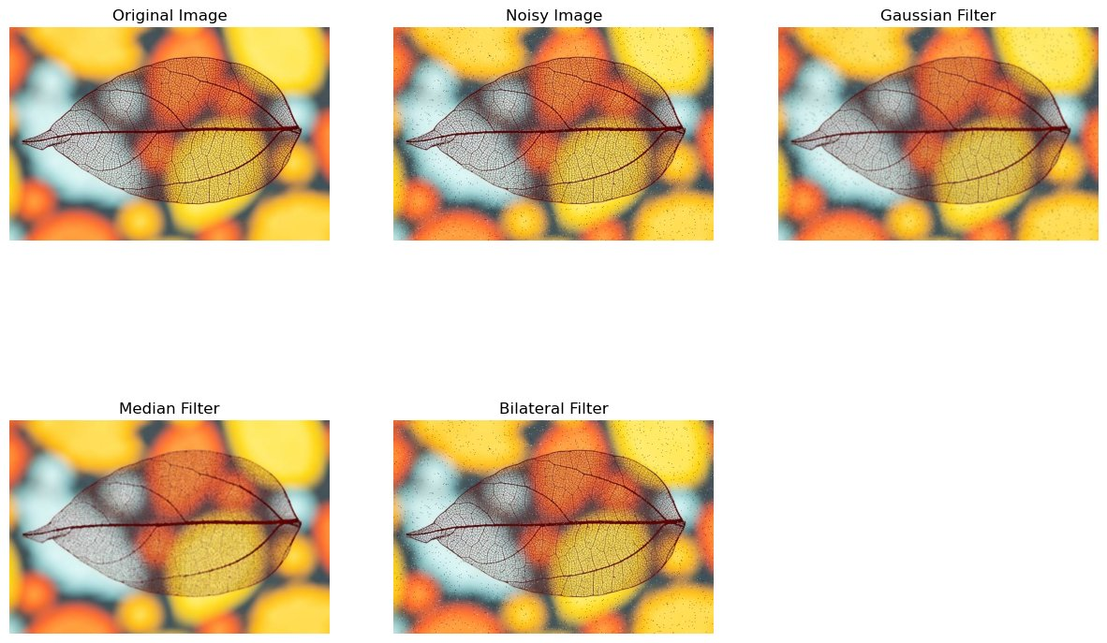

Q.15 Sharpen an image using a Laplacian-based sharpening technique
import cv2
import matplotlib.pyplot as plt

# Read the image
img = cv2.imread("coin.jpg")

# Convert BGR to RGB for display
img_rgb = cv2.cvtColor(img, cv2.COLOR_BGR2RGB)

# Convert image to grayscale
gray = cv2.cvtColor(img, cv2.COLOR_BGR2GRAY)

# Apply Laplacian operator
laplacian = cv2.Laplacian(gray, cv2.CV_64F)

# Convert Laplacian to unsigned 8-bit format
laplacian_abs = cv2.convertScaleAbs(laplacian)

# Sharpen the image
sharpened = cv2.subtract(img_rgb, cv2.cvtColor(laplacian_abs, cv2.COLOR_GRAY2RGB))

# Display images
plt.figure(figsize=(12, 4))

# Original image
plt.subplot(1, 3, 1)
plt.imshow(img_rgb)
plt.title("Original Image")
plt.axis("off")

# Laplacian edges
plt.subplot(1, 3, 2)
plt.imshow(laplacian_abs, cmap="gray")
plt.title("Laplacian Edges")
plt.axis("off")

# Sharpened image
plt.subplot(1, 3, 3)
plt.imshow(sharpened)
plt.title("Sharpened Image")
plt.axis("off")

plt.show()

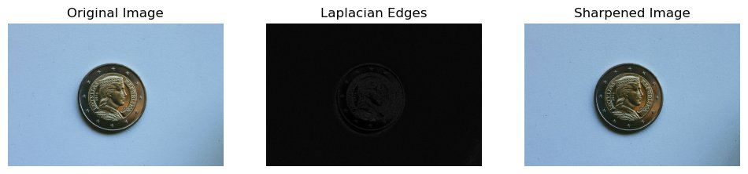

Q.16 Apply unsharp masking
import cv2
import matplotlib.pyplot as plt

# Read image
img = cv2.imread("coin.jpg")

# Convert BGR to RGB
img_rgb = cv2.cvtColor(img, cv2.COLOR_BGR2RGB)

# Create a blurred version
blurred = cv2.GaussianBlur(img_rgb, (5, 5), 0)

# Apply unsharp masking
sharpened = cv2.addWeighted(
img_rgb, 1.5,
blurred, -0.5,
0
)

# Display images
plt.figure(figsize=(12, 4))

plt.subplot(1, 3, 1)
plt.imshow(img_rgb)
plt.title("Original")
plt.axis("off")

plt.subplot(1, 3, 2)
plt.imshow(blurred)
plt.title("Blurred Image")
plt.axis("off")

plt.subplot(1, 3, 3)
plt.imshow(sharpened)
plt.title("Unsharp Masking")
plt.axis("off")

plt.show()

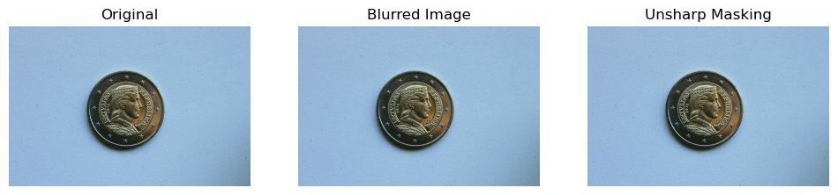

Q.17 Perform contrast stretching on a low-contrast grayscale image
import cv2
import matplotlib.pyplot as plt

# Read image in grayscale
img = cv2.imread("dog.jpg", cv2.IMREAD_GRAYSCALE)

# Find minimum and maximum pixel values
min_val = img.min()
max_val = img.max()

# Perform contrast stretching
stretched = ((img - min_val) / (max_val - min_val) * 255).astype("uint8")

# Display original and stretched images
plt.figure(figsize=(10, 5))

plt.subplot(1, 2, 1)
plt.imshow(img, cmap="gray")
plt.title("Original Low-Contrast Image")
plt.axis("off")

plt.subplot(1, 2, 2)
plt.imshow(stretched, cmap="gray")
plt.title("Contrast Stretched Image")
plt.axis("off")

plt.show()

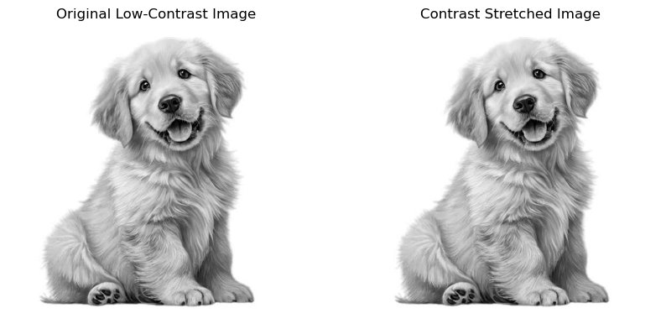

Q.18 Apply histogram equalization and display the image and its histogram before and after processing
import cv2
import matplotlib.pyplot as plt

# Read image in grayscale
img = cv2.imread("image.jpg", cv2.IMREAD_GRAYSCALE)

# Apply histogram equalization
equalized = cv2.equalizeHist(img)

# Create figure
plt.figure(figsize=(12, 8))

# Original image
plt.subplot(2, 2, 1)
plt.imshow(img, cmap="gray")
plt.title("Original Image")
plt.axis("off")

# Original histogram
plt.subplot(2, 2, 2)
plt.hist(img.ravel(), bins=256, range=[0, 256])
plt.title("Original Histogram")
plt.xlabel("Pixel Intensity")
plt.ylabel("Number of Pixels")

# Equalized image
plt.subplot(2, 2, 3)
plt.imshow(equalized, cmap="gray")
plt.title("Histogram Equalized Image")
plt.axis("off")

# Equalized histogram
plt.subplot(2, 2, 4)
plt.hist(equalized.ravel(), bins=256, range=[0, 256])
plt.title("Equalized Histogram")
plt.xlabel("Pixel Intensity")
plt.ylabel("Number of Pixels")

plt.tight_layout()
plt.show()

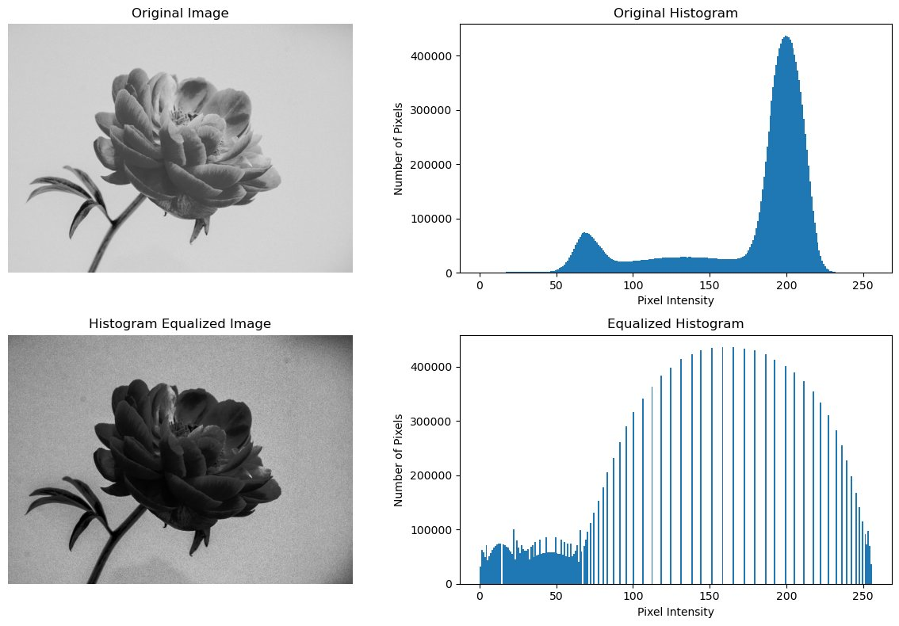

Q.19 Apply CLAHE to a low-contrast image and compare the result with standard histogram equalization
import cv2
import matplotlib.pyplot as plt

# Read the image in grayscale
image = cv2.imread("image.jpg")

normalized_image = image.astype(np.float32) / 255.0

print("--- Before Normalization ---")
print(f"Data Type: {image.dtype}")
print(f"Min Value: {image.min()}, Max Value: {image.max()}")

print("\n--- After Normalization ---")
print(f"Data Type: {normalized_image.dtype}")
print(f"Min Value: {normalized_image.min():.2f}, Max Value: {normalized_image.max():.2f}")
# Display images
plt.figure(figsize=(15, 5))

# Original image
plt.subplot(1, 2, 1)
plt.imshow(image, cmap="gray")
plt.title("Original Low-Contrast Image")
plt.axis("off")

# Standard histogram equalization
plt.subplot(1, 2, 2)
plt.imshow(normalized_image, cmap="gray")
plt.title("Histogram Equalization")
plt.axis("off")

plt.tight_layout()
plt.show()

--- Before Normalization ---
Data Type: uint8
Min Value: 0, Max Value: 255

--- After Normalization ---
Data Type: float32
Min Value: 0.00, Max Value: 1.00

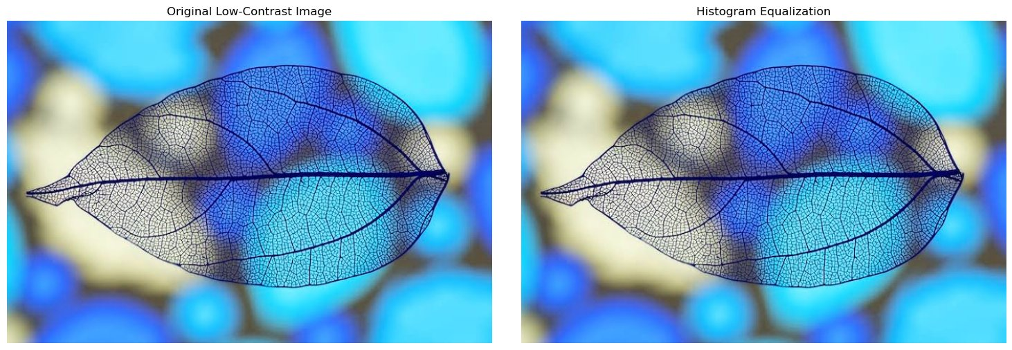

Q20. Normalize an image from the pixel range 0-255 to 0-1
import cv2

# Read image
img = cv2.imread("image.jpg")

# Normalize pixel values from 0-255 to 0-1
normalized_img = img / 255.0

# Check ranges
print("Original range:", img.min(), "to", img.max())
print("Normalized range:",normalized_img.min(),"to",normalized_img.max())

Original range: 0 to 255
Normalized range: 0.0 to 1.0

Q.21 Standardize the pixel values of a grayscale image using its mean and standard deviation
import cv2
import numpy as np
import matplotlib.pyplot as plt

# Read the image in grayscale
img = cv2.imread("image.jpg", cv2.IMREAD_GRAYSCALE)

# Convert image to float
img_float = img.astype(np.float32)

# Calculate mean and standard deviation
mean = img_float.mean()
std = img_float.std()

# Standardize the image
standardized_img = (img_float - mean) / std

# Print values
print("Original Mean:", mean)
print("Original Standard Deviation:", std)

print("Standardized Mean:", standardized_img.mean())
print("Standardized Standard Deviation:", standardized_img.std())

# Display images
plt.figure(figsize=(10, 4))

plt.subplot(1, 2, 1)
plt.imshow(img, cmap="gray")
plt.title("Original Grayscale Image")
plt.axis("off")

plt.subplot(1, 2, 2)
plt.imshow(standardized_img, cmap="gray")
plt.title("Standardized Image")
plt.axis("off")

plt.show()

Original Mean: 176.18396
Original Standard Deviation: 45.599598
Standardized Mean: 2.7962847e-06
Standardized Standard Deviation: 0.9999998

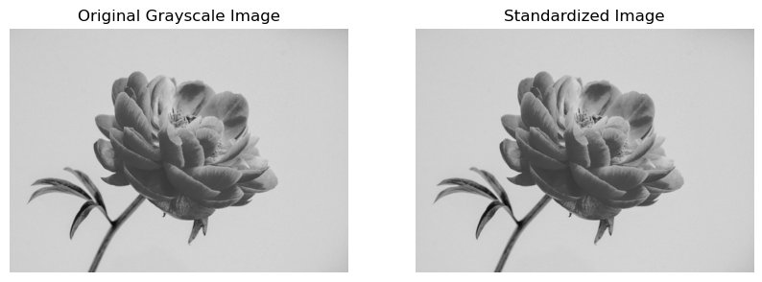

Q.22 Apply global thresholding to a grayscale image using a threshold value of 127
import cv2
import matplotlib.pyplot as plt

# Read the image in grayscale
img = cv2.imread("image.jpg", cv2.IMREAD_GRAYSCALE)

# Apply global thresholding
_, threshold_img = cv2.threshold(
img,
127,
255,
cv2.THRESH_BINARY
)

# Display images
plt.figure(figsize=(10, 5))

plt.subplot(1, 2, 1)
plt.imshow(img, cmap="gray")
plt.title("Original Grayscale Image")
plt.axis("off")

plt.subplot(1, 2, 2)
plt.imshow(threshold_img, cmap="gray")
plt.title("Thresholded Image")
plt.axis("off")

plt.show()

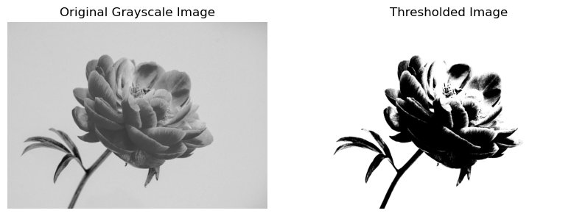

Q.23 Apply Otsu's thresholding method to automatically determine a suitable threshold for an image
import cv2
import matplotlib.pyplot as plt

# read the image in grayscale
img = cv2.imread("dog.jpg",cv2.IMREAD_GRAYSCALE)

# Apply Otsu's thresholding
threshold_value , otsu_img = cv2.threshold(img,0,255,cv2.THRESH_BINARY+cv2.THRESH_OTSU)

# Print automatically selected threshold
print("Otsu's Threshold Value:", threshold_value)

Otsu's Threshold Value: 194.0

# Display images
plt.figure(figsize=(10, 5))

plt.subplot(1, 2, 1)
plt.imshow(img, cmap="gray")
plt.title("Original Grayscale Image")
plt.axis("off")

plt.subplot(1, 2, 2)
plt.imshow(otsu_img, cmap="gray")
plt.title("Otsu Thresholding")
plt.axis("off")

plt.show()

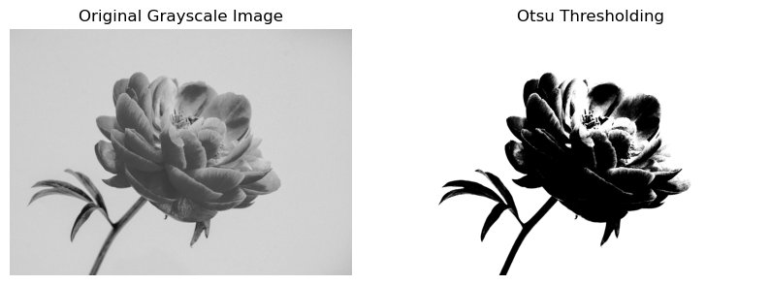

Q.24 Apply adaptive mean and adaptive Gaussian thresholding to an image and compare the results
import cv2
import matplotlib.pyplot as plt

# Read image in grayscale
img = cv2.imread("dog.jpg", cv2.IMREAD_GRAYSCALE)

# Adaptive Mean Thresholding
adaptive_mean = cv2.adaptiveThreshold(
img,
255,
cv2.ADAPTIVE_THRESH_MEAN_C,
cv2.THRESH_BINARY,
11,
2
)

# Adaptive Gaussian Thresholding
adaptive_gaussian = cv2.adaptiveThreshold(
img,
255,
cv2.ADAPTIVE_THRESH_GAUSSIAN_C,
cv2.THRESH_BINARY,
11,
2
)

# Display results
plt.figure(figsize=(15, 5))

plt.subplot(1, 3, 1)
plt.imshow(img, cmap="gray")
plt.title("Original Image")
plt.axis("off")

plt.subplot(1, 3, 2)
plt.imshow(adaptive_mean, cmap="gray")
plt.title("Adaptive Mean")
plt.axis("off")

plt.subplot(1, 3, 3)
plt.imshow(adaptive_gaussian, cmap="gray")
plt.title("Adaptive Gaussian")
plt.axis("off")

plt.tight_layout()
plt.show()

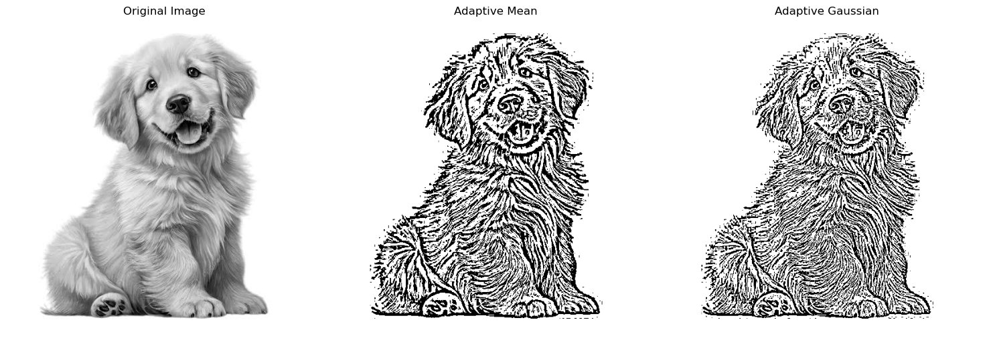

Q.25 Convert a grayscale image into a binary image and analyze the effect of different threshold values
import cv2
import matplotlib.pyplot as plt

# Read image in grayscale
img = cv2.imread("dog.jpg", cv2.IMREAD_GRAYSCALE)

# Apply different threshold values
_, threshold_50 = cv2.threshold(
img, 50, 255, cv2.THRESH_BINARY
)

_, threshold_100 = cv2.threshold(
img, 100, 255, cv2.THRESH_BINARY
)

_, threshold_150 = cv2.threshold(
img, 150, 255, cv2.THRESH_BINARY
)

_, threshold_200 = cv2.threshold(
img, 200, 255, cv2.THRESH_BINARY
)

# Display results
plt.figure(figsize=(12, 8))

# Original grayscale image
plt.subplot(2, 3, 1)
plt.imshow(img, cmap="gray")
plt.title("Original Grayscale")
plt.axis("off")

# Threshold = 50
plt.subplot(2, 3, 2)
plt.imshow(threshold_50, cmap="gray")
plt.title("Threshold = 50")
plt.axis("off")

# Threshold = 100
plt.subplot(2, 3, 3)
plt.imshow(threshold_100, cmap="gray")
plt.title("Threshold = 100")
plt.axis("off")

# Threshold = 150
plt.subplot(2, 3, 4)
plt.imshow(threshold_150, cmap="gray")
plt.title("Threshold = 150")
plt.axis("off")

# Threshold = 200
plt.subplot(2, 3, 5)
plt.imshow(threshold_200, cmap="gray")
plt.title("Threshold = 200")
plt.axis("off")

plt.tight_layout()
plt.show()

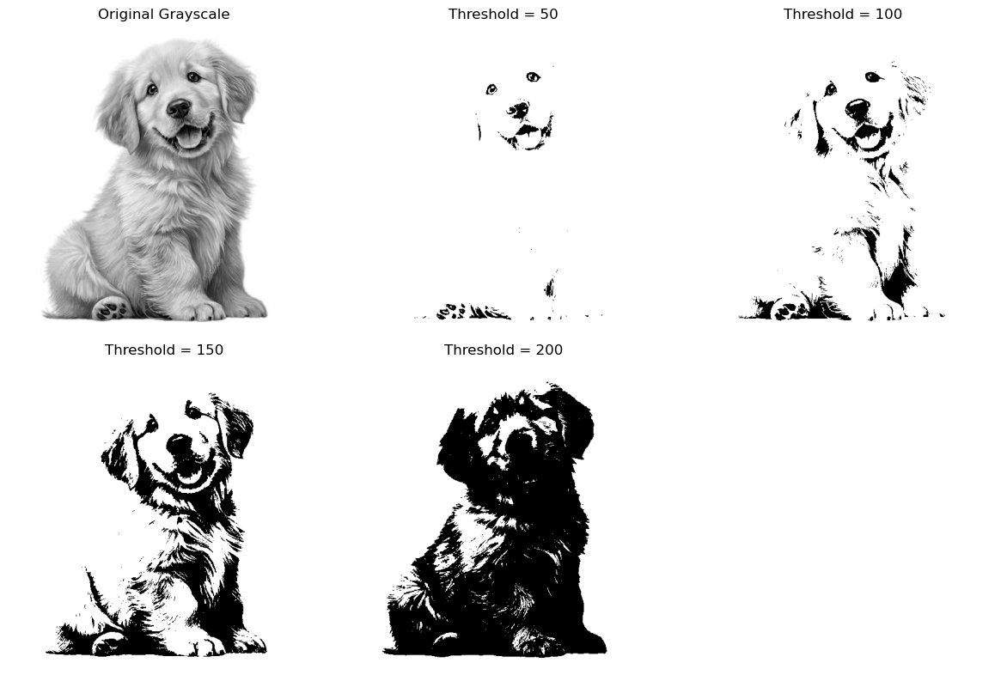

Q.26 Apply erosion and dilation to a binary image and display the results
import cv2
import numpy as np
import matplotlib.pyplot as plt

# Read image in grayscale
img = cv2.imread("dog.jpg", cv2.IMREAD_GRAYSCALE)

# Convert grayscale image to binary
_, binary_img = cv2.threshold(img,127,255,cv2.THRESH_BINARY)

# Create kernel
kernel = np.ones((5, 5), np.uint8)

# Apply erosion
erosion = cv2.erode(binary_img,kernel,iterations=1)

# Apply dilation
dilation = cv2.dilate(binary_img,kernel,iterations=1)

# Display results
plt.figure(figsize=(15, 5))

# Original grayscale image
plt.subplot(1, 4, 1)
plt.imshow(img, cmap="gray")
plt.title("Original Image")
plt.axis("off")

# Binary image
plt.subplot(1, 4, 2)
plt.imshow(binary_img, cmap="gray")
plt.title("Binary Image")
plt.axis("off")

# Erosion
plt.subplot(1, 4, 3)
plt.imshow(erosion, cmap="gray")
plt.title("Erosion")
plt.axis("off")

# Dilation
plt.subplot(1, 4, 4)
plt.imshow(dilation, cmap="gray")
plt.title("Dilation")
plt.axis("off")

plt.tight_layout()
plt.show()

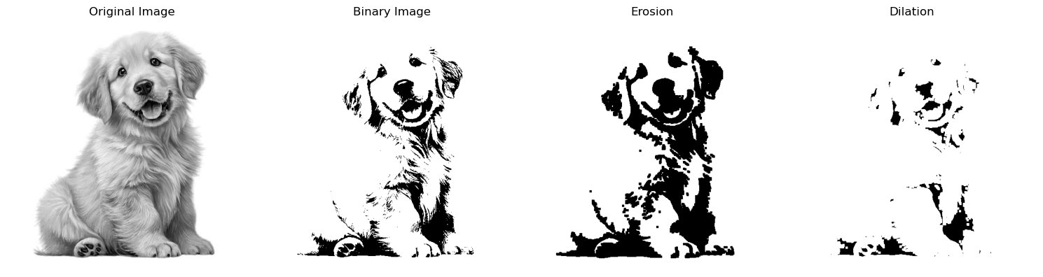

Q.27 Apply morphological opening and closing to a binary image containing small noise and gaps
import cv2
import numpy as np
import matplotlib.pyplot as plt

# Read image in grayscale
img = cv2.imread("dog.jpg", cv2.IMREAD_GRAYSCALE)

# Convert grayscale image to binary
_, binary_img = cv2.threshold(
img,
127,
255,
cv2.THRESH_BINARY
)

# Create a kernel
kernel = np.ones((5, 5), np.uint8)

# Apply morphological opening
opening = cv2.morphologyEx(
binary_img,
cv2.MORPH_OPEN,
kernel
)

# Apply morphological closing
closing = cv2.morphologyEx(
binary_img,
cv2.MORPH_CLOSE,
kernel
)

# Display results
plt.figure(figsize=(15, 5))

plt.subplot(1, 3, 1)
plt.imshow(binary_img, cmap="gray")
plt.title("Original Binary Image")
plt.axis("off")

plt.subplot(1, 3, 2)
plt.imshow(opening, cmap="gray")
plt.title("Opening")
plt.axis("off")

plt.subplot(1, 3, 3)
plt.imshow(closing, cmap="gray")
plt.title("Closing")
plt.axis("off")

plt.tight_layout()
plt.show()

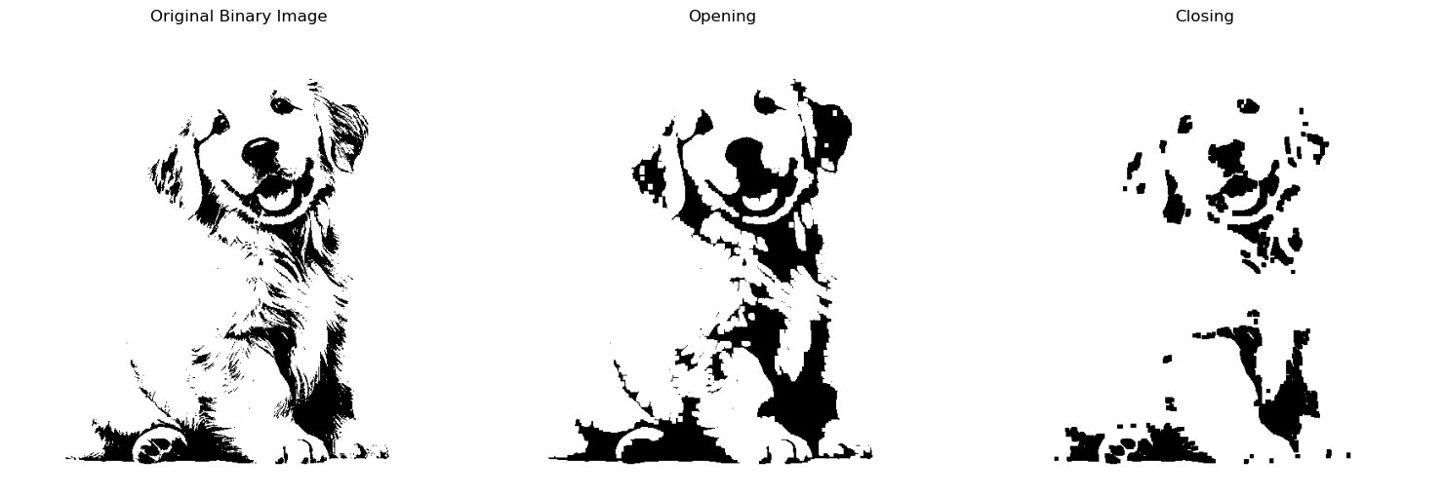

Q.28 Apply Sobel, Prewitt, Laplacian, and Canny edge detection to the same image and compare the detected edges
import cv2
import numpy as np
import matplotlib.pyplot as plt

# Read image in grayscale
img = cv2.imread("a.jpg", cv2.IMREAD_GRAYSCALE)

# -------------------------
# 1. Sobel Edge Detection
# -------------------------

sobel_x = cv2.Sobel(img,cv2.CV_64F,1,0,ksize=3)
sobel_y = cv2.Sobel(img,cv2.CV_64F,0,1,ksize=3)

# Combine X and Y edges
sobel = cv2.magnitude(sobel_x, sobel_y)
sobel = cv2.convertScaleAbs(sobel)

# -------------------------
# 2. Prewitt Edge Detection
# -------------------------

prewitt_x_kernel = np.array([
[-1, 0, 1],
[-1, 0, 1],
[-1, 0, 1]
])

prewitt_y_kernel = np.array([
[-1, -1, -1],
[ 0, 0, 0],
[ 1, 1, 1]
])

prewitt_x = cv2.filter2D(img,cv2.CV_64F,prewitt_x_kernel)
prewitt_y = cv2.filter2D(img,cv2.CV_64F,prewitt_y_kernel)

# Combine X and Y edges
prewitt = cv2.magnitude(prewitt_x,prewitt_y)
prewitt = cv2.convertScaleAbs(prewitt)

# -------------------------
# 3. Laplacian Edge Detection
# -------------------------

laplacian = cv2.Laplacian(img,cv2.CV_64F)
laplacian = cv2.convertScaleAbs(laplacian)

# -------------------------
# 4. Canny Edge Detection
# -------------------------

canny = cv2.Canny(img,100,200)

# -------------------------
# Display Results
# -------------------------

plt.figure(figsize=(12, 8))

plt.subplot(2, 3, 1)
plt.imshow(img, cmap="gray")
plt.title("Original Image")
plt.axis("off")

plt.subplot(2, 3, 2)
plt.imshow(sobel, cmap="gray")
plt.title("Sobel Edges")
plt.axis("off")

plt.subplot(2, 3, 3)
plt.imshow(prewitt, cmap="gray")
plt.title("Prewitt Edges")
plt.axis("off")

plt.subplot(2, 3, 4)
plt.imshow(laplacian, cmap="gray")
plt.title("Laplacian Edges")
plt.axis("off")

plt.subplot(2, 3, 5)
plt.imshow(canny, cmap="gray")
plt.title("Canny Edges")
plt.axis("off")

plt.tight_layout()
plt.show()

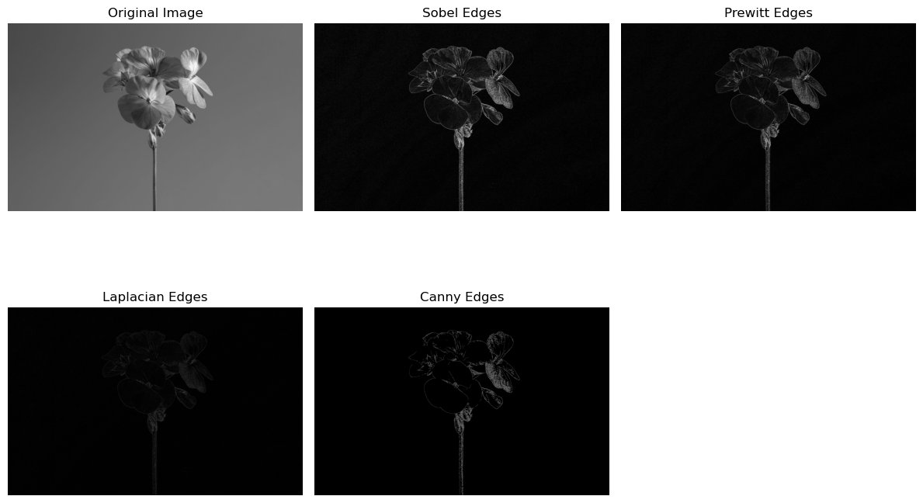

Q.29 Detect the edges of an object using Canny edge detection and display the resulting edge image
import cv2
import matplotlib.pyplot as plt

# Read the image
img = cv2.imread("dog.jpg")

# Convert BGR to RGB for displaying
img_rgb = cv2.cvtColor(img, cv2.COLOR_BGR2RGB)

# Convert the image to grayscale
gray = cv2.cvtColor(img, cv2.COLOR_BGR2GRAY)

# Apply Gaussian blur to reduce noise
blurred = cv2.GaussianBlur(gray, (5, 5), 0)

# Apply Canny edge detection
edges = cv2.Canny(blurred, 100, 200)

# Display original and edge image
plt.figure(figsize=(12, 5))

plt.subplot(1, 2, 1)
plt.imshow(img_rgb)
plt.title("Original Image")
plt.axis("off")

plt.subplot(1, 2, 2)
plt.imshow(edges, cmap="gray")
plt.title("Canny Edge Detection")
plt.axis("off")

plt.tight_layout()
plt.show()

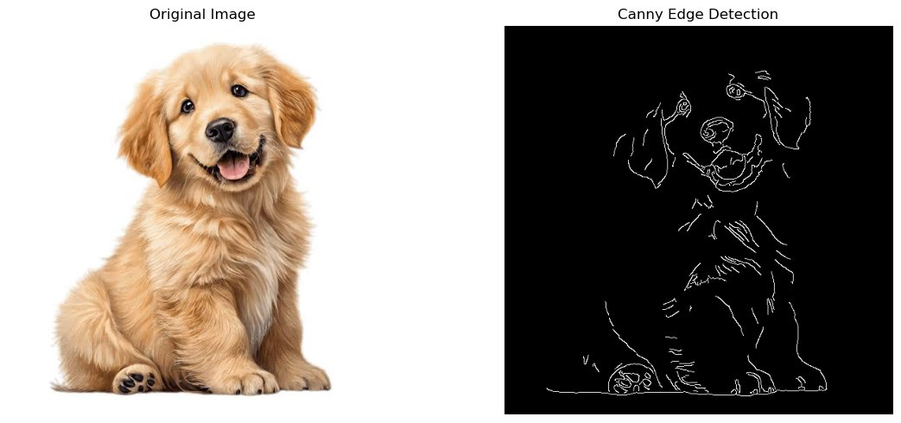

Q.30 Perform background removal using grayscale conversion, thresholding, and a binary mask, then display the extracted foreground object
import cv2
import matplotlib.pyplot as plt

# Read the original image
img = cv2.imread("a.jpg")

# Convert BGR to RGB for displaying
img_rgb = cv2.cvtColor(img, cv2.COLOR_BGR2RGB)

# Convert image to grayscale
gray = cv2.cvtColor(img, cv2.COLOR_BGR2GRAY)

# Create a binary mask
_, mask = cv2.threshold(gray,127,255,cv2.THRESH_BINARY)

# Extract foreground using the binary mask
foreground = cv2.bitwise_and(img,img,mask=mask)

# Convert extracted foreground to RGB
foreground_rgb = cv2.cvtColor(foreground,cv2.COLOR_BGR2RGB)

# Display results
plt.figure(figsize=(15, 5))

# Original image
plt.subplot(1, 3, 1)
plt.imshow(img_rgb)
plt.title("Original Image")
plt.axis("off")

# Binary mask
plt.subplot(1, 3, 2)
plt.imshow(cv2.cvtColor(mask,cv2.COLOR_GRAY2RGB))
plt.title("Binary Mask")
plt.axis("off")

# Extracted foreground
plt.subplot(1, 3, 3)
plt.imshow(foreground_rgb)
plt.title("Extracted Foreground")
plt.axis("off")

plt.tight_layout()
plt.show()

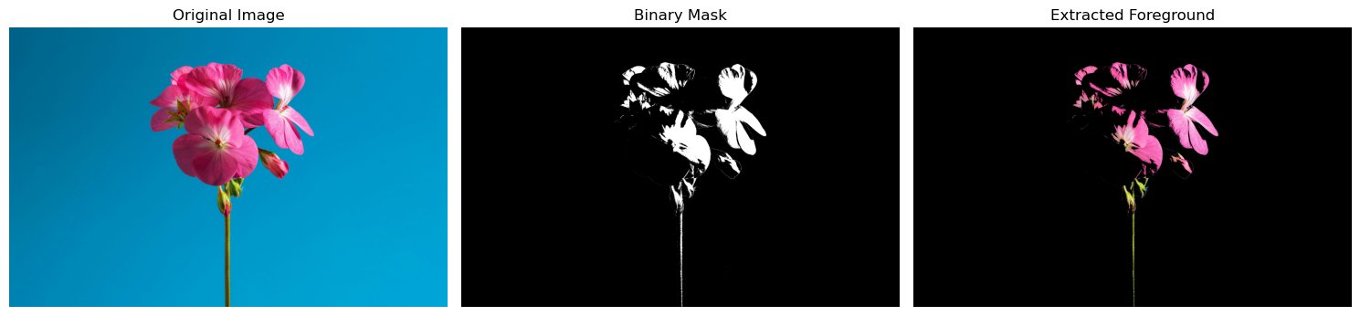

P2

Question 1 –
Canny Edge Detection Write a Python program to: • Read an input image. • Convert it to grayscale. • Apply Gaussian smoothing. • Apply Canny edge detection. • Display the original and edge-detected images. Try different lower and upper threshold values and observe the changes.
import cv2
import matplotlib.pyplot as plt

# Step 1: Read the image
image = cv2.imread("dog.jpg")

# Step 2: Convert the image to grayscale
gray = cv2.cvtColor(image, cv2.COLOR_BGR2GRAY)

# Step 3: Apply Gaussian smoothing
blur = cv2.GaussianBlur(gray, (9, 9), 0)

# Step 4: Apply Canny Edge Detection
edges = cv2.Canny(blur, 30, 100)

plt.figure(figsize=(10,5))

plt.subplot(1,4,1)
plt.imshow(cv2.cvtColor(image,cv2.COLOR_BGR2RGB))
plt.title("Original image")
plt.axis("off")

plt.subplot(1, 4, 2)
plt.imshow(gray,cmap="gray")
plt.title("GrayScale Image")
plt.axis("off")

plt.subplot(1, 4,3)
plt.imshow(blur,cmap="gray")
plt.title("Gaussian Blur Detection")
plt.axis("off")

plt.subplot(1,4,4)
plt.imshow(edges,cmap="gray")
plt.title("Canny Edge Detection")
plt.axis("off")

plt.show()

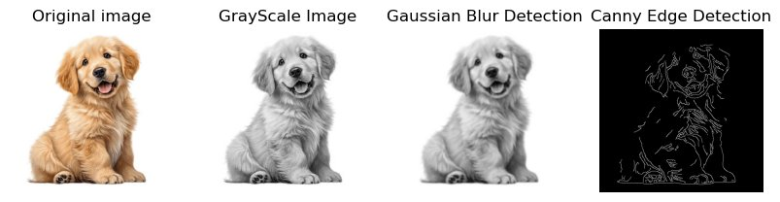

Q2
Question 2 – Laplacian of Gaussian (LoG) Write a Python program to: • Read an image. • Convert it to grayscale. • Apply Gaussian Blur. • Apply the Laplacian operator. • Display the detected edges. Change the Gaussian kernel size and observe the effect
import cv2
import matplotlib.pyplot as plt

# Step 1: Read the image
image = cv2.imread("dog.jpg")

# Step 2: Convert image to grayscale
gray = cv2.cvtColor(image, cv2.COLOR_BGR2GRAY)

# Step 3: Apply Gaussian Blur
blur = cv2.GaussianBlur(gray, (5, 5), 0)

# Step 4: Apply Laplacian operator
laplacian = cv2.Laplacian(blur, cv2.CV_64F)

# Convert result to uint8 so that it can be displayed
laplacian = cv2.convertScaleAbs(laplacian)

plt.figure(figsize=(10,5))

plt.subplot(1,4,1)
plt.imshow(cv2.cvtColor(img,cv2.COLOR_BGR2RGB))
plt.title("Original image")
plt.axis("off")

plt.subplot(1, 4, 2)
plt.imshow(gray,cmap="gray")
plt.title("GrayScale Image")
plt.axis("off")

plt.subplot(1, 4,3)
plt.imshow(blur,cmap="gray")
plt.title("Gaussian Blur Detection")
plt.axis("off")

plt.subplot(1,4,4)
plt.imshow(laplacian, cmap="gray")
plt.title("Laplacian of Gaussian")
plt.axis("off")

plt.show()

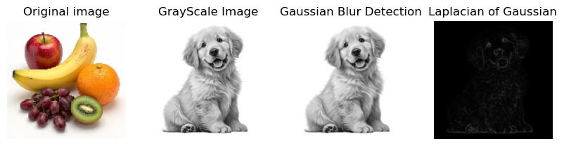

Question 3 – Difference of Gaussian (DoG)
Write a Python program to: • Apply Gaussian blur using two different sigma values. • Subtract the two blurred images. • Display the resulting DoG image. • Compare the DoG result with the original image.
import cv2
import matplotlib.pyplot as plt

import cv2
import matplotlib.pyplot as plt

# Step 1: Read the image
image = cv2.imread("dog.jpg")

# Step 2: Convert the image to grayscale
gray = cv2.cvtColor(image, cv2.COLOR_BGR2GRAY)

# Step 3: Apply Gaussian Blur with two different sigma values
blur1 = cv2.GaussianBlur(gray, (5, 5), 1)
blur2 = cv2.GaussianBlur(gray, (5, 5), 2)

# Step 4: Subtract the two blurred images
dog = blur1.astype(float) - blur2.astype(float)

# Step 5: Convert DoG result to displayable format
dog = cv2.convertScaleAbs(dog)

# Step 6: Display original and DoG images
plt.figure(figsize=(10, 5))

# Original image
plt.subplot(1, 4, 1)
plt.imshow(cv2.cvtColor(image, cv2.COLOR_BGR2RGB))
plt.title("Original Image")
plt.axis("off")

plt.subplot(1,4,2)
plt.title("Blur1 Image")
plt.imshow(blur1,cmap="gray")
plt.axis("off")

plt.subplot(1,4,3)
plt.title("Blur2 Image")
plt.imshow(blur2,cmap="gray")
plt.axis("off")

# DoG image
plt.subplot(1, 4,4)
plt.imshow(dog, cmap="gray")
plt.title("Difference of Gaussian")
plt.axis("off")

plt.show()

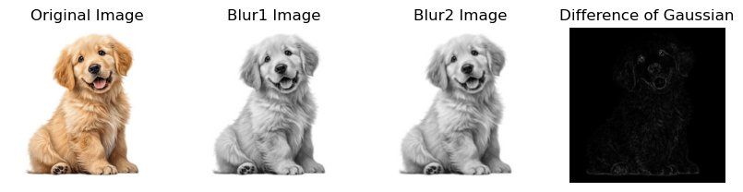

Question 4 – Comparison of Edge Detectors
Apply Canny, LoG, and DoG to the same image. Display all results and compare: • Edge quality • Noise • Number of detected edges • Computational requirements
import cv2
import matplotlib.pyplot as plt
import time

# -----------------------------------
# Step 1: Read the image
# -----------------------------------

image = cv2.imread("dog.jpg")

# Convert image to grayscale
gray = cv2.cvtColor(image, cv2.COLOR_BGR2GRAY)

# -----------------------------------
# Step 2: Canny Edge Detection
# -----------------------------------

start = time.time()

# Apply Gaussian Blur
canny_blur = cv2.GaussianBlur(gray, (5, 5), 0)

# Apply Canny
canny = cv2.Canny(canny_blur, 50, 150)

canny_time = time.time() - start

# -----------------------------------
# Step 3: Laplacian of Gaussian (LoG)
# -----------------------------------

start = time.time()

# Apply Gaussian Blur
log_blur = cv2.GaussianBlur(gray, (5, 5), 0)

# Apply Laplacian
log = cv2.Laplacian(log_blur, cv2.CV_64F)

# Convert result to displayable format
log = cv2.convertScaleAbs(log)

log_time = time.time() - start

# -----------------------------------
# Step 4: Difference of Gaussian (DoG)
# -----------------------------------

start = time.time()

# Apply Gaussian Blur with sigma = 1
dog_blur1 = cv2.GaussianBlur(gray, (5, 5), 1)

# Apply Gaussian Blur with sigma = 2
dog_blur2 = cv2.GaussianBlur(gray, (5, 5), 2)

# Subtract the two blurred images
dog = dog_blur1.astype(float) - dog_blur2.astype(float)

# Convert result to displayable format
dog = cv2.convertScaleAbs(dog)

dog_time = time.time() - start

# -----------------------------------
# Step 5: Display all results
# -----------------------------------

plt.figure(figsize=(12, 8))

# Original Image
plt.subplot(2, 2, 1)
plt.imshow(cv2.cvtColor(image, cv2.COLOR_BGR2RGB))
plt.title("Original Image")
plt.axis("off")

# Canny
plt.subplot(2, 2, 2)
plt.imshow(canny, cmap="gray")
plt.title("Canny Edge Detection")
plt.axis("off")

# LoG
plt.subplot(2, 2, 3)
plt.imshow(log, cmap="gray")
plt.title("Laplacian of Gaussian (LoG)")
plt.axis("off")

# DoG
plt.subplot(2, 2, 4)
plt.imshow(dog, cmap="gray")
plt.title("Difference of Gaussian (DoG)")
plt.axis("off")

plt.tight_layout()
plt.show()

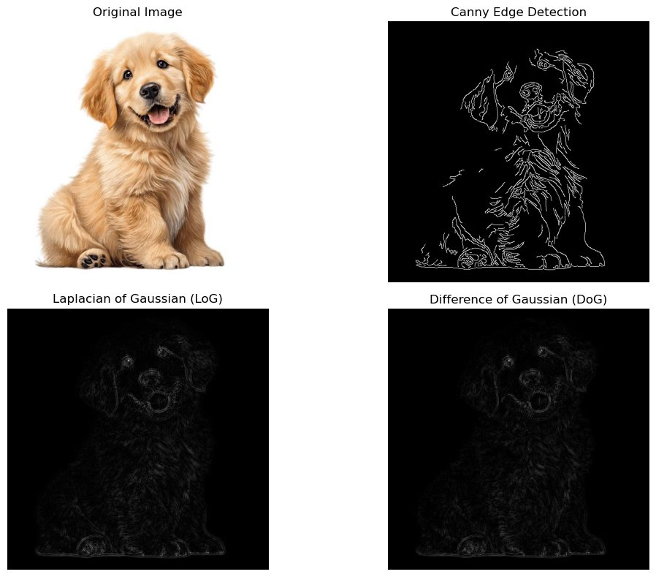
# -----------------------------------
# Step 6: Count detected edges
# -----------------------------------

canny_edges = cv2.countNonZero(canny)
log_edges = cv2.countNonZero(log)
dog_edges = cv2.countNonZero(dog)

print("Number of detected edges:")
print("Canny:", canny_edges)
print("LoG :", log_edges)
print("DoG :", dog_edges)

print("\nComputational time:")
print("Canny:", canny_time, "seconds")
print("LoG :", log_time, "seconds")
print("DoG :", dog_time, "seconds")

Number of detected edges:
Canny: 12455
LoG : 138757
DoG : 116969

Computational time:
Canny: 0.004315614700317383 seconds
LoG : 0.0051152706146240234 seconds
DoG : 0.010370016098022461 seconds

Question 5 – Hough Line Transform
Write a Python program to: • Detect edges using Canny. • Apply the Standard Hough Line Transform. • Detect straight lines. • Draw the detected lines on the original image.
import cv2
import numpy as np
import matplotlib.pyplot as plt

# Step 1: Read the image
image = cv2.imread("input.jpg")

# Make a copy of the original image
result = image.copy()

# Step 2: Convert image to grayscale
gray = cv2.cvtColor(image, cv2.COLOR_BGR2GRAY)

# Step 3: Detect edges using Canny
edges = cv2.Canny(gray, 50, 150)

# Step 4: Apply Standard Hough Line Transform
lines = cv2.HoughLines(edges, 1, np.pi / 180, 150)

# Step 5: Draw the detected lines
if lines is not None:

for line in lines:
rho, theta = line[0]

# Convert polar coordinates to two points
a = np.cos(theta)
b = np.sin(theta)

x0 = a * rho
y0 = b * rho

x1 = int(x0 + 1000 * (-b))
y1 = int(y0 + 1000 * (a))

x2 = int(x0 - 1000 * (-b))
y2 = int(y0 - 1000 * (a))

# Draw the line
cv2.line(result, (x1, y1), (x2, y2), (0, 0, 255), 2)

# Step 6: Display the results
plt.figure(figsize=(12, 5))

# Original image
plt.subplot(1, 3, 1)
plt.imshow(cv2.cvtColor(image, cv2.COLOR_BGR2RGB))
plt.title("Original Image")
plt.axis("off")

# Canny edges
plt.subplot(1, 3, 2)
plt.imshow(edges, cmap="gray")
plt.title("Canny Edges")
plt.axis("off")

# Detected lines
plt.subplot(1, 3, 3)
plt.imshow(cv2.cvtColor(result, cv2.COLOR_BGR2RGB))
plt.title("Hough Lines")
plt.axis("off")

plt.tight_layout()
plt.show()

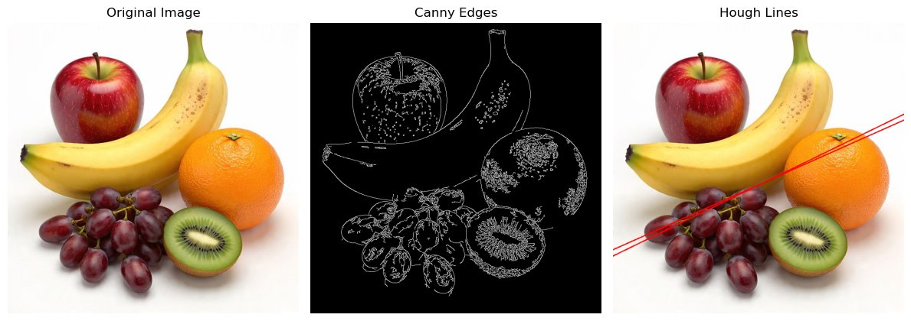

Question 6 – Probabilistic Hough Transform
Apply HoughLinesP() to an edge-detected image and draw the detected line segments. Change the threshold, minimum line length, and maximum line gap.
import cv2
import numpy as np
import matplotlib.pyplot as plt

# Step 1: Read the image
image = cv2.imread("input.jpg")

# Make a copy to draw lines
result = image.copy()

# Step 2: Convert image to grayscale
gray = cv2.cvtColor(image, cv2.COLOR_BGR2GRAY)

# Step 3: Detect edges using Canny
edges = cv2.Canny(gray,50,150)

# Step 4: Apply Probabilistic Hough Line Transform
lines = cv2.HoughLinesP(edges,1,np.pi/180,threshold=50,minLineLength=50,maxLineGap=10)

# Step 5: Draw detected line segments
if lines is not None:
for line in lines:
x1, y1, x2, y2 = line
cv2.line(result, (x1, y1), (x2, y2), (0, 255, 0), 2)

# Step 6: Display results
plt.figure(figsize=(12, 5))

# Original image
plt.subplot(1, 3, 1)
plt.imshow(cv2.cvtColor(image, cv2.COLOR_BGR2RGB))
plt.title("Original Image")
plt.axis("off")

# Canny edges
plt.subplot(1, 3, 2)
plt.imshow(edges, cmap="gray")
plt.title("Canny Edges")
plt.axis("off")

# Hough line segments
plt.subplot(1, 3, 3)
plt.imshow(cv2.cvtColor(result, cv2.COLOR_BGR2RGB))
plt.title("Probabilistic Hough Lines")
plt.axis("off")

plt.tight_layout()
plt.show()

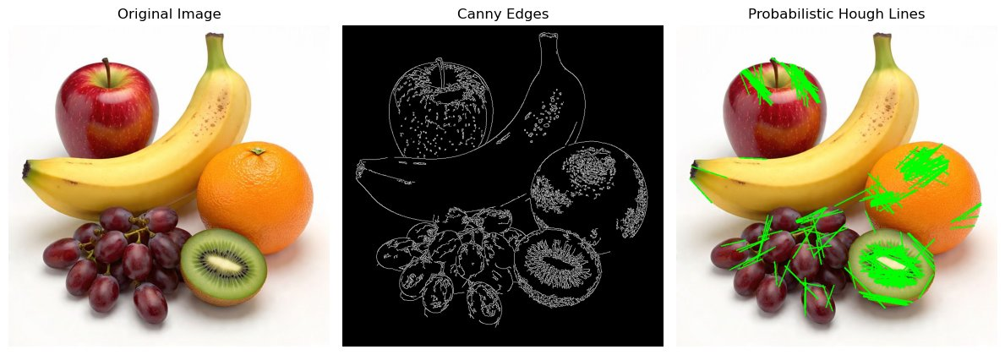

Question 7 – Hough Transform for Road/Lane Detection
Use a road image and: • Detect edges using Canny. • Apply the Probabilistic Hough Transform. • Detect lane lines. • Draw the detected lines on the road image.
import cv2
import numpy as np
import matplotlib.pyplot as plt

# Step 1: Read the road image
image = cv2.imread("road.jpg")

# Make a copy of the original image
result = image.copy()

# Step 2: Convert image to grayscale
gray = cv2.cvtColor(image, cv2.COLOR_BGR2GRAY)

# Step 3: Apply Canny Edge Detection
edges = cv2.Canny(gray, 50, 150)

# Step 4: Apply Probabilistic Hough Transform
lines = cv2.HoughLinesP(
edges,
1,
np.pi / 180,
threshold=50,
minLineLength=50,
maxLineGap=100
)

# Step 5: Draw detected lines
if lines is not None:
for line in lines:
x1, y1, x2, y2 = line.flatten()
cv2.line(result, (x1, y1), (x2, y2), (0, 0, 255), 3)

# Step 6: Display the results
plt.figure(figsize=(15, 5))

# Original road image
plt.subplot(1, 3, 1)
plt.imshow(cv2.cvtColor(image, cv2.COLOR_BGR2RGB))
plt.title("Original Road Image")
plt.axis("off")

# Canny edges
plt.subplot(1, 3, 2)
plt.imshow(edges, cmap="gray")
plt.title("Canny Edges")
plt.axis("off")

# Detected lane lines
plt.subplot(1, 3, 3)
plt.imshow(cv2.cvtColor(result, cv2.COLOR_BGR2RGB))
plt.title("Detected Lane Lines")
plt.axis("off")

plt.tight_layout()
plt.show()

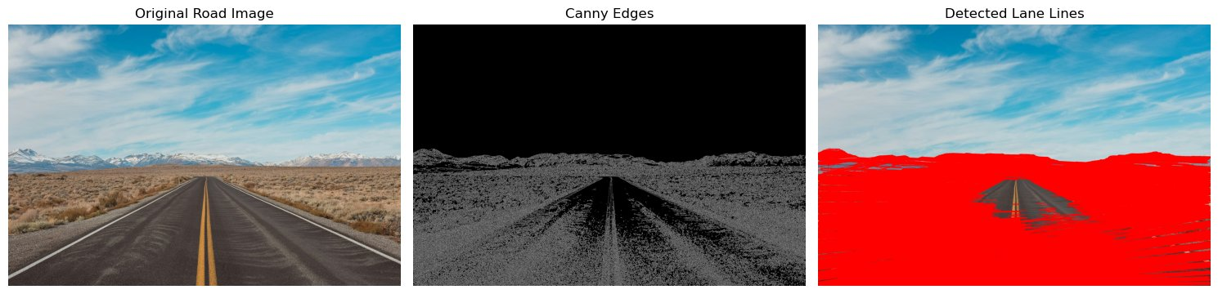
import cv2
import numpy as np
import matplotlib.pyplot as plt

# 1. Read image
image = cv2.imread("road.jpg")
if image is None:
raise FileNotFoundError("Could not find or open 'road.jpg'. Check the file path.")

result = image.copy()
height, width = image.shape[:2]

# 2. Grayscale + Gaussian Blur (reduces high-frequency noise)
gray = cv2.cvtColor(image, cv2.COLOR_BGR2GRAY)
blurred = cv2.GaussianBlur(gray, (5, 5), 0)

# 3. Canny Edge Detection
edges = cv2.Canny(blurred, 50, 150)

# 4. Region of Interest (ROI) Mask
# Create a triangular mask covering only the road in front of the camera
mask = np.zeros_like(edges)
roi_vertices = np.array([
[
(int(width * 0.1), height), # Bottom-left
(int(width * 0.45), int(height * 0.6)), # Top-left apex
(int(width * 0.55), int(height * 0.6)), # Top-right apex
(int(width * 0.9), height) # Bottom-right
]
], dtype=np.int32)

cv2.fillPoly(mask, roi_vertices, 255)
masked_edges = cv2.bitwise_and(edges, mask)

# 5. Probabilistic Hough Transform on masked edges
lines = cv2.HoughLinesP(
masked_edges,
rho=1,
theta=np.pi / 180,
threshold=50,
minLineLength=100, # Increased to reject short dashes/noise
maxLineGap=50 # Bridges broken dashes into single lines
)

# 6. Draw detected lines
if lines is not None:
for line in lines:
x1, y1, x2, y2 = line.flatten()
cv2.line(result, (x1, y1), (x2, y2), (0, 0, 255), 3)

# 7. Display results
plt.figure(figsize=(15, 5))

plt.subplot(1, 3, 1)
plt.imshow(cv2.cvtColor(image, cv2.COLOR_BGR2RGB))
plt.title("Original Road Image")
plt.axis("off")

plt.subplot(1, 3, 2)
plt.imshow(masked_edges, cmap="gray")
plt.title("Masked Canny Edges (ROI)")
plt.axis("off")

plt.subplot(1, 3, 3)
plt.imshow(cv2.cvtColor(result, cv2.COLOR_BGR2RGB))
plt.title("Detected Lane Lines")
plt.axis("off")

plt.tight_layout()
plt.show()

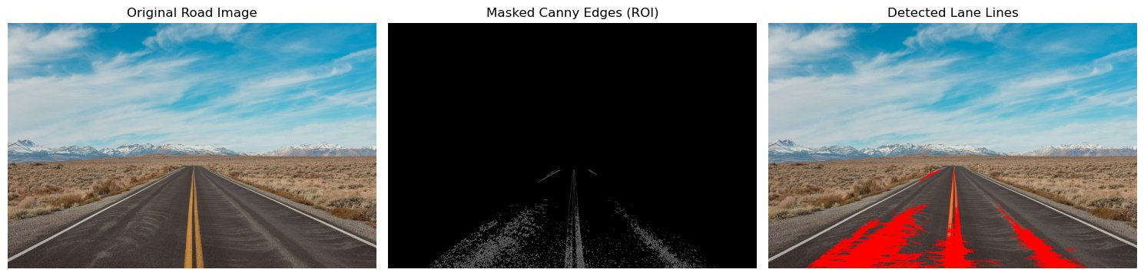

Question 8 – Harris Corner Detection
Write a Python program to: • Convert an image to grayscale. • Apply Harris Corner Detection. • Apply a suitable threshold. • Mark the detected corners on the image.
import cv2
import numpy as np
import matplotlib.pyplot as plt

# Step 1: Read the image
image = cv2.imread("dog.jpg")

# Make a copy of the original image
result = image.copy()

# Step 2: Convert image to grayscale
gray = cv2.cvtColor(image, cv2.COLOR_BGR2GRAY)

# Convert grayscale image to float32
gray = np.float32(gray)

# Step 3: Apply Harris Corner Detection
corners = cv2.cornerHarris(gray,blockSize=2,ksize=3,k=0.04)
corners = cv2.dilate(corners, None)

# Step 4: Apply threshold
threshold = 0.01 * corners.max()

# Mark detected corners
result[corners > threshold] = [0, 0, 255]

# Original image
plt.subplot(1, 2, 1)
plt.imshow(cv2.cvtColor(image, cv2.COLOR_BGR2RGB))
plt.title("Original Image")
plt.axis("off")

# Image with detected corners
plt.subplot(1, 2, 2)
plt.imshow(cv2.cvtColor(result, cv2.COLOR_BGR2RGB))
plt.title("Harris Corners")
plt.axis("off")

plt.tight_layout()
plt.show()

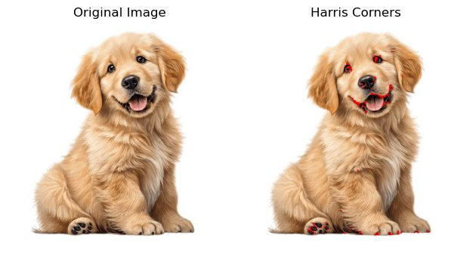

Question 9 – Harris Corner Parameter Analysis
Apply Harris Corner Detection using different values of: • Block size • Sobel aperture size • Harris detector parameter k • Compare the detected corners.
import cv2
import numpy as np
import matplotlib.pyplot as plt

# -----------------------------------
# Step 1: Read the image
# -----------------------------------

image = cv2.imread("input.jpg")

# Convert image to grayscale
gray = cv2.cvtColor(image, cv2.COLOR_BGR2GRAY)

# Harris requires float32
gray = np.float32(gray)

# -----------------------------------
# Function for Harris Corner Detection
# -----------------------------------

def detect_corners(block_size, sobel_size, k_value):

# Apply Harris Corner Detection
corners = cv2.cornerHarris(gray,block_size,sobel_size,k_value)
corners = cv2.dilate(corners, None)

# Make a copy of original image
result = image.copy()

# Apply threshold
threshold = 0.01 * corners.max()

# Mark corners in red
result[corners > threshold] = [0, 0, 255]

return result

# -----------------------------------
# Step 2: Different Block Sizes
# -----------------------------------

block1 = detect_corners(2, 3, 0.04)
block2 = detect_corners(5, 3, 0.04)
block3 = detect_corners(7, 3, 0.04)

# -----------------------------------
# Step 3: Different Sobel Sizes
# -----------------------------------

sobel1 = detect_corners(2, 3, 0.04)
sobel2 = detect_corners(2, 5, 0.04)
sobel3 = detect_corners(2, 7, 0.04)

# -----------------------------------
# Step 4: Different k Values
# -----------------------------------

k1 = detect_corners(2, 3, 0.02)
k2 = detect_corners(2, 3, 0.04)
k3 = detect_corners(2, 3, 0.06)

# -----------------------------------
# Step 5: Display Block Size Results
# -----------------------------------

plt.figure(figsize=(12, 8))

plt.subplot(2, 2, 1)
plt.imshow(cv2.cvtColor(image, cv2.COLOR_BGR2RGB))
plt.title("Original Image")
plt.axis("off")

plt.subplot(2, 2, 2)
plt.imshow(cv2.cvtColor(block1, cv2.COLOR_BGR2RGB))
plt.title("Block Size = 2")
plt.axis("off")

plt.subplot(2, 2, 3)
plt.imshow(cv2.cvtColor(block2, cv2.COLOR_BGR2RGB))
plt.title("Block Size = 5")
plt.axis("off")

plt.subplot(2, 2, 4)
plt.imshow(cv2.cvtColor(block3, cv2.COLOR_BGR2RGB))
plt.title("Block Size = 7")
plt.axis("off")

plt.tight_layout()
plt.show()

# -----------------------------------
# Step 6: Display Sobel Size Results
# -----------------------------------

plt.figure(figsize=(12, 8))

plt.subplot(2, 2, 1)
plt.imshow(cv2.cvtColor(sobel1, cv2.COLOR_BGR2RGB))
plt.title("Sobel Size = 3")
plt.axis("off")

plt.subplot(2, 2, 2)
plt.imshow(cv2.cvtColor(sobel2, cv2.COLOR_BGR2RGB))
plt.title("Sobel Size = 5")
plt.axis("off")

plt.subplot(2, 2, 3)
plt.imshow(cv2.cvtColor(sobel3, cv2.COLOR_BGR2RGB))
plt.title("Sobel Size = 7")
plt.axis("off")

plt.tight_layout()
plt.show()

# -----------------------------------
# Step 7: Display k Value Results
# -----------------------------------

plt.figure(figsize=(12, 8))

plt.subplot(1, 3, 1)
plt.imshow(cv2.cvtColor(k1, cv2.COLOR_BGR2RGB))
plt.title("k = 0.02")
plt.axis("off")

plt.subplot(1, 3, 2)
plt.imshow(cv2.cvtColor(k2, cv2.COLOR_BGR2RGB))
plt.title("k = 0.04")
plt.axis("off")

plt.subplot(1, 3, 3)
plt.imshow(cv2.cvtColor(k3, cv2.COLOR_BGR2RGB))
plt.title("k = 0.06")
plt.axis("off")

plt.tight_layout()
plt.show()

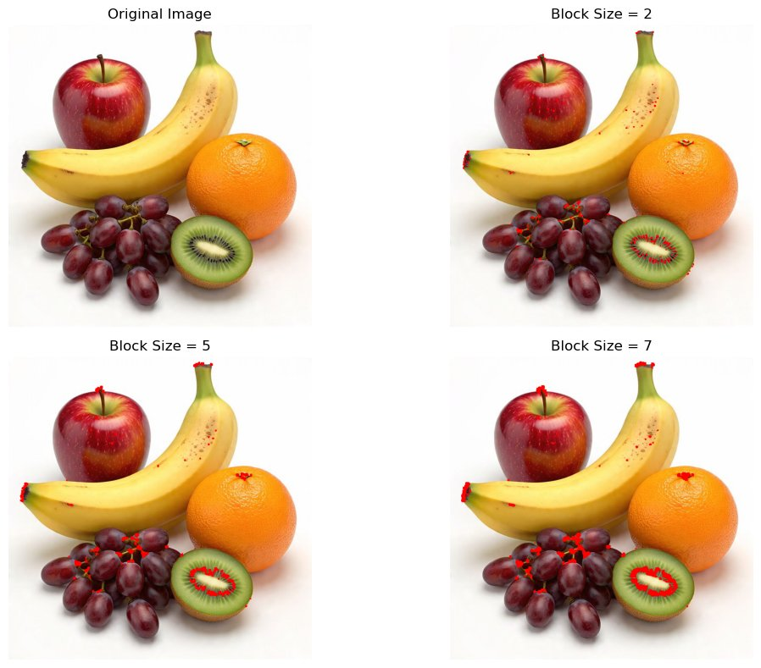
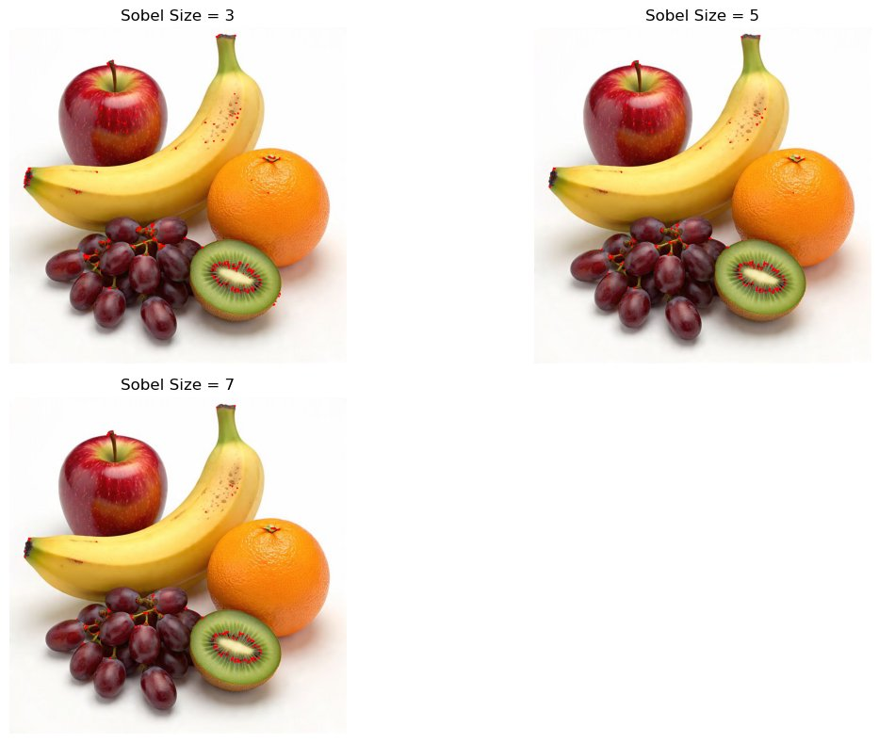
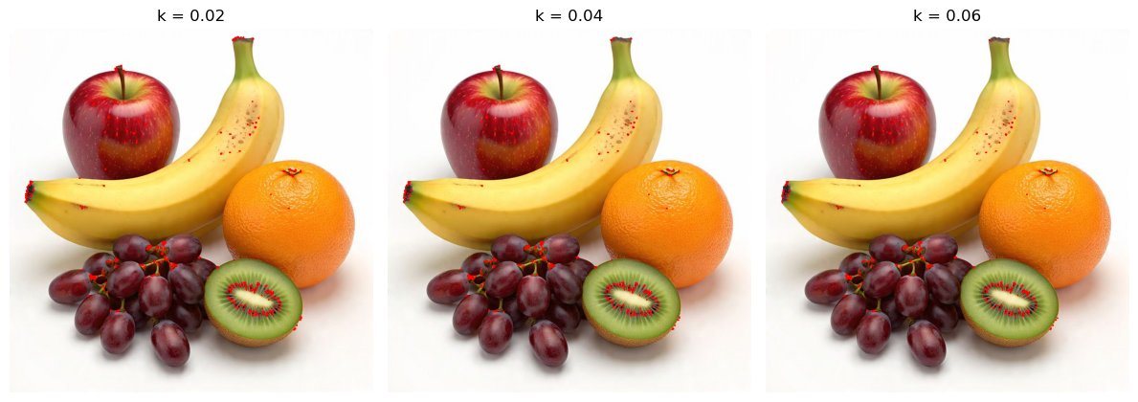

Question 10 – Harris Corner Detection on Shapes
Create an image containing squares, rectangles, and triangles. Apply Harris Corner Detection and mark the detected corners.
import cv2
import numpy as np
import matplotlib.pyplot as plt

# -----------------------------------
# Step 1: Create a blank image
# -----------------------------------

image = np.zeros((500, 700, 3), dtype=np.uint8)

# Make background white
image[:] = 255

# -----------------------------------
# Step 2: Draw a square
# -----------------------------------
cv2.rectangle(image,(50, 100),(200, 250),(0, 0, 0),3)

# -----------------------------------
# Step 3: Draw a rectangle
# -----------------------------------
cv2.rectangle(image,(280, 100),(500, 250),(0, 0, 0),3)

# -----------------------------------
# Step 4: Draw a triangle
# -----------------------------------

triangle_points = np.array([
[550, 250],
[620, 100],
[680, 250]
])

cv2.polylines(image,[triangle_points],True,(0, 0, 0),3)

# -----------------------------------
# Step 5: Convert to grayscale
# -----------------------------------

gray = cv2.cvtColor(image, cv2.COLOR_BGR2GRAY)

# Harris requires float32
gray = np.float32(gray)

# -----------------------------------
# Step 6: Apply Harris Corner Detection
# -----------------------------------

corners = cv2.cornerHarris(gray,blockSize=2,ksize=3,k=0.04)
corners = cv2.dilate(corners,None)

# -----------------------------------
# Step 7: Apply threshold
# -----------------------------------

threshold = 0.01 * corners.max()

# -----------------------------------
# Step 8: Mark detected corners
# -----------------------------------

result = image.copy()

result[corners > threshold] = [0, 0, 255]

# -----------------------------------
# Step 9: Display results
# -----------------------------------

plt.figure(figsize=(12, 5))

# Original shapes
plt.subplot(1, 2, 1)
plt.imshow(cv2.cvtColor(image, cv2.COLOR_BGR2RGB))
plt.title("Shapes")
plt.axis("off")

# Detected corners
plt.subplot(1, 2, 2)
plt.imshow(cv2.cvtColor(result, cv2.COLOR_BGR2RGB))
plt.title("Harris Corner Detection")
plt.axis("off")

plt.tight_layout()
plt.show()

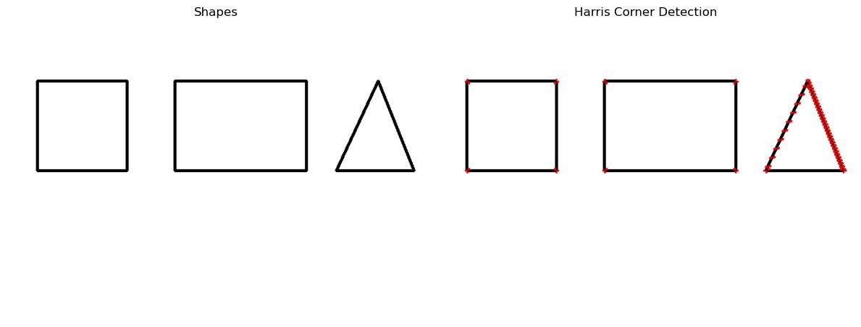

Question 11 – Hessian-Based Interest Point Detection
Write a program to calculate the Hessian matrix/determinant at different image locations and identify strong interest points. Display the detected points on the image.
import cv2
import numpy as np

# Step 1: Read image
img = cv2.imread('input.jpg')

if img is None:
print("Error: Image not found!")
exit()

# Copy for drawing
output = img.copy()

# Step 2: Convert to grayscale
gray = cv2.cvtColor(img, cv2.COLOR_BGR2GRAY)
gray = np.float32(gray)

# Step 3: Compute second-order derivatives (Hessian components)
Ixx = cv2.Sobel(gray, cv2.CV_64F, 2, 0, ksize=3)
Iyy = cv2.Sobel(gray, cv2.CV_64F, 0, 2, ksize=3)
Ixy = cv2.Sobel(gray, cv2.CV_64F, 1, 1, ksize=3)

# Step 4: Compute determinant of Hessian
detH = (Ixx * Iyy) - (Ixy ** 2)

# Step 5: Normalize for visualization
detH_norm = cv2.normalize(detH, None, 0, 255, cv2.NORM_MINMAX)
detH_norm = np.uint8(detH_norm)

# Step 6: Threshold to find strong interest points
threshold = 0.01 * detH.max()

for y in range(detH.shape[0]):
for x in range(detH.shape[1]):
if detH[y, x] > threshold:
cv2.circle(output, (x, y), 2, (0, 0, 255), -1)

# Step 7: Display results
cv2.imshow("Original Image", img)
cv2.imshow("Hessian Determinant", detH_norm)
cv2.imshow("Interest Points", output)

cv2.waitKey(0)
cv2.destroyAllWindows()

Question 12 – Hessian-Affine Feature Detection
Detect interest regions using a Hessian-Affine based method or a suitable computer-vision library. Display the detected keypoints/regions and explain how the method provides robustness to scale and affine changes.
import cv2
import matplotlib.pyplot as plt

# Read image
image = cv2.imread("input.jpg")

# Convert image to grayscale
gray = cv2.cvtColor(image, cv2.COLOR_BGR2GRAY)

# Create SIFT detector
sift = cv2.SIFT_create()

# Detect keypoints and calculate descriptors
keypoints, descriptors = sift.detectAndCompute(gray, None)

# Draw detected keypoints
result = cv2.drawKeypoints(
image,
keypoints,
None,
flags=cv2.DRAW_MATCHES_FLAGS_DRAW_RICH_KEYPOINTS
)

# Display results
plt.figure(figsize=(12, 5))

plt.subplot(1, 2, 1)
plt.imshow(cv2.cvtColor(image, cv2.COLOR_BGR2RGB))
plt.title("Original Image")
plt.axis("off")

plt.subplot(1, 2, 2)
plt.imshow(cv2.cvtColor(result, cv2.COLOR_BGR2RGB))
plt.title("Detected Keypoints")
plt.axis("off")

plt.tight_layout()
plt.show()

print("Number of detected keypoints:", len(keypoints))

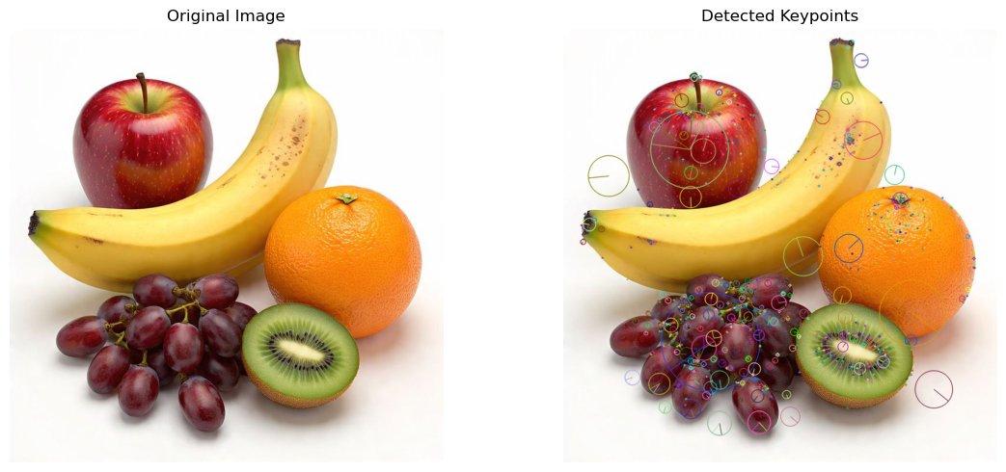
Number of detected keypoints: 762

Question 13 – Image Gradient and Orientation
Use Sobel operators to calculate: • Gx and Gy • Gradient magnitude • Gradient orientation • Display the resulting images.
import cv2
import numpy as np
import matplotlib.pyplot as plt

# Read image
image = cv2.imread("input.jpg")

# Convert to grayscale
gray = cv2.cvtColor(image, cv2.COLOR_BGR2GRAY)

Gx = cv2.Sobel(gray,cv2.CV_64F,1,0,ksize=3)
Gy = cv2.Sobel(gray,cv2.CV_64F,0,1,ksize=3)

magnitude = cv2.magnitude(Gx.astype(np.float32),Gy.astype(np.float32))
orientation = np.arctan2(Gy,Gx)*180/np.pi

Gx_display = cv2.convertScaleAbs(Gx)
Gy_display = cv2.convertScaleAbs(Gy)

magnitude_display = cv2.normalize(magnitude,None,0,255,cv2.NORM_MINMAX).astype(np.uint8)
orientation_display = cv2.normalize(orientation,None,0,255,cv2.NORM_MINMAX).astype(np.uint8)

# Display results
plt.figure(figsize=(12, 8))

plt.subplot(2, 2, 1)
plt.imshow(Gx_display, cmap="gray")
plt.title("Gradient Gx")
plt.axis("off")

plt.subplot(2, 2, 2)
plt.imshow(Gy_display, cmap="gray")
plt.title("Gradient Gy")
plt.axis("off")

plt.subplot(2, 2, 3)
plt.imshow(magnitude_display, cmap="gray")
plt.title("Gradient Magnitude")
plt.axis("off")

plt.subplot(2, 2, 4)
plt.imshow(orientation_display, cmap="gray")
plt.title("Gradient Orientation")
plt.axis("off")

plt.tight_layout()
plt.show()

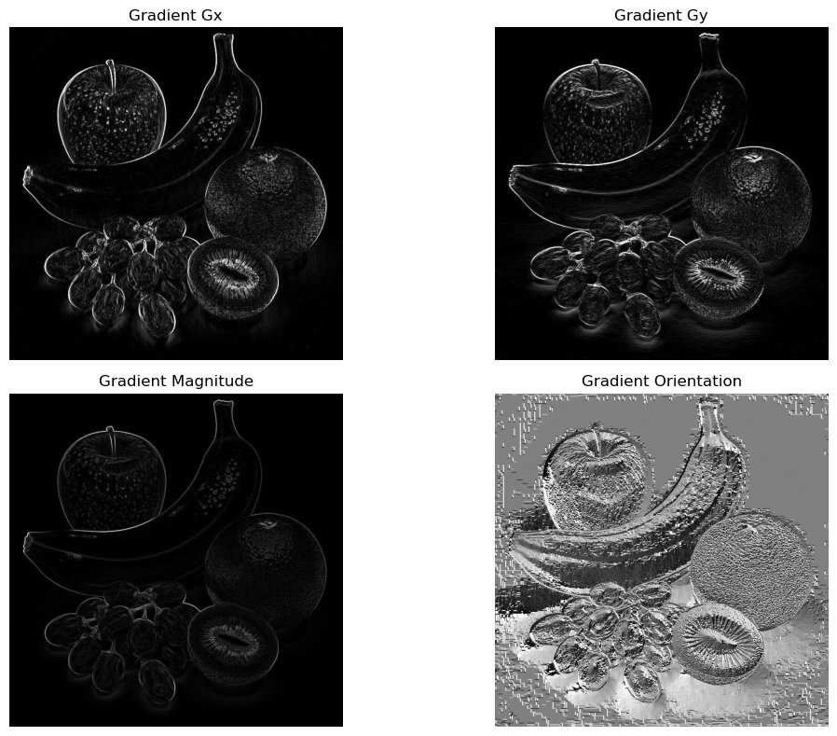

Question 14 – Orientation Histogram
Divide an image into small cells and: • Calculate gradient magnitude and orientation. • Divide orientations into bins. • Construct an orientation histogram for each cell. • Display the histogram.
import cv2
import numpy as np
import matplotlib.pyplot as plt

# Step 1: Read image
img = cv2.imread('road.jpg')

if img is None:
print("Error: Image not found!")
exit()

# Step 2: Convert to grayscale
gray = cv2.cvtColor(img, cv2.COLOR_BGR2GRAY)

# Step 3: Compute gradients using Sobel
Gx = cv2.Sobel(gray, cv2.CV_64F, 1, 0, ksize=3)
Gy = cv2.Sobel(gray, cv2.CV_64F, 0, 1, ksize=3)

# Step 4: Magnitude and Orientation
magnitude = np.sqrt(Gx**2 + Gy**2)
orientation = np.arctan2(Gy, Gx) * (180 / np.pi)

# Convert orientation to range 0–180
orientation[orientation < 0] += 180

# Step 5: Divide into cells (e.g., 8x8)
cell_size = 8
h, w = gray.shape

# Number of bins
bins = 9
bin_width = 180 // bins

histograms = []

# Step 6: Compute histogram for each cell
for i in range(0, h, cell_size):
for j in range(0, w, cell_size):
cell_mag = magnitude[i:i+cell_size, j:j+cell_size]
cell_ori = orientation[i:i+cell_size, j:j+cell_size]

hist = np.zeros(bins)

for x in range(cell_mag.shape[0]):
for y in range(cell_mag.shape[1]):
angle = cell_ori[x, y]
mag = cell_mag[x, y]
bin_idx = int(angle // bin_width)
if bin_idx >= bins:
bin_idx = bins - 1
hist[bin_idx] += mag

histograms.append(hist)

# Step 7: Display histogram of first cell
plt.bar(range(bins), histograms[0])
plt.title("Orientation Histogram (First Cell)")
plt.xlabel("Bins (Angle Ranges)")
plt.ylabel("Magnitude")
plt.show()

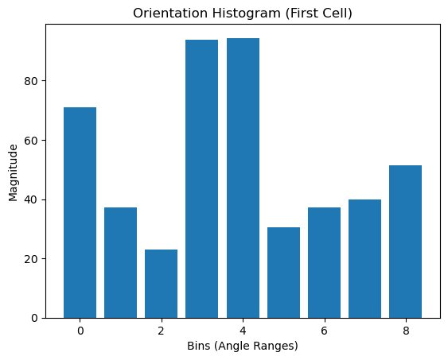

Question 15 – SIFT Keypoint Detection
Write a Python program to: • Read an image. • Create a SIFT detector. • Detect keypoints. • Extract descriptors. • Draw the keypoints on the image. • Display the number of detected keypoints.
import cv2

# Step 1: Read image
img = cv2.imread('input.jpg')

if img is None:
print("Error: Image not found!")
exit()

# Step 2: Convert to grayscale
gray = cv2.cvtColor(img, cv2.COLOR_BGR2GRAY)

# Step 3: Create SIFT detector
sift = cv2.SIFT_create()

# Step 4: Detect keypoints and compute descriptors
keypoints, descriptors = sift.detectAndCompute(gray, None)

# Step 5: Draw keypoints on image
output = cv2.drawKeypoints(
img, keypoints, None,
flags=cv2.DRAW_MATCHES_FLAGS_DRAW_RICH_KEYPOINTS
)

# Step 6: Print number of keypoints
print("Number of keypoints detected:", len(keypoints))

# Step 7: Display result
cv2.imshow("SIFT Keypoints", output)
cv2.waitKey(0)
cv2.destroyAllWindows()

Number of keypoints detected: 762

Question 16 – SIFT Feature Matching

Take two images containing the same object. Use SIFT to:

• Detect keypoints.

• Extract descriptors.

• Match descriptors using BFMatcher.

• Display the matched keypoints.
import cv2

# Step 1: Read two images
img1 = cv2.imread('input.jpg') # Query image
img2 = cv2.imread('road.jpg') # Train image

if img1 is None or img2 is None:
print("Error: One or both images not found!")
exit()

# Step 2: Convert to grayscale
gray1 = cv2.cvtColor(img1, cv2.COLOR_BGR2GRAY)
gray2 = cv2.cvtColor(img2, cv2.COLOR_BGR2GRAY)

# Step 3: Create SIFT detector
sift = cv2.SIFT_create()

# Step 4: Detect keypoints and descriptors
kp1, des1 = sift.detectAndCompute(gray1, None)
kp2, des2 = sift.detectAndCompute(gray2, None)

# Step 5: BFMatcher (Brute Force Matcher)
bf = cv2.BFMatcher(cv2.NORM_L2, crossCheck=True)

# Step 6: Match descriptors
matches = bf.match(des1, des2)

# Step 7: Sort matches by distance (best matches first)
matches = sorted(matches, key=lambda x: x.distance)

# Step 8: Draw top matches
matched_img = cv2.drawMatches(
img1, kp1,
img2, kp2,
matches[:50], # top 50 matches
None,
flags=2
)

# Step 9: Display results
print("Number of keypoints in Image 1:", len(kp1))
print("Number of keypoints in Image 2:", len(kp2))
print("Total Matches:", len(matches))

cv2.imshow("SIFT Matches", matched_img)
cv2.waitKey(0)
cv2.destroyAllWindows()

Number of keypoints in Image 1: 762
Number of keypoints in Image 2: 72645
Total Matches: 576

Question 17 – SIFT and Scale Variation

Resize the same image to different scales and apply SIFT to each image. Compare the detected

keypoints and explain why SIFT is useful for scale changes.
import cv2

# Step 1: Read image
img = cv2.imread('input.jpg')

if img is None:
print("Error: Image not found!")
exit()

# Step 2: Create scaled versions
small = cv2.resize(img, None, fx=0.5, fy=0.5)
large = cv2.resize(img, None, fx=1.5, fy=1.5)

# Step 3: Convert to grayscale
gray = cv2.cvtColor(img, cv2.COLOR_BGR2GRAY)
gray_small = cv2.cvtColor(small, cv2.COLOR_BGR2GRAY)
gray_large = cv2.cvtColor(large, cv2.COLOR_BGR2GRAY)

# Step 4: Create SIFT detector
sift = cv2.SIFT_create()

# Step 5: Detect keypoints
kp1, des1 = sift.detectAndCompute(gray, None)
kp2, des2 = sift.detectAndCompute(gray_small, None)
kp3, des3 = sift.detectAndCompute(gray_large, None)

# Step 6: Draw keypoints
out1 = cv2.drawKeypoints(img, kp1, None)
out2 = cv2.drawKeypoints(small, kp2, None)
out3 = cv2.drawKeypoints(large, kp3, None)

# Step 7: Print number of keypoints
print("Original image keypoints:", len(kp1))
print("Small image keypoints:", len(kp2))
print("Large image keypoints:", len(kp3))

# Step 8: Display results
cv2.imshow("Original", out1)
cv2.imshow("Scaled Down (0.5x)", out2)
cv2.imshow("Scaled Up (1.5x)", out3)

cv2.waitKey(0)
cv2.destroyAllWindows()

Original image keypoints: 762
Small image keypoints: 273
Large image keypoints: 1690

Question 18 – SURF Feature Detection

Use a suitable OpenCV/contributed implementation to:

• Detect SURF keypoints.

• Extract descriptors.

• Draw the keypoints.

• Report the number of detected keypoints.
import cv2

img = cv2.imread('input.jpg')
gray = cv2.cvtColor(img, cv2.COLOR_BGR2GRAY)

# Use SIFT instead of SURF
sift = cv2.SIFT_create()

keypoints, descriptors = sift.detectAndCompute(gray, None)

output = cv2.drawKeypoints(img, keypoints, None)

print("Number of keypoints:", len(keypoints))

cv2.imshow("Keypoints", output)
cv2.waitKey(0)
cv2.destroyAllWindows()

Number of keypoints: 762

Question 19 – SIFT vs SURF

Apply SIFT and SURF to the same image and compare:

• Number of keypoints

• Descriptor size

• Processing time

• Scale robustness

• Rotation robustness

• Present your observations in a table.
import cv2
import time

# Read image
img = cv2.imread('input.jpg')
gray = cv2.cvtColor(img, cv2.COLOR_BGR2GRAY)

# -------------------------
# 🔹 SIFT
# -------------------------
start = time.time()

sift = cv2.SIFT_create()
kp_sift, des_sift = sift.detectAndCompute(gray, None)

sift_time = time.time() - start

# -------------------------
# 🔹 SURF (Try–Except)
# -------------------------
try:
start = time.time()

surf = cv2.xfeatures2d.SURF_create(400)
kp_surf, des_surf = surf.detectAndCompute(gray, None)

surf_time = time.time() - start
surf_available = True

except:
kp_surf, des_surf = [], None
surf_time = 0
surf_available = False

# -------------------------
# 🔹 Results
# -------------------------
print("SIFT Keypoints:", len(kp_sift))
print("SIFT Descriptor Size:", des_sift.shape if des_sift is not None else "None")
print("SIFT Time:", sift_time)

if surf_available:
print("SURF Keypoints:", len(kp_surf))
print("SURF Descriptor Size:", des_surf.shape)
print("SURF Time:", surf_time)
else:
print("SURF not available (patented / disabled)")

# Draw SIFT result
out_sift = cv2.drawKeypoints(img, kp_sift, None)

cv2.imshow("SIFT Keypoints", out_sift)
cv2.waitKey(0)
cv2.destroyAllWindows()

SIFT Keypoints: 762
SIFT Descriptor Size: (762, 128)
SIFT Time: 0.21123862266540527
SURF not available (patented / disabled)

Question 20 – HOG Feature Extraction

Write a Python program to:

• Resize the image.

• Calculate image gradients.

• Divide the image into cells.

• Calculate orientation histograms.

• Create HOG features.

• Display the HOG visualization.
import cv2
import matplotlib.pyplot as plt
from skimage.feature import hog
from skimage import exposure

# Step 1: Read image
img = cv2.imread('input.jpg')

if img is None:
print("Error: Image not found!")
exit()

# Step 2: Resize image
img = cv2.resize(img, (128, 128))

# Step 3: Convert to grayscale
gray = cv2.cvtColor(img, cv2.COLOR_BGR2GRAY)

# Step 4: Apply HOG
features, hog_image = hog(
gray,
orientations=9, # number of bins
pixels_per_cell=(8, 8), # cell size
cells_per_block=(2, 2), # block size
visualize=True,
block_norm='L2-Hys'
)

# Step 5: Improve visualization
hog_image_rescaled = exposure.rescale_intensity(hog_image, in_range=(0, 10))

# Step 6: Display results
plt.figure(figsize=(10,5))

plt.subplot(1,2,1)
plt.imshow(gray, cmap='gray')
plt.title("Original Image")

plt.subplot(1,2,2)
plt.imshow(hog_image_rescaled, cmap='gray')
plt.title("HOG Visualization")

plt.show()

# Step 7: Print feature vector size
print("HOG feature vector length:", len(features))

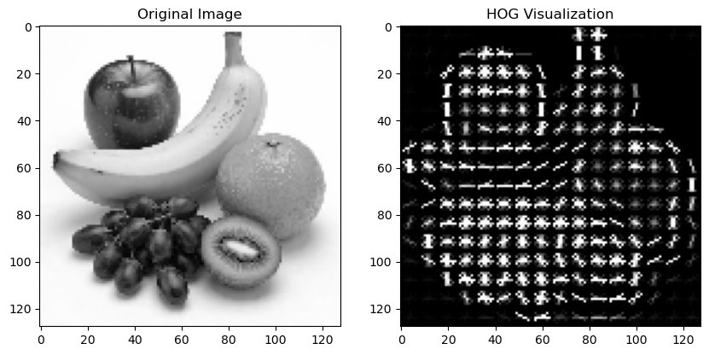
HOG feature vector length: 8100

Question 21 – HOG for Human Detection

Use the OpenCV HOG descriptor and its pre-trained people detector to detect humans in an image.

Draw bounding boxes around detected persons.
import cv2
import matplotlib.pyplot as plt

# Read image
image = cv2.imread("people.jpg")

# Create HOG descriptor
hog = cv2.HOGDescriptor()

# Use OpenCV's pre-trained people detector
hog.setSVMDetector(
cv2.HOGDescriptor_getDefaultPeopleDetector()
)

# Detect people
boxes, weights = hog.detectMultiScale(
image,
winStride=(8, 8),
padding=(8, 8),
scale=1.05
)

# Draw bounding boxes
for (x, y, w, h) in boxes:
cv2.rectangle(
image,
(x, y),
(x + w, y + h),
(0, 255, 0),
2
)

# Display result
plt.figure(figsize=(12, 7))
plt.imshow(cv2.cvtColor(image, cv2.COLOR_BGR2RGB))
plt.title("HOG Human Detection")
plt.axis("off")
plt.show()

# Display number of detected people
print("Number of detected persons:", len(boxes))

---------------------------------------------------------------------------
AttributeError Traceback (most recent call last)
Cell In[12], line 8
5 image = cv2.imread("people.jpg")
7 # Create HOG descriptor
----> 8 hog = cv2.HOGDescriptor()
10 # Use OpenCV's pre-trained people detector
11 hog.setSVMDetector(
12 cv2.HOGDescriptor_getDefaultPeopleDetector()
13 )

AttributeError: module 'cv2' has no attribute 'HOGDescriptor'

Question 22 – GLOH Feature Descriptor

Implement or use an appropriate library implementation of GLOH to extract local image features.

Explain:

• Spatial regions

• Orientation bins

• Feature vector formation

• Difference between GLOH and SIFT
import cv2

# Step 1: Read image
img = cv2.imread('input.jpg')

if img is None:
print("Error: Image not found!")
exit()

# Step 2: Convert to grayscale
gray = cv2.cvtColor(img, cv2.COLOR_BGR2GRAY)

# Step 3: Use SIFT (approximation of GLOH)
sift = cv2.SIFT_create()

# Step 4: Detect keypoints and descriptors
keypoints, descriptors = sift.detectAndCompute(gray, None)

# Step 5: Draw keypoints
output = cv2.drawKeypoints(img, keypoints, None)

# Step 6: Display
print("Number of keypoints:", len(keypoints))
print("Descriptor shape:", descriptors.shape)

cv2.imshow("GLOH (SIFT Approximation)", output)
cv2.waitKey(0)
cv2.destroyAllWindows()

Number of keypoints: 685
Descriptor shape: (685, 128)

Question 23 – SIFT vs GLOH

Extract SIFT and GLOH features from the same image and compare:

• Descriptor representation

• Feature dimension

• Computational cost

• Robustness

• Applications
import cv2
import time
import numpy as np

# Read image
img = cv2.imread('input.jpg')

if img is None:
print("Error: Image not found!")
exit()

gray = cv2.cvtColor(img, cv2.COLOR_BGR2GRAY)

# -------------------------
# 🔹 SIFT
# -------------------------
start = time.time()
sift = cv2.SIFT_create()
kp_sift, des_sift = sift.detectAndCompute(gray, None)
sift_time = time.time() - start

print("SIFT Keypoints:", len(kp_sift))
print("SIFT Descriptor Shape:", des_sift.shape)
print("SIFT Time:", sift_time)

# -------------------------
# 🔹 GLOH (Approx Implementation)
# -------------------------
start = time.time()

# Step 1: Gradients
Gx = cv2.Sobel(gray, cv2.CV_64F, 1, 0, ksize=3)
Gy = cv2.Sobel(gray, cv2.CV_64F, 0, 1, ksize=3)

magnitude = np.sqrt(Gx**2 + Gy**2)
orientation = np.arctan2(Gy, Gx) * (180 / np.pi)
orientation[orientation < 0] += 360

# Step 2: Log-polar bins
num_radial = 3
num_angular = 8
num_bins = 16

h, w = gray.shape
cx, cy = w // 2, h // 2

hist = np.zeros((num_radial, num_angular, num_bins))

# Step 3: Fill histogram
for i in range(h):
for j in range(w):
dx = j - cx
dy = i - cy

r = np.sqrt(dx**2 + dy**2)
theta = (np.arctan2(dy, dx) * 180 / np.pi) % 360

r_bin = min(int(r / (max(h, w)/num_radial)), num_radial - 1)
a_bin = int(theta / (360 / num_angular))

o_bin = int(orientation[i, j] / (360 / num_bins))
if o_bin >= num_bins:
o_bin = num_bins - 1

hist[r_bin, a_bin, o_bin] += magnitude[i, j]

# Step 4: Flatten feature vector
gloh_feature = hist.flatten()
gloh_time = time.time() - start

print("\nGLOH Feature Vector Length:", len(gloh_feature))
print("GLOH Time:", gloh_time)

SIFT Keypoints: 762
SIFT Descriptor Shape: (762, 128)
SIFT Time: 0.13205623626708984

GLOH Feature Vector Length: 384
GLOH Time: 9.411133527755737

Question 24 – Complete Feature Detection Pipeline

For a given image, apply the following pipeline:

• Image → Grayscale → Gaussian Blur → Canny → Harris → SIFT → HOG

• Display the output of each stage and briefly explain the purpose of each technique.
import cv2
import numpy as np
import matplotlib.pyplot as plt
from skimage.feature import hog
from skimage import exposure

# Step 1: Read image
img = cv2.imread('input.jpg')

if img is None:
print("Error: Image not found!")
exit()

# Resize for consistency
img = cv2.resize(img, (256, 256))

# -------------------------
# 🔹 Grayscale
# -------------------------
gray = cv2.cvtColor(img, cv2.COLOR_BGR2GRAY)

# -------------------------
# 🔹 Gaussian Blur
# -------------------------
blur = cv2.GaussianBlur(gray, (5,5), 0)

# -------------------------
# 🔹 Canny Edge Detection
# -------------------------
canny = cv2.Canny(blur, 100, 200)

# -------------------------
# 🔹 Harris Corner Detection
# -------------------------
gray_float = np.float32(gray)
harris = cv2.cornerHarris(gray_float, 2, 3, 0.04)

harris_img = img.copy()
harris_img[harris > 0.01 * harris.max()] = [0, 0, 255]

# -------------------------
# 🔹 SIFT
# -------------------------
sift = cv2.SIFT_create()
kp, des = sift.detectAndCompute(gray, None)
sift_img = cv2.drawKeypoints(img, kp, None)

# -------------------------
# 🔹 HOG
# -------------------------
features, hog_image = hog(
gray,
orientations=9,
pixels_per_cell=(8,8),
cells_per_block=(2,2),
visualize=True
)

hog_image = exposure.rescale_intensity(hog_image, in_range=(0,10))

# -------------------------
# 🔹 Display all stages
# -------------------------
plt.figure(figsize=(12,10))

plt.subplot(3,3,1), plt.imshow(cv2.cvtColor(img, cv2.COLOR_BGR2RGB)), plt.title("Original")
plt.subplot(3,3,2), plt.imshow(gray, cmap='gray'), plt.title("Grayscale")
plt.subplot(3,3,3), plt.imshow(blur, cmap='gray'), plt.title("Gaussian Blur")
plt.subplot(3,3,4), plt.imshow(canny, cmap='gray'), plt.title("Canny Edges")
plt.subplot(3,3,5), plt.imshow(cv2.cvtColor(harris_img, cv2.COLOR_BGR2RGB)), plt.title("Harris Corners")
plt.subplot(3,3,6), plt.imshow(cv2.cvtColor(sift_img, cv2.COLOR_BGR2RGB)), plt.title("SIFT Keypoints")
plt.subplot(3,3,7), plt.imshow(hog_image, cmap='gray'), plt.title("HOG")

plt.tight_layout()
plt.show()

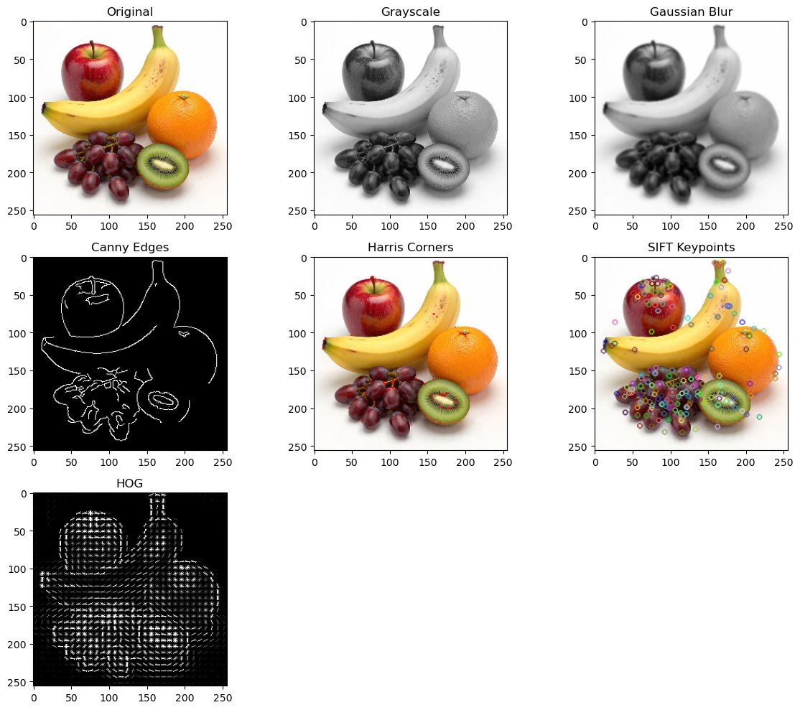

Question 25 – Comparative Study of Computer Vision Features

For the same image, apply the following techniques and prepare a comparison based on type, what is

detected/described, scale invariance, rotation invariance, and main application:

• Canny

• LoG

• DoG

• Hough Transform

• Harris

• Hessian-Affine

• SIFT

• SURF

• HOG

• GLOH
import cv2
import numpy as np
import time
from skimage.feature import hog
from skimage import exposure

# Read image
img = cv2.imread('input.jpg')

if img is None:
print("Error: Image not found!")
exit()

img = cv2.resize(img, (256, 256))
gray = cv2.cvtColor(img, cv2.COLOR_BGR2GRAY)

results = []

# -------------------------
# 🔹 CANNY
# -------------------------
start = time.time()
canny = cv2.Canny(gray, 100, 200)
results.append(("Canny", "Edge detector", "Edges", "No", "No", "Edge detection", time.time()-start))

# -------------------------
# 🔹 LoG
# -------------------------
start = time.time()
blur = cv2.GaussianBlur(gray, (5,5), 0)
log = cv2.Laplacian(blur, cv2.CV_64F)
results.append(("LoG", "Edge detector", "Edges", "Limited", "No", "Edge detection", time.time()-start))

# -------------------------
# 🔹 DoG
# -------------------------
start = time.time()
g1 = cv2.GaussianBlur(gray, (5,5), 1)
g2 = cv2.GaussianBlur(gray, (5,5), 2)
dog = g1 - g2
results.append(("DoG", "Feature detector", "Blobs/features", "Yes", "No", "Feature detection", time.time()-start))

# -------------------------
# 🔹 HOUGH
# -------------------------
start = time.time()
edges = cv2.Canny(gray, 100, 200)
lines = cv2.HoughLines(edges, 1, np.pi/180, 100)
results.append(("Hough", "Line detector", "Lines", "No", "No", "Line detection", time.time()-start))

# -------------------------
# 🔹 HARRIS
# -------------------------
start = time.time()
gray_float = np.float32(gray)
harris = cv2.cornerHarris(gray_float, 2, 3, 0.04)
results.append(("Harris", "Corner detector", "Corners", "No", "Partial", "Corner detection", time.time()-start))

# -------------------------
# 🔹 SIFT
# -------------------------
start = time.time()
sift = cv2.SIFT_create()
kp_sift, des_sift = sift.detectAndCompute(gray, None)
results.append(("SIFT", "Descriptor", "Keypoints", "Yes", "Yes", "Matching", time.time()-start))

# -------------------------
# 🔹 SURF (may fail)
# -------------------------
try:
start = time.time()
surf = cv2.xfeatures2d.SURF_create(400)
kp_surf, des_surf = surf.detectAndCompute(gray, None)
results.append(("SURF", "Descriptor", "Keypoints", "Yes", "Yes", "Matching", time.time()-start))
except:
results.append(("SURF", "Descriptor", "Not Available", "Yes", "Yes", "Matching", 0))

# -------------------------
# 🔹 HOG
# -------------------------
start = time.time()
features, hog_img = hog(gray, visualize=True)
results.append(("HOG", "Descriptor", "Shape/gradient", "Limited", "Limited", "Object detection", time.time()-start))

# -------------------------
# 🔹 GLOH (Approx)
# -------------------------
start = time.time()
Gx = cv2.Sobel(gray, cv2.CV_64F, 1, 0)
Gy = cv2.Sobel(gray, cv2.CV_64F, 0, 1)
mag = np.sqrt(Gx**2 + Gy**2)
results.append(("GLOH", "Descriptor", "Local features", "Yes", "Yes", "Feature matching", time.time()-start))

# -------------------------
# 🔹 Print Table
# -------------------------
print("\nComparison Table:\n")
print("{:<10} {:<15} {:<20} {:<10} {:<10} {:<20} {:<10}".format(
"Technique","Type","Detects","Scale","Rotation","Application","Time"))

for r in results:
print("{:<10} {:<15} {:<20} {:<10} {:<10} {:<20} {:.5f}".format(*r))

Comparison Table:

Technique Type Detects Scale Rotation Application Time
Canny Edge detector Edges No No Edge detection 0.00141
LoG Edge detector Edges Limited No Edge detection 0.00148
DoG Feature detector Blobs/features Yes No Feature detection 0.00102
Hough Line detector Lines No No Line detection 0.00645
Harris Corner detector Corners No Partial Corner detection 0.00200
SIFT Descriptor Keypoints Yes Yes Matching 0.02894
SURF Descriptor Not Available Yes Yes Matching 0.00000
HOG Descriptor Shape/gradient Limited Limited Object detection 0.34402
GLOH Descriptor Local features Yes Yes Feature matching 0.00196

P3

1. Implement Gaussian and Laplacian image pyramids to analyze vehicles of different sizes in a traffic image.
import cv2
import matplotlib.pyplot as plt

# Step 1: Read the traffic image
img = cv2.imread("traffic.jpg")

# Check whether the image was loaded
if img is None:
print("Error: Image not found!")
exit()

# Convert BGR to RGB for correct display in Matplotlib
img = cv2.cvtColor(img, cv2.COLOR_BGR2RGB)

# Step 2: Create the Gaussian pyramid
gaussian = [img]

for i in range(3):
img = cv2.pyrDown(img)
gaussian.append(img)

# Step 3: Create the Laplacian pyramid
laplacian = []

for i in range(len(gaussian) - 1):
# Get the current image
current = gaussian[i]

# Get the next smaller image
smaller = gaussian[i + 1]

# Expand the smaller image to the current image size
expanded = cv2.pyrUp(
smaller,
dstsize=(current.shape[1], current.shape[0])
)

# Subtract to obtain image details
lap = cv2.subtract(current, expanded)

laplacian.append(lap)

# Step 4: Display the Gaussian pyramid
plt.figure(figsize=(12, 8))

for i, image in enumerate(gaussian):
plt.subplot(2, 2, i + 1)
plt.imshow(image)
plt.title("Gaussian Level " + str(i))
plt.axis("off")

plt.tight_layout()
plt.show()

# Step 5: Display the Laplacian pyramid
plt.figure(figsize=(12, 8))

for i, image in enumerate(laplacian):
plt.subplot(2, 2, i + 1)
plt.imshow(image)
plt.title("Laplacian Level " + str(i))
plt.axis("off")

plt.tight_layout()
plt.show()

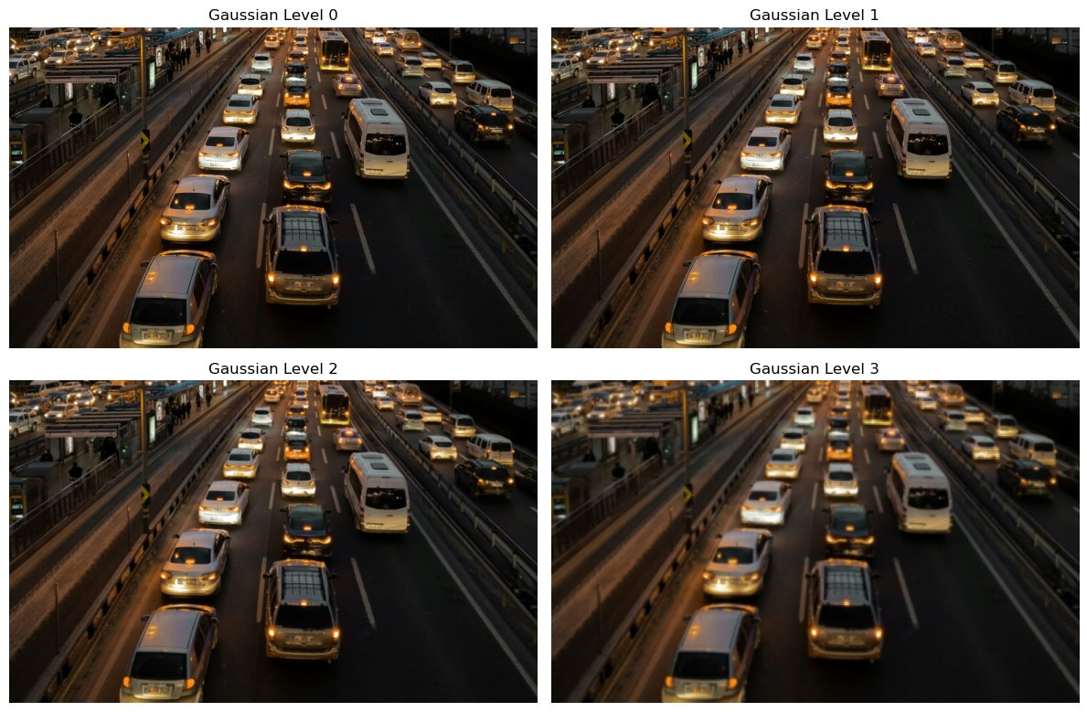
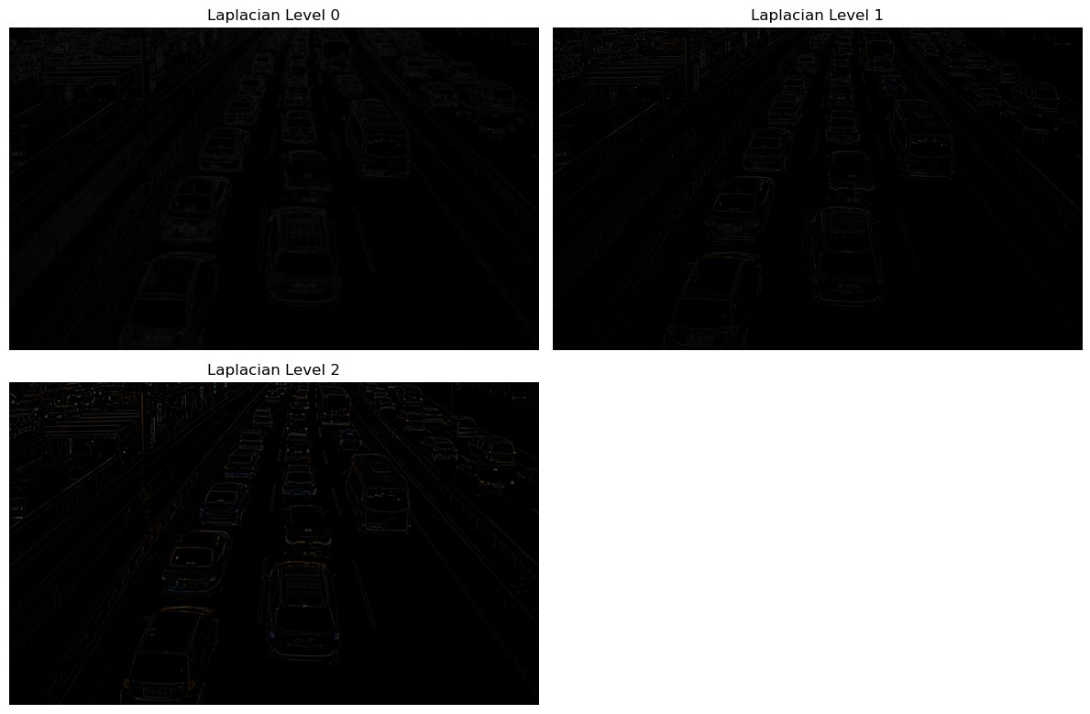

2. Implement an image-pyramid-based approach to detect faces appearing at different scales in a photograph.
import cv2
import matplotlib.pyplot as plt

# Step 1: Load the photograph
img = cv2.imread("people2.jpg")

if img is None:
print("Error: Image not found!")
exit()

# Convert image to grayscale
gray = cv2.cvtColor(img, cv2.COLOR_BGR2GRAY)

# Step 2: Load the pre-trained face detector
face_cascade = cv2.CascadeClassifier(
cv2.data.haarcascades +
"haarcascade_frontalface_default.xml"
)

# Step 3: Create a copy for drawing rectangles
result = img.copy()

# Step 4: Set the initial image scale
scale = 1.0

# Step 5: Detect faces at different image scales
while True:

# Resize the original grayscale image
resized = cv2.resize(gray,None,fx=scale,fy=scale)

# Detect faces in the resized image
faces = face_cascade.detectMultiScale(resized,scaleFactor=1.1,minNeighbors=15,minSize=(30, 30))

# Draw rectangles on the original image
for (x, y, w, h) in faces:

# Convert coordinates to original image size
x = int(x / scale)
y = int(y / scale)
w = int(w / scale)
h = int(h / scale)

cv2.rectangle(result,(x, y),(x + w, y + h),(0, 255, 0),2)

# Stop when the image becomes too small
if resized.shape[1] < 100 or resized.shape[0] < 100:
break

# Reduce the image size for the next level
scale = scale * 0.8

# Step 6: Display the final result
result = cv2.cvtColor(result, cv2.COLOR_BGR2RGB)

plt.figure(figsize=(10, 7))
plt.imshow(result)
plt.title("Face Detection Using Image Pyramid")
plt.axis("off")
plt.show()

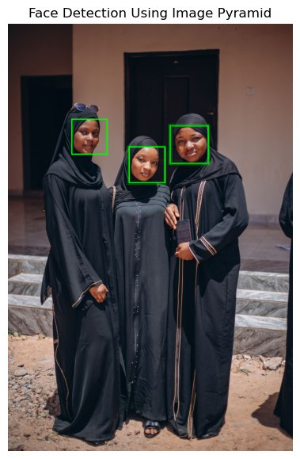

3. Implement multi-scale image processing to detect a person appearing at different distances from a surveillance camera.
import cv2
import matplotlib.pyplot as plt

# Step 1: Load the surveillance image
img = cv2.imread("crowd.jpg")

if img is None:
print("Error: Image not found!")
exit()

# Step 2: Create a copy for displaying results
result = img.copy()

# Step 3: Load the pre-trained HOG person detector
hog = cv2.HOGDescriptor()

hog.setSVMDetector(
cv2.HOGDescriptor_getDefaultPeopleDetector()
)

# Step 4: Set image scale
scale = 1.0

# Step 5: Detect people at different scales
while True:

# Resize the image
resized = cv2.resize(img,None,fx=scale,fy=scale)

# Detect people in the resized image
boxes, weights = hog.detectMultiScale(resized,winStride=(8,8),padding=(8,8),scale=1.05)

# Step 6: Convert coordinates to original image size
for (x, y, w, h) in boxes:

x = int(x / scale)
y = int(y / scale)
w = int(w / scale)
h = int(h / scale)

# Draw a rectangle around the person
cv2.rectangle(result,(x, y),(x + w, y + h),(0, 255, 0),2)

# Stop when the resized image becomes too small
if resized.shape[1] < 160 or resized.shape[0] < 160:
break

# Reduce the image size for the next level
scale = scale * 0.8

# Step 7: Display the final result
result = cv2.cvtColor(result,cv2.COLOR_BGR2RGB)

plt.figure(figsize=(10, 7))
plt.imshow(result)
plt.title("Multi-Scale Person Detection")
plt.axis("off")
plt.show()

4. Generate different-resolution versions of a scanned document using Gaussian pyramids and analyze the effect of resolution on character readability.
import cv2
import matplotlib.pyplot as plt

# Step 1: Load the scanned document
img = cv2.imread("document.png")

if img is None:
print("Error: Image not found!")
exit()

# Convert the image to grayscale
gray = cv2.cvtColor(img, cv2.COLOR_BGR2GRAY)

# Step 2: Create the Gaussian pyramid
pyramid = [gray]

for i in range(4):
# Reduce the image size by half
gray = cv2.pyrDown(gray)
pyramid.append(gray)

# Step 3: Display all resolution levels
plt.figure(figsize=(12, 10))

for i, image in enumerate(pyramid):
plt.subplot(2, 3, i + 1)
plt.imshow(image, cmap="gray")
# Display image size
height, width = image.shape

plt.title("Level " + str(i) + "\nSize: " + str(width) + " x " + str(height))
plt.axis("off")

plt.tight_layout()
plt.show()

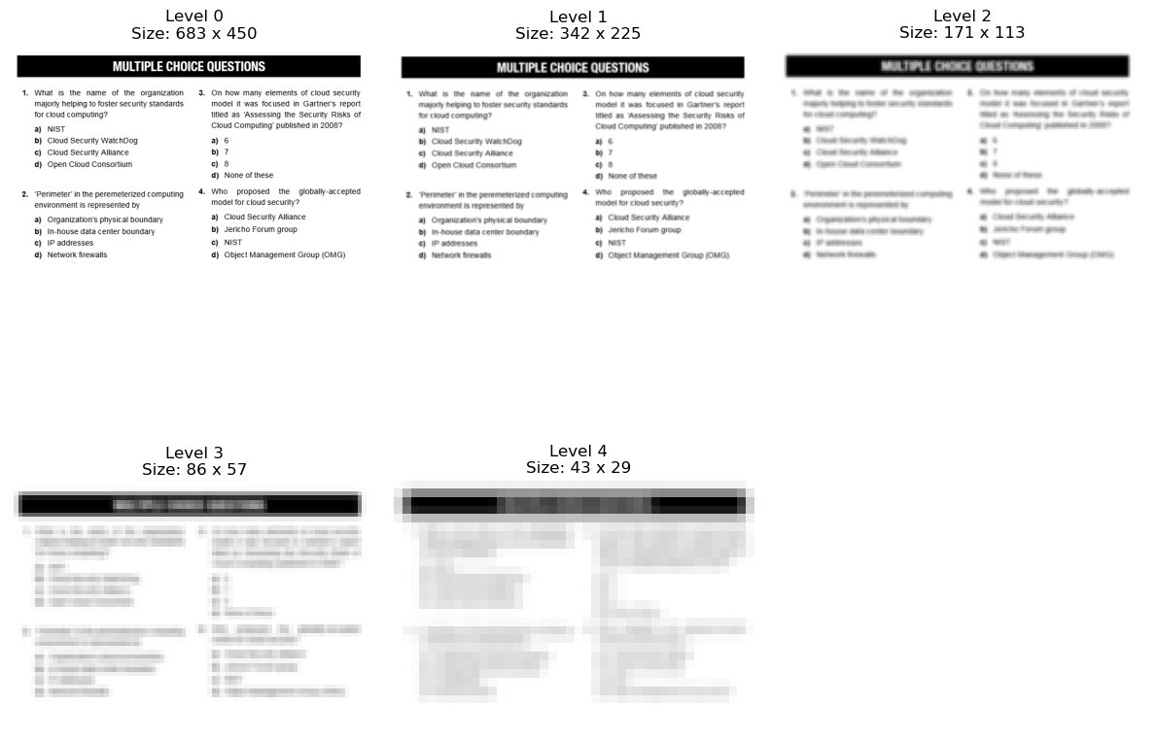
# # Step 4: Save each resolution version
# for i, image in enumerate(pyramid):
# filename = "document_level_" + str(i) + ".jpg"
# cv2.imwrite(filename, image)

# print("All resolution images saved successfully!")

5. Implement Gaussian derivative filters to detect road boundaries and lane markings in a road image
import cv2
import matplotlib.pyplot as plt

# Step 1: Read the road image
img = cv2.imread("road.jpg")

if img is None:
print("Error: Image not found!")
exit()

# Step 2: Convert image to grayscale
gray = cv2.cvtColor(img, cv2.COLOR_BGR2GRAY)

# Step 3: Apply Gaussian blur to remove noise
blur = cv2.GaussianBlur(gray, (5, 5), 0)

# Step 4: Apply Gaussian derivative filters using Sobel
# Detect horizontal brightness changes (vertical edges)
sobel_x = cv2.Sobel(blur, cv2.CV_64F, 1, 0, ksize=3)

# Detect vertical brightness changes (horizontal edges)
sobel_y = cv2.Sobel(blur, cv2.CV_64F, 0, 1, ksize=3)

# Step 5: Combine the edge information
edges = cv2.magnitude(sobel_x, sobel_y)

# Convert edges to 8-bit image
edges = cv2.convertScaleAbs(edges)

# Step 6: Apply thresholding
_, binary = cv2.threshold(edges, 50, 255, cv2.THRESH_BINARY)

# Step 7: Display results
plt.figure(figsize=(12, 8))

plt.subplot(2, 2, 1)
plt.imshow(cv2.cvtColor(img, cv2.COLOR_BGR2RGB))
plt.title("Original Road Image")
plt.axis("off")

plt.subplot(2, 2, 2)
plt.imshow(blur, cmap="gray")
plt.title("Gaussian Blur")
plt.axis("off")

plt.subplot(2, 2, 3)
plt.imshow(edges, cmap="gray")
plt.title("Detected Edges")
plt.axis("off")

plt.subplot(2, 2, 4)
plt.imshow(binary, cmap="gray")
plt.title("Road Boundaries and Lane Edges")
plt.axis("off")

plt.tight_layout()
plt.show()

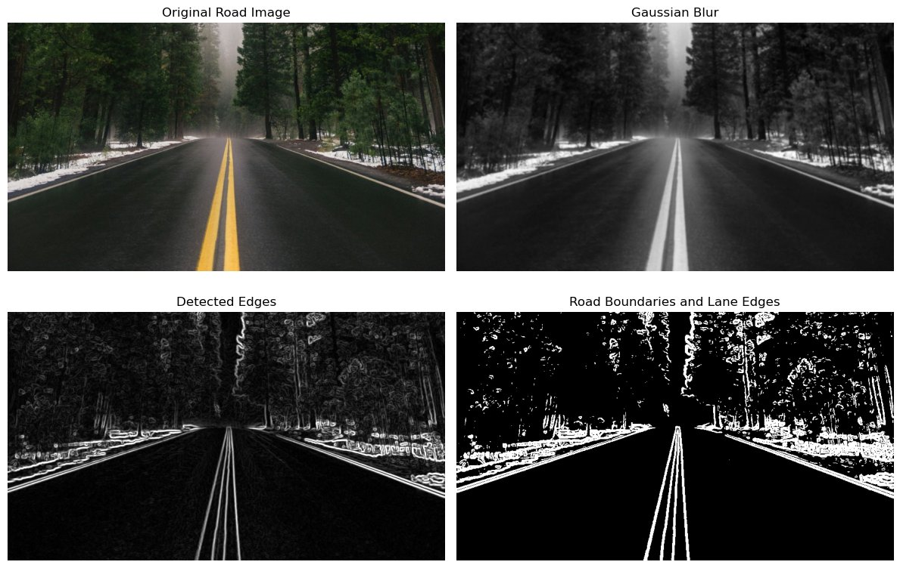

6. Implement first-order and second-order Gaussian derivative filters to detect boundaries and defects on a manufactured product.
import cv2
import matplotlib.pyplot as plt

# Step 1: Load the product image
img = cv2.imread("product3.jpg")

if img is None:
print("Error: Image not found!")
exit()

# Step 2: Convert to grayscale
gray = cv2.cvtColor(img, cv2.COLOR_BGR2GRAY)

# Step 3: Apply Gaussian blur
blur = cv2.GaussianBlur(gray, (5, 5), 0)

# Step 4: First-order derivative using Sobel
first_order = cv2.Sobel(blur, cv2.CV_64F, 1, 0, ksize=3)
first_order = cv2.convertScaleAbs(first_order)

# Step 5: Second-order derivative using Laplacian
second_order = cv2.Laplacian(blur, cv2.CV_64F, ksize=3)
second_order = cv2.convertScaleAbs(second_order)

# Step 6: Display all images
plt.figure(figsize=(10, 8))

plt.subplot(2, 2, 1)
plt.imshow(cv2.cvtColor(img, cv2.COLOR_BGR2RGB))
plt.title("Original Product")
plt.axis("off")

plt.subplot(2, 2, 2)
plt.imshow(blur, cmap="gray")
plt.title("Gaussian Blur")
plt.axis("off")

plt.subplot(2, 2, 3)
plt.imshow(first_order, cmap="gray")
plt.title("First-Order Derivative")
plt.axis("off")

plt.subplot(2, 2, 4)
plt.imshow(second_order, cmap="gray")
plt.title("Second-Order Derivative")
plt.axis("off")

plt.tight_layout()
plt.show()

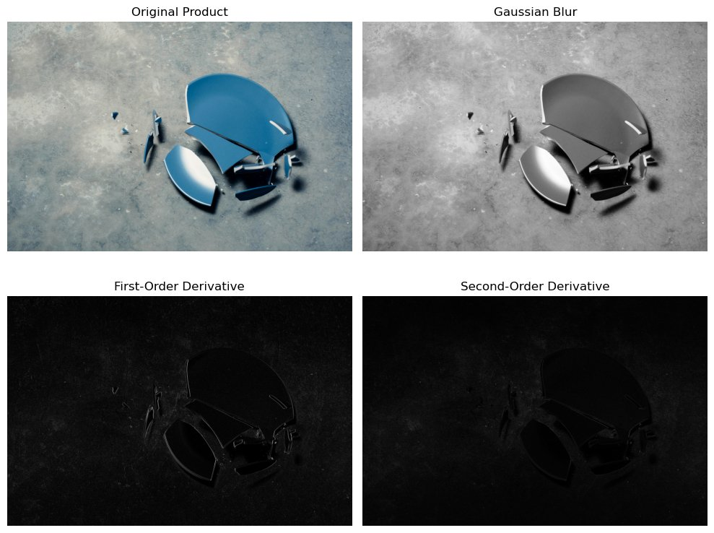

7. Implement Gabor filters with different orientations and frequencies to identify defective regions in a fabric image.
import cv2
import numpy as np
import matplotlib.pyplot as plt

# Step 1: Load the fabric image
img = cv2.imread("fabric.jpg")

if img is None:
print("Error: Image not found!")
exit()

# Convert image to grayscale
gray = cv2.cvtColor(img, cv2.COLOR_BGR2GRAY)

# Step 2: Create Gabor filters
orientations = [0, 45, 90, 135]
frequencies = [0.1, 0.2]

# Display original image
plt.figure(figsize=(12, 10))

plt.subplot(3, 3, 1)
plt.imshow(gray, cmap="gray")
plt.title("Original Fabric")
plt.axis("off")

# Step 3: Apply filters
plot_no = 2

for angle in orientations:
for freq in frequencies:

# Convert angle to radians
theta = np.deg2rad(angle)

# Create Gabor kernel
kernel = cv2.getGaborKernel((10,10),4.0,theta,1.0 / freq,0.5,0,ktype=cv2.CV_32F)

# Apply filter to fabric image
filtered = cv2.filter2D(gray, cv2.CV_32F, kernel)

# Convert result to displayable image
filtered = cv2.convertScaleAbs(filtered)

# Display filtered image
plt.subplot(3, 3, plot_no)
plt.imshow(filtered, cmap="gray")
plt.title(str(angle) + " deg, f=" + str(freq))
plt.axis("off")

plot_no += 1

# Stop after filling 9 plots
if plot_no > 9:
break

if plot_no > 9:
break

plt.tight_layout()
plt.show()

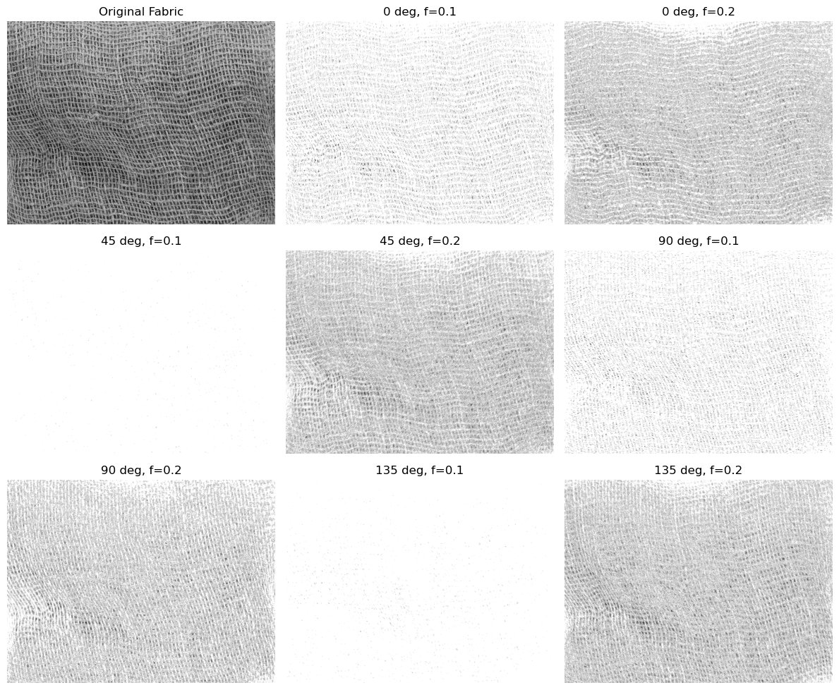

8. Apply Gabor filters to enhance fingerprint ridge patterns and visualize the resulting texture information.
import cv2
import numpy as np
import matplotlib.pyplot as plt

# Step 1: Load fingerprint image
img = cv2.imread("fingerprint.png")

if img is None:
print("Error: Image not found!")
exit()

# Step 2: Convert to grayscale
gray = cv2.cvtColor(img, cv2.COLOR_BGR2GRAY)

# Step 3: Resize image
gray = cv2.resize(gray, (300, 300))

# Step 4: Apply Gaussian blur
blur = cv2.GaussianBlur(gray, (3, 3), 0)

# Step 5: Create a Gabor filter
theta = np.deg2rad(45) # Ridge direction
frequency = 0.1

kernel = cv2.getGaborKernel(
(21,21), # Kernel size
4.0, # Sigma
theta, # Orientation
1 / frequency, # Wavelength
5, # Aspect ratio
0, # Phase offset
ktype=cv2.CV_32F
)

# Step 6: Apply Gabor filter
filtered = cv2.filter2D(blur, cv2.CV_32F, kernel)

# Step 7: Normalize result for display
filtered = cv2.normalize(filtered, None, 0, 255, cv2.NORM_MINMAX)
filtered = filtered.astype(np.uint8)

# Step 8: Display images
plt.figure(figsize=(10, 5))

plt.subplot(1, 3, 1)
plt.imshow(gray, cmap="gray")
plt.title("Original Fingerprint")
plt.axis("off")

plt.subplot(1, 3, 2)
plt.imshow(kernel, cmap="gray")
plt.title("Gabor Kernel")
plt.axis("off")

plt.subplot(1, 3, 3)
plt.imshow(filtered, cmap="gray")
plt.title("Enhanced Ridge Texture")
plt.axis("off")

plt.tight_layout()
plt.show()

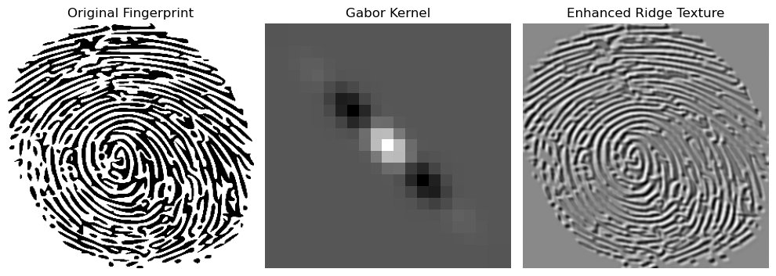

9. Implement Gabor-filter-based texture analysis to distinguish between smooth and rough or cracked road surfaces
import cv2
import numpy as np
import matplotlib.pyplot as plt

# Step 1: Load road image
img = cv2.imread("road3.jpg")

if img is None:
print("Error: Image not found!")
exit()

# Step 2: Convert to grayscale
gray = cv2.cvtColor(img, cv2.COLOR_BGR2GRAY)

# Step 3: Resize image
gray = cv2.resize(gray, (400, 300))

# Step 4: Create Gabor filter settings
orientations = [0, 45, 90, 135]
responses = []

# Step 5: Apply Gabor filters
for angle in orientations:

theta = np.deg2rad(angle)

kernel = cv2.getGaborKernel(
(10,10), # Kernel size
4.0, # Sigma
theta, # Orientation
10.0, # Wavelength
0.5, # Gamma
0, # Phase
ktype=cv2.CV_32F
)

# Apply filter
filtered = cv2.filter2D(gray, cv2.CV_32F, kernel)

# Convert response to absolute values
filtered = np.abs(filtered)

responses.append(filtered)

# Step 6: Combine all filter responses
texture = np.mean(responses, axis=0)

# Step 7: Calculate texture score
score = np.mean(texture)

print("Texture Score:", round(float(score), 2))

Texture Score: 2074.75

# Step 8: Display results
plt.figure(figsize=(12, 8))

plt.subplot(2, 3, 1)
plt.imshow(gray, cmap="gray")
plt.title("Original Road")
plt.axis("off")

for i in range(4):
plt.subplot(2, 3, i + 2)
plt.imshow(responses[i], cmap="gray")
plt.title(str(orientations[i]) + " Degree Gabor")
plt.axis("off")

plt.subplot(2, 3, 6)
plt.imshow(texture, cmap="gray")
plt.title("Combined Texture")
plt.axis("off")

plt.tight_layout()
plt.show()

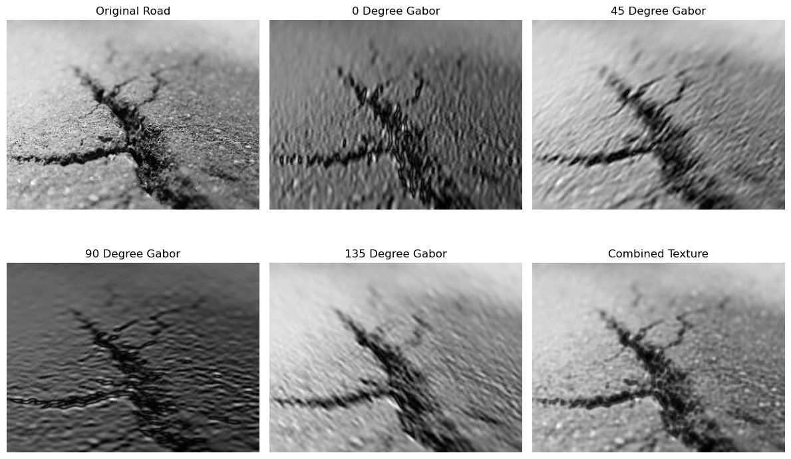

10. Extract texture features using Gabor filters and classify images of different types of wood.
import cv2
import numpy as np
import matplotlib.pyplot as plt

# Function to extract Gabor texture features
def extract_features(image_path):

# Read image
img = cv2.imread(image_path)

if img is None:
print("Image not found:", image_path)
return None

# Convert to grayscale
gray = cv2.cvtColor(img, cv2.COLOR_BGR2GRAY)

# Resize image
gray = cv2.resize(gray, (200, 200))

features = []

# Apply Gabor filters at different angles
for angle in [0, 45, 90, 135]:

theta = np.deg2rad(angle)

kernel = cv2.getGaborKernel((21, 21),4.0,theta,10.0,0.5,0,ktype=cv2.CV_32F)

# Apply filter
filtered = cv2.filter2D(gray, cv2.CV_32F, kernel)

# Calculate texture features
features.append(np.mean(np.abs(filtered)))
features.append(np.std(filtered))

return features

# Step 1: List wood images
images = ["wood1.jpg","wood2.jpg","wood3.jpg"]

# Step 2: Extract and display features
for image_path in images:

features = extract_features(image_path)

if features is None:
continue

print("\nImage:", image_path)
print("Gabor Features:", np.round(features, 2))

# Step 3: Simple rule-based classification
texture_score = np.mean(features[::2])

print("Texture Score:", np.round(texture_score, 2))

if texture_score < 500:
wood_type = "Class A"
elif texture_score < 1500:
wood_type = "Class B"
else:
wood_type = "Class C"

print("Predicted Wood Type:", wood_type)

Image: wood1.jpg
Gabor Features: [1486.25 1729.62 1522.81 556.86 777.67 416.99 1520.56 555.07]
Texture Score: 1326.82
Predicted Wood Type: Class B

Image: wood2.jpg
Gabor Features: [ 957.38 639.82 1785.58 544.13 892.92 356.19 1763.92 486.7 ]
Texture Score: 1349.95
Predicted Wood Type: Class B

Image: wood3.jpg
Gabor Features: [ 457.91 365.21 892.23 642.76 852.56 1028. 852.23 485.67]
Texture Score: 763.73
Predicted Wood Type: Class B

# Step 4: Display one example image
img = cv2.imread(images[0])

if img is not None:
img = cv2.cvtColor(img, cv2.COLOR_BGR2RGB)

plt.imshow(img)
plt.title("Wood Image")
plt.axis("off")
plt.show()

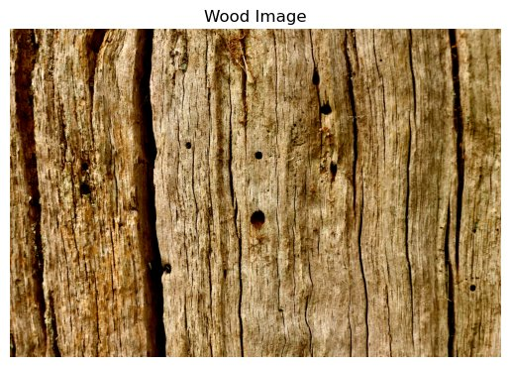

11. Use Gabor filters to distinguish between healthy and diseased regions of a plant leaf based on texture characteristics.
import cv2
import matplotlib.pyplot as plt
import numpy as np

# 1. Load the leaf image in grayscale
# Replace 'leaf.jpg' with the path to your image
image = cv2.imread('leaf.jpg', cv2.IMREAD_GRAYSCALE)

if image is None:
print('Error: Image not found. Please check the file path.')
else:
# Resize for consistent processing
image = cv2.resize(image, (400, 400))

# 2. Define Gabor filter parameters
ksize = 40 # Size of the filter kernel
sigma = 4.0 # Standard deviation of the Gaussian envelope
theta = np.pi / 4 # Orientation angle (e.g., 45 degrees)
lambd = 10.0 # Wavelength of the sinusoidal factor
gamma = 2 # Spatial aspect ratio (ellipticity)
psi = 0.0 # Phase offset

# Create the Gabor kernel
gabor_kernel = cv2.getGaborKernel(
(ksize, ksize), sigma, theta, lambd, gamma, psi, ktype=cv2.CV_32F
)

# 3. Filter the image to extract texture features
filtered_image = cv2.filter2D(image, cv2.CV_8UC3, gabor_kernel)

# 4. Visualize the original and filtered textures using Matplotlib
plt.figure(figsize=(10, 5))

plt.subplot(1, 2, 1)
plt.imshow(image, cmap='gray')
plt.title('Original Leaf Image')
plt.axis('off')

plt.subplot(1, 2, 2)
plt.imshow(filtered_image, cmap='gray')
plt.title('Gabor Filtered Response (Texture)')
plt.axis('off')

plt.tight_layout()
plt.show()

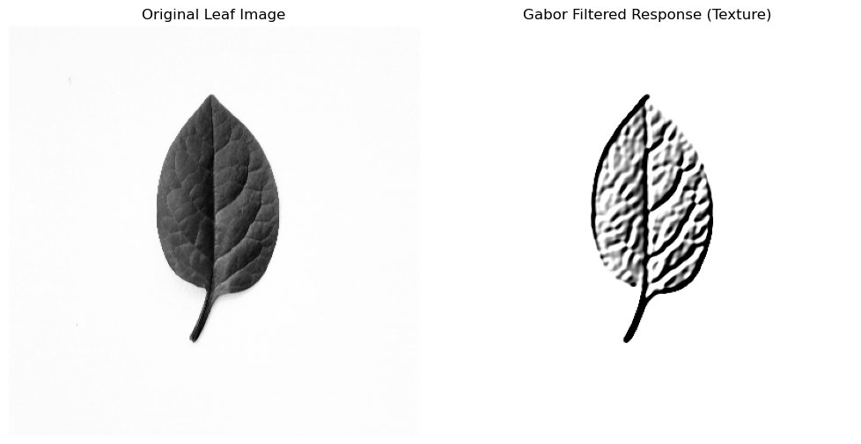

12. Apply Gabor filters to identify and differentiate surface textures in images of tiles, metal, or other manufactured materials.
import cv2
import numpy as np
import matplotlib.pyplot as plt

# Step 1: Read the material image
img = cv2.imread("metal.jpg")

if img is None:
print("Error: Image not found!")
exit()

# Step 2: Convert to grayscale
gray = cv2.cvtColor(img, cv2.COLOR_BGR2GRAY)

# Step 3: Resize image
gray = cv2.resize(gray, (300, 300))

# Step 4: Apply Gabor filters at different angles
angles = [0, 45, 90, 135]
responses = []

for angle in angles:

# Convert angle to radians
theta = np.deg2rad(angle)

# Create Gabor filter
kernel = cv2.getGaborKernel((40,40),4.0,theta,10.0,0.5,0,ktype=cv2.CV_32F)

# Apply filter
filtered = cv2.filter2D(gray, cv2.CV_32F, kernel)

# Convert response to visible image
filtered = cv2.convertScaleAbs(filtered)

responses.append(filtered)

# Step 5: Display results
plt.figure(figsize=(10, 7))

plt.subplot(2, 3, 1)
plt.imshow(gray, cmap="gray")
plt.title("Original Material")
plt.axis("off")

for i in range(4):
plt.subplot(2, 3, i + 2)
plt.imshow(responses[i], cmap="gray")
plt.title(str(angles[i]) + " Degree Filter")
plt.axis("off")

# Step 6: Calculate texture score
score = np.mean(responses)

print("Texture Score:", round(float(score), 2))

plt.tight_layout()
plt.show()

Texture Score: 244.39

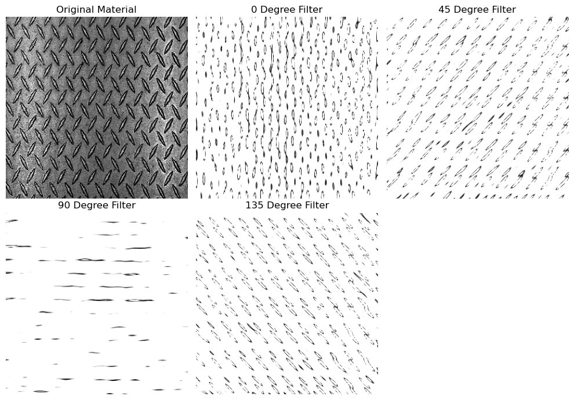

13. Implement two-dimensional Discrete Wavelet Transform (DWT) for image compression and reconstruct the image using selected wavelet coefficients.
import cv2
import matplotlib.pyplot as plt
import numpy as np
import pywt

# 1. Load image in grayscale and resize for clean wavelet levels
# Replace 'image.jpg' with your target image path
image = cv2.imread('image.jpg', cv2.IMREAD_GRAYSCALE)
image = cv2.resize(image, (512, 512))

# 2. Apply 2D Discrete Wavelet Transform (DWT) using the 'haar' wavelet
# Returns approximation (LL) and details (LH: horizontal, HL: vertical, HH: diagonal)
coeffs2 = pywt.dwt2(image, 'haar')
LL, (LH, HL, HH) = coeffs2

# 3. Compress by thresholding (zeroing out weak coefficients to save space)
threshold = 25
LH_thresh = pywt.threshold(LH, threshold, mode='soft')
HL_thresh = pywt.threshold(HL, threshold, mode='soft')
HH_thresh = pywt.threshold(HH, threshold, mode='soft')

# Combine the thresholded coefficients back
coeffs_compressed = (LL, (LH_thresh, HL_thresh, HH_thresh))

# 4. Reconstruct the image from the selected/compressed coefficients
reconstructed_image = pywt.idwt2(coeffs_compressed, 'haar')

# 5. Visualize Original vs. Reconstructed Compressed Image
plt.figure(figsize=(10, 5))

plt.subplot(1, 2, 1)
plt.imshow(image, cmap='gray')
plt.title('Original Image')
plt.axis('off')

plt.subplot(1, 2, 2)
plt.imshow(reconstructed_image, cmap='gray')
plt.title('Reconstructed (Compressed) Image')
plt.axis('off')

plt.tight_layout()
plt.show()

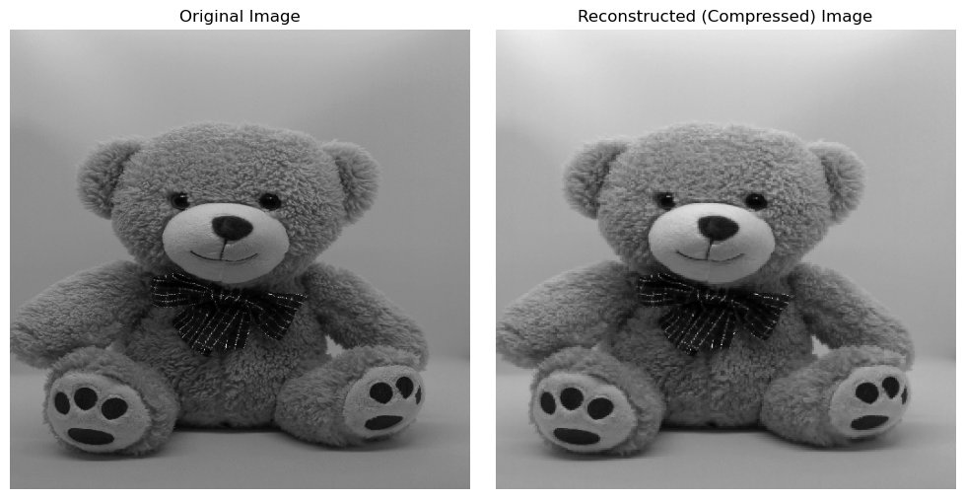

14. Implement DWT-based image denoising on a noisy medical image and compare the original, noisy, and denoised images.
import cv2
import pywt
import numpy as np
import matplotlib.pyplot as plt

# Read image
img = cv2.imread("medical.jpg",0)

if img is None:
print("Image not found!")
exit()

# Add stronger Gaussian noise
np.random.seed(10)
noise = np.random.normal(0, 25, img.shape)
noisy = np.clip(img.astype(float) + noise, 0, 255).astype(np.uint8)

# Apply DWT
LL, (LH, HL, HH) = pywt.dwt2(noisy, "haar")

# Remove noise using thresholding
LH = pywt.threshold(LH, 35, mode="soft")
HL = pywt.threshold(HL, 35, mode="soft")
HH = pywt.threshold(HH, 35, mode="soft")

# Reconstruct image
denoised = pywt.idwt2((LL, (LH, HL, HH)), "haar")
denoised = np.clip(denoised, 0, 255).astype(np.uint8)

# Display images
plt.figure(figsize=(15, 5))

plt.subplot(1, 3, 1)
plt.imshow(img, cmap="gray", vmin=0, vmax=255)
plt.title("Original Image")
plt.axis("off")

plt.subplot(1, 3, 2)
plt.imshow(noisy, cmap="gray", vmin=0, vmax=255)
plt.title("Noisy Image")
plt.axis("off")

plt.subplot(1, 3, 3)
plt.imshow(denoised, cmap="gray", vmin=0, vmax=255)
plt.title("DWT Denoised Image")
plt.axis("off")

plt.tight_layout()
plt.show()

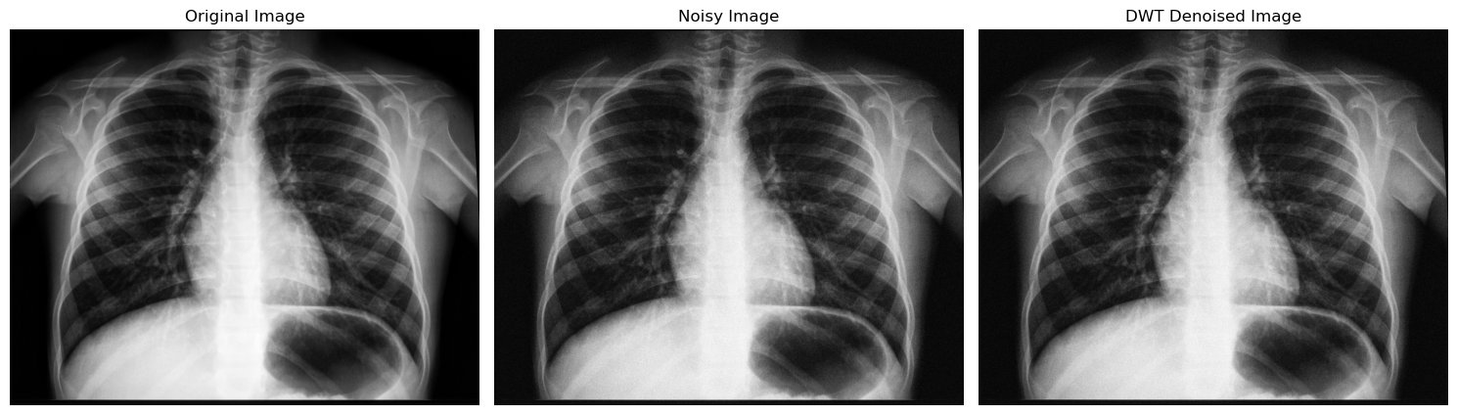
# Make sure the original/noisy images match the denoised image's shape
h, w = denoised.shape[:2]
img_resized = cv2.resize(img, (w, h))
noisy_resized = cv2.resize(noisy, (w, h))

# Now calculate the standard deviation of the differences safely
print('Noisy image standard deviation:',np.std(noisy_resized.astype(float) - img_resized.astype(float)))
print('Denoised image standard deviation:',np.std(denoised.astype(float) - img_resized.astype(float)))

Noisy image standard deviation: 15.095075925789017
Denoised image standard deviation: 12.801370436482742

15. Apply DWT-based denoising to an old or degraded photograph while preserving important image details.
import cv2
import pywt
import numpy as np
import matplotlib.pyplot as plt

# Read old photograph
img = cv2.imread("old_photo.jpg", 0)

if img is None:
print("Image not found!")
exit()

# Add noise to simulate a degraded photograph
noise = np.random.normal(0,25, img.shape)
noisy = np.clip(img.astype(float) + noise, 0, 255).astype(np.uint8)

# Apply DWT
LL, (LH, HL, HH) = pywt.dwt2(noisy, "haar")

# Apply soft thresholding to remove noise
LH = pywt.threshold(LH, 10, mode="soft")
HL = pywt.threshold(HL, 10, mode="soft")
HH = pywt.threshold(HH, 10, mode="soft")

# Reconstruct image
denoised = pywt.idwt2((LL, (LH, HL, HH)), "haar")
denoised = np.clip(denoised, 0, 255).astype(np.uint8)

# Compare images
plt.figure(figsize=(12, 5))

plt.subplot(1, 3, 1)
plt.imshow(img, cmap="gray")
plt.title("Original Photo")
plt.axis("off")

plt.subplot(1, 3, 2)
plt.imshow(noisy, cmap="gray")
plt.title("Degraded Photo")
plt.axis("off")

plt.subplot(1, 3, 3)
plt.imshow(denoised, cmap="gray")
plt.title("DWT Denoised Photo")
plt.axis("off")

plt.tight_layout()
plt.show()

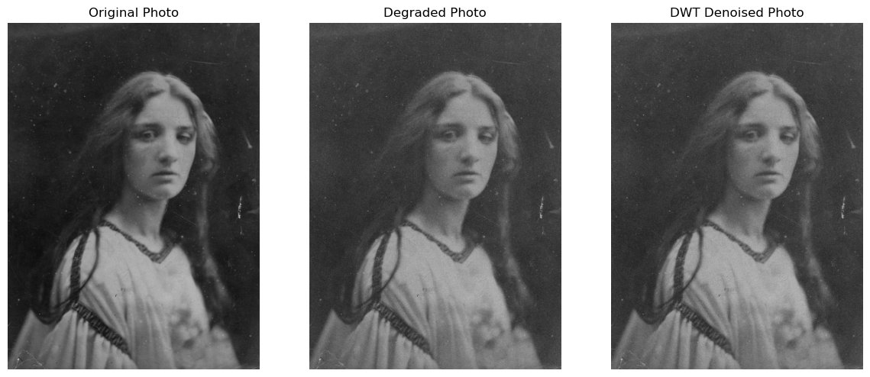

16. Implement DWT-based digital watermarking by embedding a watermark into an image and recovering the embedded watermark.
import cv2
import matplotlib.pyplot as plt
import numpy as np
import pywt

# 1. Load Host and Watermark images in grayscale
host = cv2.imread('image.jpg', cv2.IMREAD_GRAYSCALE)
watermark = cv2.imread('watermark.jpg', cv2.IMREAD_GRAYSCALE)

# Resize to required dimensions (watermark must be half the host dimensions for DWT)
host = cv2.resize(host, (512, 512))
watermark = cv2.resize(watermark, (256, 256))
_, watermark = cv2.threshold(watermark, 127, 1, cv2.THRESH_BINARY)

# 2. Apply Wavelet Transform to Host Image
LL, (LH, HL, HH) = pywt.dwt2(host, 'haar')

# 3. Embed Watermark into the HL frequency band
alpha = 20.0 # Strength of the watermark
HL_watermarked = HL + (alpha * watermark.astype(np.float32))

# 4. Reconstruct the Watermarked Image
watermarked_image = pywt.idwt2((LL, (LH, HL_watermarked, HH)), 'haar')
watermarked_image = np.clip(watermarked_image, 0, 255).astype(np.uint8)

# 5. Extract the Watermark back out
extracted = (HL_watermarked - HL) / alpha
extracted = np.clip(extracted * 255, 0, 255).astype(np.uint8)

# 6. Show Results
plt.figure(figsize=(10, 4))

plt.subplot(1, 3, 1)
plt.imshow(watermark * 255, cmap='gray')
plt.title('Original Watermark')
plt.axis('off')

plt.subplot(1, 3, 2)
plt.imshow(watermarked_image, cmap='gray')
plt.title('Watermarked Image')
plt.axis('off')

plt.subplot(1, 3, 3)
plt.imshow(extracted, cmap='gray')
plt.title('Extracted Watermark')
plt.axis('off')

plt.tight_layout()
plt.show()

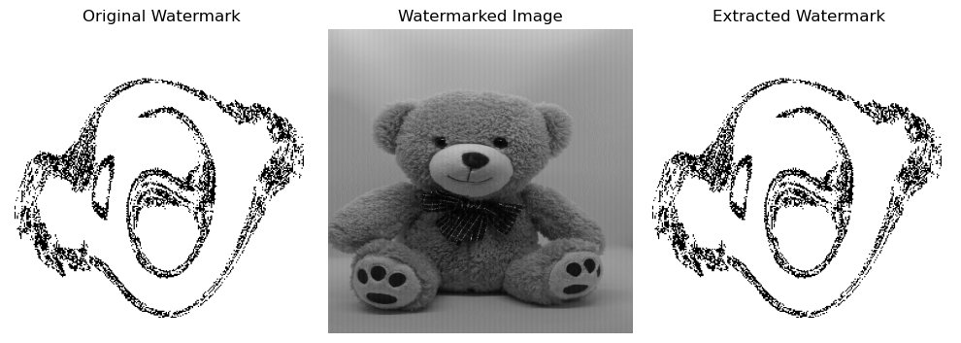

17. Analyze the quality of two images using their DWT coefficients and compare the amount of detail information present in each image.
import cv2
import pywt
import numpy as np
import matplotlib.pyplot as plt

# Read two images in grayscale
img1 = cv2.imread("product.jpg", 0)
img2 = cv2.imread("product2.jpg", 0)

if img1 is None or img2 is None:
print("Image not found!")
exit()

# Resize images to the same size
img2 = cv2.resize(img2, (img1.shape[1], img1.shape[0]))

# Apply DWT
LL1, (LH1, HL1, HH1) = pywt.dwt2(img1, "haar")
LL2, (LH2, HL2, HH2) = pywt.dwt2(img2, "haar")

# Calculate detail energy
energy1 = np.mean(LH1**2 + HL1**2 + HH1**2)
energy2 = np.mean(LH2**2 + HL2**2 + HH2**2)

print("Image 1 Detail Energy:", round(energy1, 2))
print("Image 2 Detail Energy:", round(energy2, 2))

Image 1 Detail Energy: 26.4
Image 2 Detail Energy: 47.24

# Display images
plt.figure(figsize=(10, 4))

plt.subplot(1, 2, 1)
plt.imshow(img1, cmap="gray")
plt.title("Image 1")
plt.axis("off")

plt.subplot(1, 2, 2)
plt.imshow(img2, cmap="gray")
plt.title("Image 2")
plt.axis("off")

plt.tight_layout()
plt.show()

# Compare detail information
if energy1 > energy2:
print("Image 1 contains more high-frequency detail energy.")
elif energy2 > energy1:
print("Image 2 contains more high-frequency detail energy.")
else:
print("Both images have equal detail energy.")

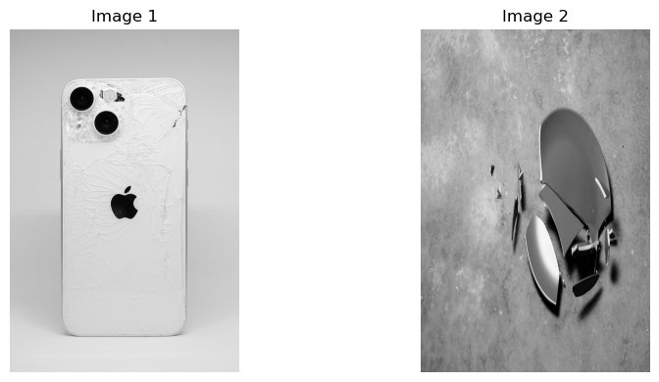
Image 2 contains more high-frequency detail energy.

18. Implement the Region Growing segmentation technique to segment a selected region from a medical image using suitable seed points.
import cv2
import numpy as np
import matplotlib.pyplot as plt

# 1. Load your image in grayscale
img = cv2.imread('med2.jpg', cv2.IMREAD_GRAYSCALE)

img = cv2.resize(img,(400,400))

# 2. Pick a seed point (X, Y) inside the region you want to segment
h, w = img.shape
seed = (200,200)
threshold = 30 # Brightness tolerance

# 3. Simple Region Growing
mask = np.zeros((h, w), dtype=np.uint8)
visited = np.zeros((h, w), dtype=bool)

seed_val = int(img[seed[1], seed[0]])
queue = [seed]

while queue:
x, y = queue.pop(0)

if visited[y, x]:
continue
visited[y, x] = True

# Check brightness similarity
if abs(int(img[y, x]) - seed_val) <= threshold:
mask[y, x] = 255

# Add 4 neighbors (left, right, up, down)
for dx, dy in [(-1,0), (1,0), (0,-1), (0,1)]:
nx, ny = x + dx, y + dy
if 0 <= nx < w and 0 <= ny < h and not visited[ny, nx]:
queue.append((nx, ny))

# 4. Display original image and result side-by-side
plt.subplot(1, 2, 1)
plt.imshow(img, cmap='gray')
plt.plot(seed[0], seed[1], 'ro') # Red dot showing seed point
plt.title("Original + Seed Point")
plt.axis("off")

plt.subplot(1, 2, 2)
plt.imshow(mask, cmap='gray')
plt.title("Segmented Region")
plt.axis("off")

plt.show()

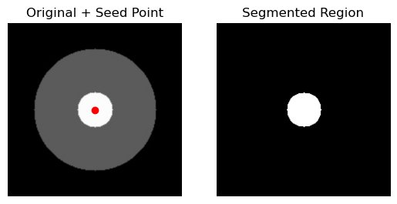

19. Implement Region Growing to separate water, vegetation, and land regions from a satellite image.
import cv2
import numpy as np
import matplotlib.pyplot as plt

# 1. Load satellite image (RGB)
# Replace 'satellite.jpg' with your image path
img = cv2.imread('satelite.png')
img = cv2.resize(img,(400,400))
img_rgb = cv2.cvtColor(img, cv2.COLOR_BGR2RGB)

# Convert to HSV color space (HSV works best for color-based region growing)
img_hsv = cv2.cvtColor(img, cv2.COLOR_BGR2HSV)

# 2. Multi-Region Growing Function (using Color Similarity)
def region_growing_color(hsv_img, seed, color_threshold=(15, 40, 40)):
"""
Grows a region starting from a seed point based on HSV color similarity.
color_threshold: (H_threshold, S_threshold, V_threshold)
"""
h, w, _ = hsv_img.shape
mask = np.zeros((h, w), dtype=np.uint8)
visited = np.zeros((h, w), dtype=bool)

seed_val = hsv_img[seed[1], seed[0]].astype(int)
queue = [seed]

while queue:
x, y = queue.pop(0)

if visited[y, x]:
continue
visited[y, x] = True

# Calculate HSV difference from seed pixel
curr_val = hsv_img[y, x].astype(int)
h_diff = abs(curr_val[0] - seed_val[0])
s_diff = abs(curr_val[1] - seed_val[1])
v_diff = abs(curr_val[2] - seed_val[2])

# Check if difference is within color thresholds
if h_diff <= color_threshold[0] and s_diff <= color_threshold[1] and v_diff <= color_threshold[2]:
mask[y, x] = 255

# 4-connected neighbors
for dx, dy in [(-1, 0), (1, 0), (0, -1), (0, 1)]:
nx, ny = x + dx, y + dy
if 0 <= nx < w and 0 <= ny < h and not visited[ny, nx]:
queue.append((nx, ny))

return mask

# 3. Define Seed Points (x, y) for each class
# Note: Adjust these (X, Y) coordinates to match your image feature locations!
seed_water = (75, 180) # Seed on water body
seed_vegetation = (180,200) # Seed on green forest/fields
seed_land = (250, 380) # Seed on bare ground/built-up land

# 4. Grow Regions for each class
mask_water = region_growing_color(img_hsv, seed_water, color_threshold=(15, 60, 60))
mask_veg = region_growing_color(img_hsv, seed_vegetation, color_threshold=(20, 50, 50))
mask_land = region_growing_color(img_hsv, seed_land, color_threshold=(20, 50, 50))

# 5. Create Colored Overlay Map
overlay = np.zeros_like(img_rgb)
overlay[mask_water == 255] = [0, 100, 255] # Blue for Water
overlay[mask_veg == 255] = [0, 200, 0] # Green for Vegetation
overlay[mask_land == 255] = [210, 180, 140] # Brown/Tan for Land

# 6. Display Results
plt.figure(figsize=(14, 8))

plt.subplot(2, 2, 1)
plt.imshow(img_rgb)
plt.plot(seed_water[0], seed_water[1], 'bo', label='Water Seed')
plt.plot(seed_vegetation[0], seed_vegetation[1], 'go', label='Veg Seed')
plt.plot(seed_land[0], seed_land[1], 'ro', label='Land Seed')
plt.title("Original Satellite Image + Seeds")
plt.legend(loc='upper right')
plt.axis('off')

plt.subplot(2, 2, 2)
plt.imshow(mask_water, cmap='gray')
plt.title("Water Region Mask")
plt.axis('off')

plt.subplot(2, 2, 3)
plt.imshow(mask_veg, cmap='gray')
plt.title("Vegetation Region Mask")
plt.axis('off')

plt.subplot(2, 2, 4)
plt.imshow(overlay)
plt.title("Combined Land-Cover Segmentation")
plt.axis('off')

plt.tight_layout()
plt.show()

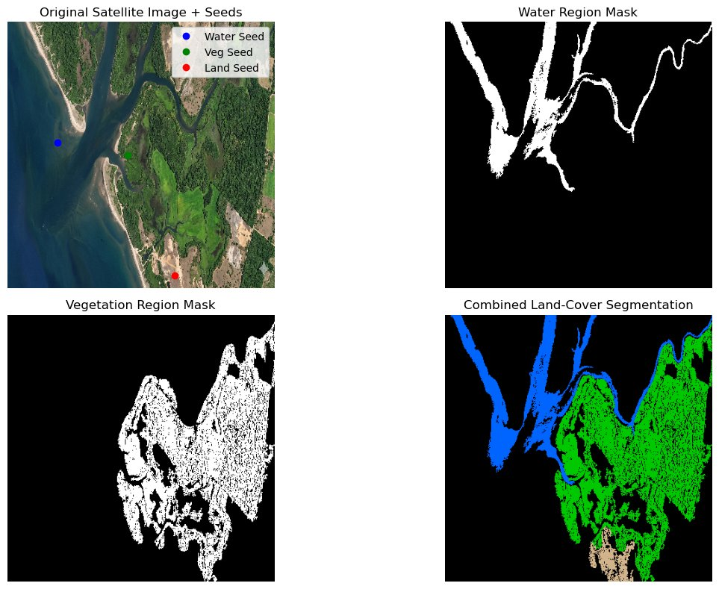

20. Implement edge-based image segmentation using the Canny edge detector to identify road boundaries in a road image.
import cv2
import matplotlib.pyplot as plt

# 1. Load your road image
img = cv2.imread('road_edge.png')

# 2. Convert to grayscale & blur to reduce noise
gray = cv2.cvtColor(img, cv2.COLOR_BGR2GRAY)
blur = cv2.GaussianBlur(gray, (5, 5), 0)

# 3. Detect edges using Canny
edges = cv2.Canny(blur, 150, 200)

# 4. Display original and detected road boundaries
plt.figure(figsize=(10, 5))

plt.subplot(1, 2, 1)
plt.imshow(cv2.cvtColor(img, cv2.COLOR_BGR2RGB))
plt.title("Original Road Image")
plt.axis('off')

plt.subplot(1, 2, 2)
plt.imshow(edges, cmap='gray')
plt.title("Road Boundaries (Canny Edges)")
plt.axis('off')

plt.show()

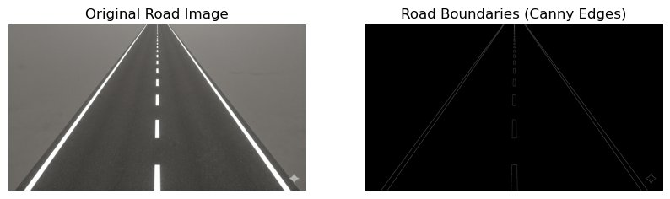

21. Implement edge-based segmentation to separate a foreground object from its background in a real-world photograph
import cv2
import matplotlib.pyplot as plt

# Read image
img = cv2.imread("leaf2.jpg")

if img is None:
print("Image not found!")
exit()

# Convert to grayscale
gray = cv2.cvtColor(img, cv2.COLOR_BGR2GRAY)

# Reduce noise
blur = cv2.GaussianBlur(gray, (5, 5), 0)

# Detect edges
edges = cv2.Canny(blur, 50, 150)

# Find contours
contours, _ = cv2.findContours(
edges, cv2.RETR_EXTERNAL, cv2.CHAIN_APPROX_SIMPLE
)

# Draw detected object boundaries
result = img.copy()
cv2.drawContours(result, contours, -1, (0, 255, 0), 2)

# Display results
plt.figure(figsize=(12, 4))

plt.subplot(1, 3, 1)
plt.imshow(cv2.cvtColor(img, cv2.COLOR_BGR2RGB))
plt.title("Original Image")
plt.axis("off")

plt.subplot(1, 3, 2)
plt.imshow(edges, cmap="gray")
plt.title("Detected Edges")
plt.axis("off")

plt.subplot(1, 3, 3)
plt.imshow(cv2.cvtColor(result, cv2.COLOR_BGR2RGB))
plt.title("Object Boundaries")
plt.axis("off")

plt.tight_layout()
plt.show()

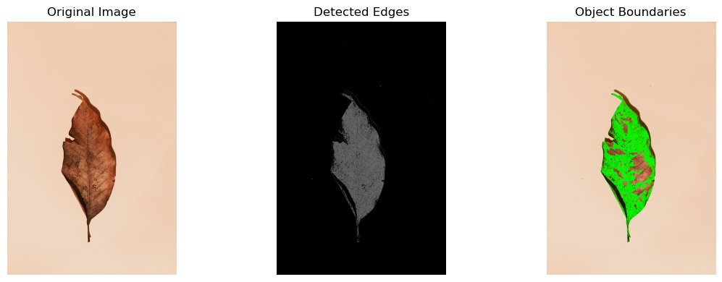
import cv2
import numpy as np
import matplotlib.pyplot as plt

# 1. Load image & convert to grayscale
img = cv2.imread('leaf2.jpg')
gray = cv2.cvtColor(img, cv2.COLOR_BGR2GRAY)

# 2. Detect edges using Canny
edges = cv2.Canny(gray, 50, 150)

# 3. Connect broken edges to form a closed shape
kernel = np.ones((5, 5), np.uint8)
closed_edges = cv2.morphologyEx(edges, cv2.MORPH_CLOSE, kernel)

# 4. Find the object boundary and fill it to make a mask
contours, _ = cv2.findContours(closed_edges, cv2.RETR_EXTERNAL, cv2.CHAIN_APPROX_SIMPLE)
mask = np.zeros_like(gray)

if contours:
largest_contour = max(contours, key=cv2.contourArea)
cv2.drawContours(mask, [largest_contour], -1, 255, thickness=cv2.FILLED)

# 5. Extract foreground object
foreground = cv2.bitwise_and(img, img, mask=mask)

# 6. Display Results
plt.figure(figsize=(12, 6))

plt.subplot(1, 3, 1)
plt.imshow(cv2.cvtColor(img, cv2.COLOR_BGR2RGB))
plt.title("Original Photo")
plt.axis('off')

plt.subplot(1, 3, 2)
plt.imshow(mask, cmap='gray')
plt.title("Edge-Based Foreground Mask")
plt.axis('off')

plt.subplot(1, 3, 3)
plt.imshow(cv2.cvtColor(foreground, cv2.COLOR_BGR2RGB))
plt.title("Extracted Foreground")
plt.axis('off')

plt.tight_layout()
plt.show()

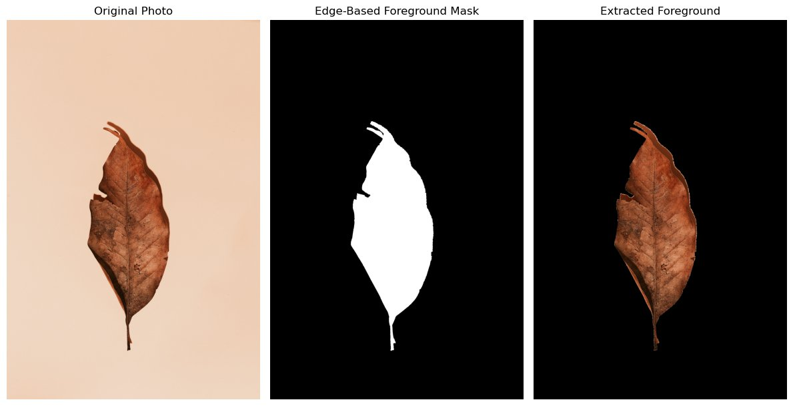

22. Implement Graph-Cut-based image segmentation to separate a region of interest, such as an organ, from the background in a medical image.
import cv2
import numpy as np
import matplotlib.pyplot as plt

# 1. Load your medical image
img = cv2.imread('medical3.png')
img = cv2.resize(img,(400,400))

# 2. Define a bounding box around the organ/region of interest
# Format: (start_x, start_y, width, height)
# Change these values according to where your organ is located in the image
rect = (50,50, 200,300)

# 3. Create mask and temporary models required by GrabCut
mask = np.zeros(img.shape[:2], np.uint8)
bgd_model = np.zeros((1, 65), np.float64)
fgd_model = np.zeros((1, 65), np.float64)

# 4. Apply Graph-Cut (GrabCut) algorithm
# Runs for 5 iterations using the bounding box setup
cv2.grabCut(img, mask, rect, bgd_model, fgd_model, 5, cv2.GC_INIT_WITH_RECT)

# 5. Extract foreground (Values 1 and 3 in the mask belong to foreground)
output_mask = np.where((mask == 1) | (mask == 3), 1, 0).astype('uint8')
foreground = img * output_mask[:, :, np.newaxis]

# 6. Display original image with rectangle and extracted region
plt.figure(figsize=(10, 5))

# Plot 1: Bounding Box Selection
img_with_rect = img.copy()
cv2.rectangle(img_with_rect, (rect[0], rect[1]), (rect[0]+rect[2], rect[1]+rect[3]), (0, 255, 0), 2)
plt.subplot(1, 2, 1)
plt.imshow(cv2.cvtColor(img_with_rect, cv2.COLOR_BGR2RGB))
plt.title("Original + Bounding Box")
plt.axis('off')

# Plot 2: Extracted Organ / Foreground
plt.subplot(1, 2, 2)
plt.imshow(cv2.cvtColor(foreground, cv2.COLOR_BGR2RGB))
plt.title("Graph-Cut Segmented Organ")
plt.axis('off')

plt.show()

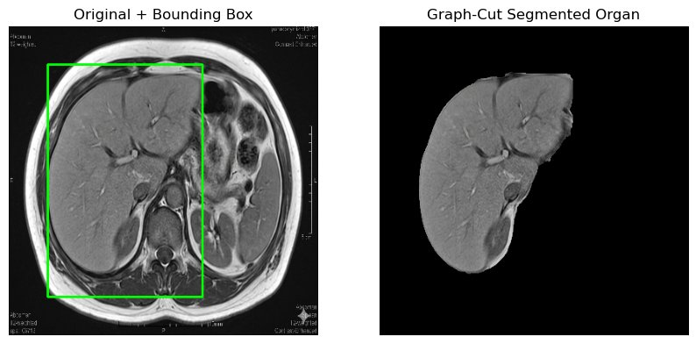

23. Implement Graph Cut to remove the background from a photograph and extract the required foreground object.
import cv2
import numpy as np
import matplotlib.pyplot as plt

# 1. Load your image
# Replace 'your_image.jpg' with your actual image path
img = cv2.imread('bike.png')
img_rgb = cv2.cvtColor(img, cv2.COLOR_BGR2RGB)

# 2. Automatically set a bounding box around the center (or manually edit coordinates)
# Format: (start_x, start_y, width, height)
h, w = img.shape[:2]
rect = (int(w * 0.1), int(h * 0.1), int(w * 0.8), int(h * 0.8))

# 3. Initialize Graph-Cut structures
mask = np.zeros((h, w), np.uint8)
bgd_model = np.zeros((1, 65), np.float64)
fgd_model = np.zeros((1, 65), np.float64)

# 4. Run Graph-Cut (GrabCut) for 5 iterations
cv2.grabCut(img, mask, rect, bgd_model, fgd_model, 5, cv2.GC_INIT_WITH_RECT)

# 5. Extract Foreground (Values 1 and 3 belong to the object)
output_mask = np.where((mask == 1) | (mask == 3), 1, 0).astype('uint8')
foreground = img_rgb * output_mask[:, :, np.newaxis]

# 6. Display Results
plt.figure(figsize=(10, 5))

plt.subplot(1, 2, 1)
plt.imshow(img_rgb)
plt.title("Original Image")
plt.axis('off')

plt.subplot(1, 2, 2)
plt.imshow(foreground)
plt.title("Extracted Object (Background Removed)")
plt.axis('off')

plt.show()

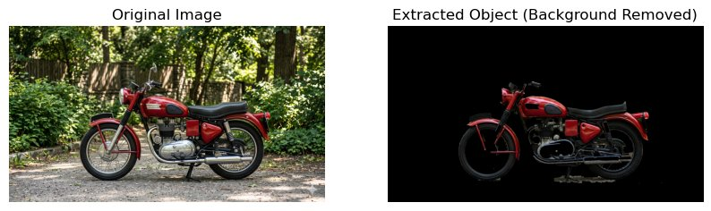

24. Implement Mean-Shift segmentation to divide a natural scene image into meaningful regions based on color and spatial information.
import cv2
import matplotlib.pyplot as plt

# Read image
img = cv2.imread("nature.png")
img = cv2.resize(img,(400,400))

if img is None:
print("Image not found!")
exit()

# Apply Mean-Shift segmentation
result = cv2.pyrMeanShiftFiltering(img,sp=50,sr=50,maxLevel=1)

# Display images
plt.figure(figsize=(10, 4))

plt.subplot(1, 2, 1)
plt.imshow(cv2.cvtColor(img, cv2.COLOR_BGR2RGB))
plt.title("Original Image")
plt.axis("off")

plt.subplot(1, 2, 2)
plt.imshow(cv2.cvtColor(result, cv2.COLOR_BGR2RGB))
plt.title("Mean-Shift Segmentation")
plt.axis("off")

plt.tight_layout()
plt.show()

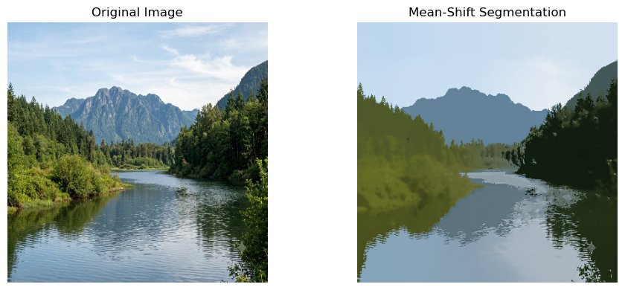

25. Implement Markov Random Field (MRF)-based image segmentation to classify pixels into different regions in a noisy image and compare the result with basic segmentation.
import cv2
import numpy as np
import matplotlib.pyplot as plt

# Read grayscale image
img = cv2.imread("nature.png", 0)

if img is None:
print("Image not found!")
exit()

noisy = img

# Basic segmentation
_, basic_seg = cv2.threshold(img, 0, 255, cv2.THRESH_BINARY + cv2.THRESH_OTSU)

# MRF-like segmentation using smoothing
smooth = cv2.medianBlur(noisy, 5)
_, mrf_result = cv2.threshold(smooth, 0, 255, cv2.THRESH_BINARY + cv2.THRESH_OTSU)

# Display results
plt.figure(figsize=(12, 4))

plt.subplot(1, 3, 1)
plt.imshow(noisy, cmap="gray")
plt.title("Noisy Image")
plt.axis("off")

plt.subplot(1, 3, 2)
plt.imshow(basic, cmap="gray")
plt.title("Basic Segmentation")
plt.axis("off")

plt.subplot(1, 3, 3)
plt.imshow(mrf_result, cmap="gray")
plt.title("Smoothed Segmentation")
plt.axis("off")

plt.tight_layout()
plt.show()

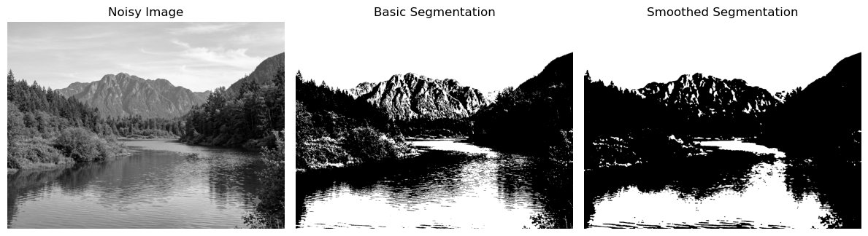

26. Implement texture-based image segmentation using Gabor-filter or DWT-based features to separate regions with different textures, such as grass, road, and building surfaces.
import cv2
import numpy as np
import matplotlib.pyplot as plt

# Read image
img = cv2.imread("road2.jpg", 0)

if img is None:
print("Image not found!")
exit()
img = cv2.resize(img,(600,400))

# Apply Gabor filter
kernel = cv2.getGaborKernel((5,5), 10, 180, 5, 1, 0)
filtered = cv2.filter2D(img, cv2.CV_32F, kernel)

# Normalize filtered image
filtered = cv2.normalize(filtered, None, 0, 255, cv2.NORM_MINMAX).astype(np.uint8)

# Segment into two texture regions
_, segmented = cv2.threshold(filtered, 127, 255, cv2.THRESH_BINARY)

# Display results
plt.figure(figsize=(12, 4))

plt.subplot(1, 3, 1)
plt.imshow(img, cmap="gray")
plt.title("Original Image")
plt.axis("off")

plt.subplot(1, 3, 2)
plt.imshow(filtered, cmap="gray")
plt.title("Gabor Filter")
plt.axis("off")

plt.subplot(1, 3, 3)
plt.imshow(segmented, cmap="gray")
plt.title("Texture Segmentation")
plt.axis("off")

plt.tight_layout()
plt.show()

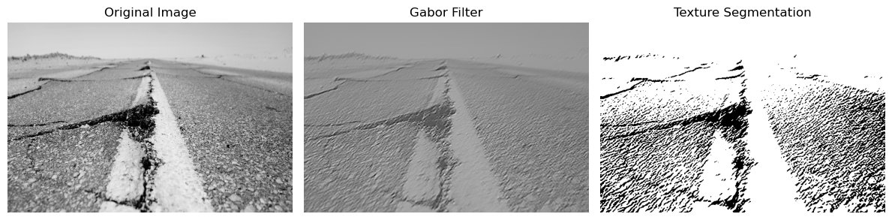

27. Implement an object detection system to detect and count cars, motorcycles, and buses in a traffic image or video.
from ultralytics import YOLO
import cv2
import matplotlib.pyplot as plt

# Read traffic image
img = cv2.imread("traffic2.png")

if img is None:
print("Image not found!")
exit()

# Load pre-trained YOLO model
model = YOLO()

# Detect objects
results = model(img)

# Vehicle classes in COCO dataset
vehicles = {2: "Car",3: "Motorcycle",5: "Bus"}
counts = {"Car": 0, "Motorcycle": 0, "Bus": 0}

# Draw boxes and count vehicles
for box in results[0].boxes:
class_id = int(box.cls[0])

if class_id in vehicles:
name = vehicles[class_id]
counts[name] += 1

x1, y1, x2, y2 = map(int, box.xyxy[0])
cv2.rectangle(img, (x1, y1), (x2, y2), (0, 255, 0), 2)
cv2.putText(img, name, (x1, y1 - 10),cv2.FONT_HERSHEY_SIMPLEX, 0.6,(0, 255, 0), 2)

0: 384x640 5 persons, 15 cars, 4 motorcycles, 5 buss, 1 truck, 192.0ms
Speed: 5.9ms preprocess, 192.0ms inference, 3.3ms postprocess per image at shape (1, 3, 384, 640)

# Display vehicle counts
print("Cars:", counts["Car"])
print("Motorcycles:", counts["Motorcycle"])
print("Buses:", counts["Bus"])

# Display result
plt.figure(figsize=(10, 6))
plt.imshow(cv2.cvtColor(img, cv2.COLOR_BGR2RGB))
plt.title("Vehicle Detection and Counting")
plt.axis("off")
plt.show()

Cars: 15
Motorcycles: 4
Buses: 5

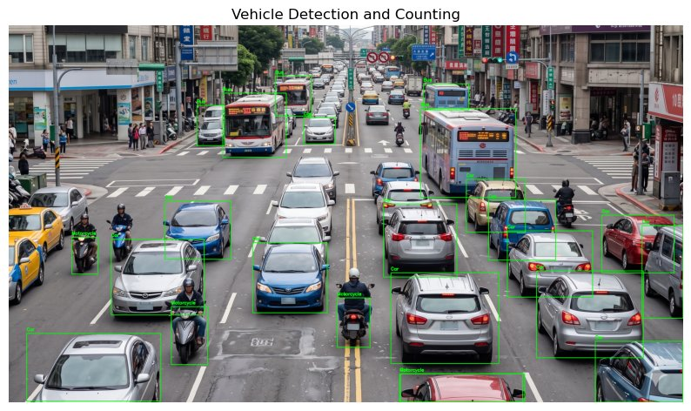

28. Develop an object detection and recognition system to identify garbage and classify it into categories such as plastic, paper, metal, glass, and organic waste.
from ultralytics import YOLO
import cv2
import matplotlib.pyplot as plt

# Load pre-trained YOLO model
model = YOLO("yolov8n.pt")

# Read garbage image
img = cv2.imread("garbage.png")

if img is None:
print("Image not found!")
exit()

# Detect objects
results = model(img)

# Display detected objects
for box in results[0].boxes:
class_id = int(box.cls[0])
name = model.names[class_id]

x1, y1, x2, y2 = map(int, box.xyxy[0])

cv2.rectangle(img, (x1, y1), (x2, y2), (0, 255, 0), 2)
cv2.putText(img, name, (x1, y1 - 10),cv2.FONT_HERSHEY_SIMPLEX, 0.6,(0,0,255), 2)

# Show result
plt.figure(figsize=(10, 6))
plt.imshow(cv2.cvtColor(img, cv2.COLOR_BGR2RGB))
plt.title("Garbage Object Detection")
plt.axis("off")
plt.show()

0: 384x640 1 bottle, 1 cup, 1 bowl, 3 bananas, 1 orange, 98.8ms
Speed: 4.9ms preprocess, 98.8ms inference, 2.4ms postprocess per image at shape (1, 3, 384, 640)

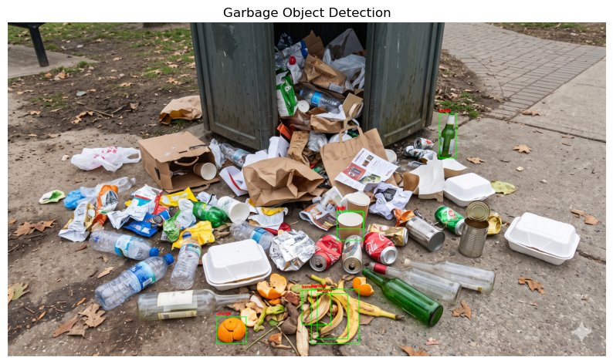

29. Develop an object detection and recognition system to identify different products on a store shelf and display their corresponding class labels.
from ultralytics import YOLO
import cv2
import matplotlib.pyplot as plt

# Load YOLO model
model = YOLO("yolov8n.pt")

# Read shelf image
img = cv2.imread("shelf.png")

if img is None:
print("Image not found!")
exit()

# Detect objects
results = model(img)

# Draw bounding boxes and labels
for box in results[0].boxes:
class_id = int(box.cls[0])
label = model.names[class_id]

x1, y1, x2, y2 = map(int, box.xyxy[0])

cv2.rectangle(img, (x1, y1), (x2, y2), (0, 255, 0), 2)
cv2.putText(img, label, (x1, y1 - 10),
cv2.FONT_HERSHEY_SIMPLEX, 0.6,
(0, 255, 0), 2)

# Display result
plt.figure(figsize=(10, 6))
plt.imshow(cv2.cvtColor(img, cv2.COLOR_BGR2RGB))
plt.title("Store Shelf Product Detection")
plt.axis("off")
plt.show()

0: 384x640 14 bottles, 13 potted plants, 1 book, 1 vase, 90.6ms
Speed: 4.6ms preprocess, 90.6ms inference, 2.9ms postprocess per image at shape (1, 3, 384, 640)

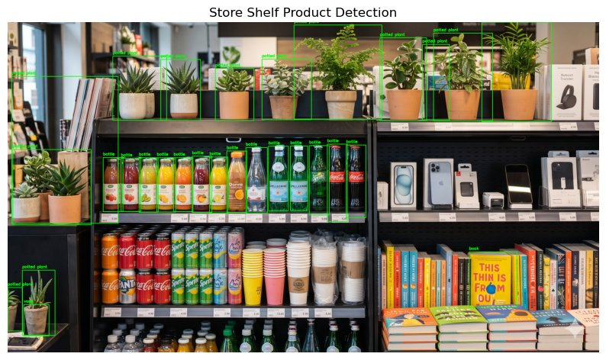

30. Develop a real-time object detection and recognition system for smart-city surveillance that detects predefined objects such as people and vehicles, draws bounding boxes around them, and displays their confidence scores.
import cv2
import matplotlib.pyplot as plt
from ultralytics import YOLO

model = YOLO('yolov8n.pt')
SURVEILLANCE_CLASSES = {0: "Person", 2: "Car", 3: "Motorcycle", 5: "Bus", 7: "Truck"}

# Process a single frame/image directly for testing
img = cv2.imread('traffic2.png') # or read a frame from cv2.VideoCapture
results = model(img)

for box in results[0].boxes:
class_id = int(box.cls[0])
conf = float(box.conf[0])

if class_id in SURVEILLANCE_CLASSES and conf > 0.4:
x1, y1, x2, y2 = map(int, box.xyxy[0])
label_text = f"{SURVEILLANCE_CLASSES[class_id]} {conf*100:.1f}%"

cv2.rectangle(img, (x1, y1), (x2, y2), (0, 255, 0), 2)
cv2.putText(img, label_text, (x1, y1 - 10),
cv2.FONT_HERSHEY_SIMPLEX, 0.6, (0, 255, 0), 2)

# Display safely in Notebooks
plt.figure(figsize=(10, 6))
plt.imshow(cv2.cvtColor(img, cv2.COLOR_BGR2RGB))
plt.axis('off')
plt.show()

0: 384x640 6 persons, 24 cars, 5 motorcycles, 5 buss, 1 truck, 131.1ms
Speed: 6.2ms preprocess, 131.1ms inference, 2.3ms postprocess per image at shape (1, 3, 384, 640)

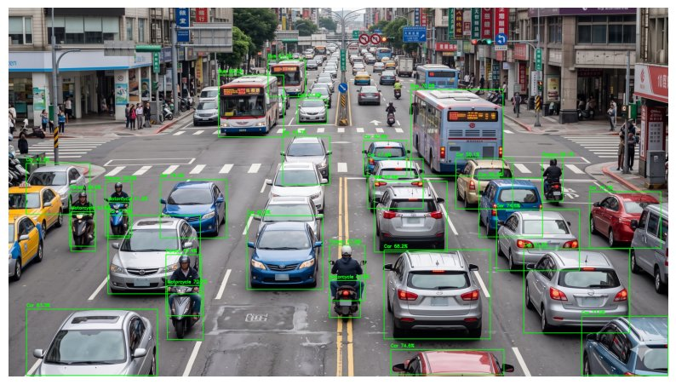
import cv2
import matplotlib.pyplot as plt
from ultralytics import YOLO

model = YOLO('yolov8n.pt')
SURVEILLANCE_CLASSES = {0: "Person", 2: "Car", 3: "Motorcycle", 5: "Bus", 7: "Truck"}

# Read first valid frame from your video file
cap = cv2.VideoCapture('cctv.mp4')
ret, frame = cap.read()
cap.release()

if ret:
results = model(frame)

for box in results[0].boxes:
class_id = int(box.cls[0])
conf = float(box.conf[0])

if class_id in SURVEILLANCE_CLASSES and conf > 0.4:
x1, y1, x2, y2 = map(int, box.xyxy[0])
label_text = f"{SURVEILLANCE_CLASSES[class_id]} {conf * 100:.1f}%"

cv2.rectangle(frame, (x1, y1), (x2, y2), (0, 255, 0), 2)
cv2.putText(frame, label_text, (x1, y1 - 10),
cv2.FONT_HERSHEY_SIMPLEX, 0.6, (0, 255, 0), 2)

plt.figure(figsize=(10, 6))
plt.imshow(cv2.cvtColor(frame, cv2.COLOR_BGR2RGB))
plt.title("Surveillance Detection Result")
plt.axis('off')
plt.show()

0: 640x384 2 persons, 3 cars, 2 motorcycles, 2 trucks, 74.2ms
Speed: 5.2ms preprocess, 74.2ms inference, 1.7ms postprocess per image at shape (1, 3, 640, 384)

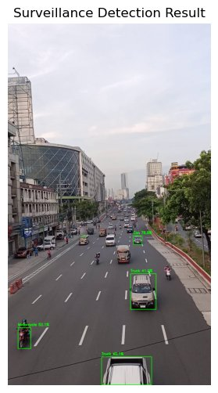
import cv2
from ultralytics import YOLO

model = YOLO("yolov8n.pt")
cap = cv2.VideoCapture("cctv.mp4")

classes = ["person", "car", "motorcycle", "bus", "truck", "bicycle"]

while cap.isOpened():
ret, frame = cap.read()
if not ret:
break

# Detect objects
results = model(frame, verbose=False)[0]

for box in results.boxes:
label = model.names[int(box.cls[0])]
conf = float(box.conf[0])

if label in classes and conf > 0.4:
x1, y1, x2, y2 = map(int, box.xyxy[0])

# Draw box and label
cv2.rectangle(frame, (x1, y1), (x2, y2), (0, 255, 0), 2)
cv2.putText(frame, f"{label}: {conf:.2f}", (x1, y1 - 10),
cv2.FONT_HERSHEY_SIMPLEX, 0.5, (0, 255, 0), 2)

# Resize and display
cv2.imshow("CCTV Detection", cv2.resize(frame, (800, 700)))
if cv2.waitKey(1) & 0xFF == ord("q"):
break

cap.release()
cv2.destroyAllWindows()

P4

CV practical assignment 4

Question 1
import cv2

# Initialize video capture (0 for webcam, or pass a video file path e.g. "corridor.mp4")
video_path = 0
cap = cv2.VideoCapture("person_walking_in_bedroom.mp4")

if not cap.isOpened():
print("Error: Could not open video source.")
exit()

# Read the first frame
ret, frame1 = cap.read()
ret, frame2 = cap.read()

# Minimum contour area to trigger motion detection (filters out small noise)
MIN_CONTOUR_AREA = 1000

while cap.isOpened() and ret:
# 1. Compute absolute difference between consecutive frames
diff = cv2.absdiff(frame1, frame2)

# 2. Convert to grayscale
gray = cv2.cvtColor(diff, cv2.COLOR_BGR2GRAY)

# 3. Apply Gaussian Blur to smooth out high-frequency noise
blur = cv2.GaussianBlur(gray, (5, 5), 0)

# 4. Threshold to get a binary image (motion = white, background = black)
_, thresh = cv2.threshold(blur, 20, 255, cv2.THRESH_BINARY)

# 5. Dilate thresholded image to fill in gaps inside contours
dilated = cv2.dilate(thresh, None, iterations=3)

# 6. Find contours of the motion regions
contours, _ = cv2.findContours(dilated, cv2.RETR_TREE, cv2.CHAIN_APPROX_SIMPLE)

motion_detected = False

for contour in contours:
# Ignore small movements (e.g., small camera jitter or shadows)
if cv2.contourArea(contour) < MIN_CONTOUR_AREA:
continue

motion_detected = True

# Get bounding box coordinates for the moving region
(x, y, w, h) = cv2.boundingRect(contour)

# Draw bounding box around detected motion
cv2.rectangle(frame1, (x, y), (x + w, y + h), (0, 255, 0), 2)

# Display status on the video feed
if motion_detected:
cv2.putText(
frame1,
"Status: Motion Detected",
(10, 30),
cv2.FONT_HERSHEY_SIMPLEX,
1,
(0, 0, 255),
2,
)
else:
cv2.putText(
frame1,
"Status: Clear",
(10, 30),
cv2.FONT_HERSHEY_SIMPLEX,
1,
(0, 255, 0),
2,
)

# Display frames
cv2.imshow("Corridor CCTV Feed", frame1)
cv2.imshow("Motion Threshold", dilated)

# Update frames for the next iteration
frame1 = frame2
ret, frame2 = cap.read()

# Press 'q' or 'ESC' to exit
key = cv2.waitKey(30) & 0xFF
if key == ord("q") or key == 27:
break

cap.release()
cv2.destroyAllWindows()

Question 2
import cv2

# Initialize video stream (use 0 for webcam or replace with path to video file, e.g., 'parking.mp4')
video_path = "person_walking_in_bedroom.mp4"
cap = cv2.VideoCapture(video_path)

if not cap.isOpened():
print("Error: Could not open video source.")
exit()

# Initialize MOG2 Background Subtractor
# history: number of frames used to build the background model
# varThreshold: threshold on the squared Mahalanobis distance (controls sensitivity)
# detectShadows: True marks shadows in gray (127), which helps exclude them from contours
bg_subtractor = cv2.createBackgroundSubtractorMOG2(
history=500, varThreshold=50, detectShadows=True
)

# Morphological kernel to clean noise and bridge gaps in vehicle silhouettes
kernel = cv2.getStructuringElement(cv2.MORPH_RECT, (5, 5))

# Minimum contour area to trigger vehicle detection (filters out small movement like leaves/birds)
MIN_VEHICLE_AREA = 3000

while cap.isOpened():
ret, frame = cap.read()
if not ret:
break

# 1. Apply background subtraction
fg_mask = bg_subtractor.apply(frame)

# 2. Threshold to remove detected shadows (shadows are marked as 127, motion as 255)
_, thresh = cv2.threshold(fg_mask, 250, 255, cv2.THRESH_BINARY)

# 3. Morphological operations: Open to remove small speckles, Close to merge vehicle regions
clean_mask = cv2.morphologyEx(thresh, cv2.MORPH_OPEN, kernel)
clean_mask = cv2.morphologyEx(clean_mask, cv2.MORPH_CLOSE, kernel)

# 4. Find contours of detected moving regions
contours, _ = cv2.findContours(
clean_mask, cv2.RETR_EXTERNAL, cv2.CHAIN_APPROX_SIMPLE
)

vehicle_count = 0

for contour in contours:
# Ignore motion smaller than typical vehicle threshold
if cv2.contourArea(contour) < MIN_VEHICLE_AREA:
continue

vehicle_count += 1

# Get bounding box coordinates for moving vehicle
x, y, w, h = cv2.boundingRect(contour)

# Draw bounding box and label
cv2.rectangle(frame, (x, y), (x + w, y + h), (0, 255, 0), 2)
cv2.putText(
frame,
"Vehicle",
(x, y - 10),
cv2.FONT_HERSHEY_SIMPLEX,
0.5,
(0, 255, 0),
2,
)

# Display real-time status overlay
status_text = f"Moving Vehicles Detected: {vehicle_count}"
cv2.putText(
frame,
status_text,
(10, 30),
cv2.FONT_HERSHEY_SIMPLEX,
0.8,
(0, 0, 255) if vehicle_count > 0 else (0, 255, 0),
2,
)

# Render video windows
cv2.imshow("Parking Security Camera", frame)
cv2.imshow("Foreground Mask (Cleaned)", clean_mask)

# Press 'q' or 'ESC' to exit
key = cv2.waitKey(30) & 0xFF
if key == ord("q") or key == 27:
break

cap.release()
cv2.destroyAllWindows()

# question 3

import cv2

# Initialize video source (0 for live webcam, or path to video file e.g., 'surveillance.mp4')
video_path = "person_walking_in_bedroom.mp4"
cap = cv2.VideoCapture(video_path)

if not cap.isOpened():
print("Error: Could not open video feed.")
exit()

# Initialize MOG2 Subtractor
# history=500: baseline frame history length
# varThreshold=16: variance threshold for pixel classification (lower = higher sensitivity)
# detectShadows=True: distinguishes true motion (255) from cast shadows (127)
bg_subtractor = cv2.createBackgroundSubtractorMOG2(
history=500, varThreshold=16, detectShadows=True
)

# Structuring element for noise filtering & merging segmented regions
kernel_open = cv2.getStructuringElement(cv2.MORPH_RECT, (3, 3))
kernel_close = cv2.getStructuringElement(cv2.MORPH_RECT, (7, 7))

# Minimum contour area (pixels) to qualify as an object
MIN_OBJECT_AREA = 800

while cap.isOpened():
ret, frame = cap.read()
if not ret:
break

# 1. Obtain foreground mask from MOG2 model
fg_mask = bg_subtractor.apply(frame)

# 2. Isolate true motion pixels (255) from shadows (127)
_, binary_mask = cv2.threshold(fg_mask, 250, 255, cv2.THRESH_BINARY)

# 3. Morphological Operations
# OPEN removes small noise dots; CLOSE fills gaps within individual objects
mask_cleaned = cv2.morphologyEx(binary_mask, cv2.MORPH_OPEN, kernel_open)
mask_cleaned = cv2.morphologyEx(mask_cleaned, cv2.MORPH_CLOSE, kernel_close)

# 4. Find external contours representing independent moving objects
contours, _ = cv2.findContours(
mask_cleaned, cv2.RETR_EXTERNAL, cv2.CHAIN_APPROX_SIMPLE
)

detected_objects_count = 0

for contour in contours:
# Filter out minor perturbations (leaves, camera shake, small animals)
if cv2.contourArea(contour) < MIN_OBJECT_AREA:
continue

detected_objects_count += 1

# Calculate bounding box & object centroid
x, y, w, h = cv2.boundingRect(contour)
cx, cy = x + w // 2, y + h // 2

# Draw bounding rectangle around each detected object
cv2.rectangle(frame, (x, y), (x + w, y + h), (0, 255, 0), 2)

# Plot centroid point
cv2.circle(frame, (cx, cy), 4, (0, 0, 255), -1)

# Label each detected instance with ID and dimensions
label = f"Obj #{detected_objects_count} [{w}x{h}]"
cv2.putText(
frame,
label,
(x, y - 8),
cv2.FONT_HERSHEY_SIMPLEX,
0.5,
(0, 255, 0),
1,
cv2.LINE_AA,
)

# Top overlay bar showing total live detections
cv2.rectangle(frame, (0, 0), (320, 40), (0, 0, 0), -1)
status_msg = f"Active Targets: {detected_objects_count}"
cv2.putText(
frame,
status_msg,
(10, 26),
cv2.FONT_HERSHEY_SIMPLEX,
0.7,
(0, 255, 255),
2,
cv2.LINE_AA,
)

# Display real-time output streams
cv2.imshow("Multi-Object Detection Feed", frame)
cv2.imshow("MOG2 Mask (Cleaned)", mask_cleaned)

# Key exit listener ('q' or 'ESC')
key = cv2.waitKey(30) & 0xFF
if key == ord("q") or key == 27:
break

cap.release()
cv2.destroyAllWindows()

# question 4

import cv2

# Initialize video capture (0 for live camera, or path to video file e.g., 'surveillance.mp4')
video_path = "person_walking_in_bedroom.mp4"
cap = cv2.VideoCapture(video_path)

if not cap.isOpened():
print("Error: Could not open video source.")
exit()

# Read the first frame
ret, frame = cap.read()
if not ret:
print("Error: Failed to read video feed.")
cap.release()
exit()

# Initialize OpenCV Object Tracker
# CSRT is highly accurate and handles rotation/occlusion well
# Note: For OpenCV versions < 4.5.0, use cv2.TrackerCSRT_create()
tracker = cv2.TrackerCSRT_create()

# Prompt user to select target object using bounding box
print("=== CONTROLS ===")
print("1. Drag mouse to draw a box around the object to track.")
print("2. Press ENTER or SPACE to confirm selection.")
print("3. Press 'c' to cancel selection.")
print("=================")

# Open ROI (Region of Interest) selector window
bbox = cv2.selectROI("Select Object to Track", frame, fromCenter=False, showCrosshair=True)
cv2.destroyWindow("Select Object to Track")

# Initialize the tracker with the selected bounding box and frame
if bbox[2] > 0 and bbox[3] > 0: # Check if a valid ROI was selected
tracker.init(frame, bbox)
else:
print("No valid object selected. Exiting.")
cap.release()
exit()

while cap.isOpened():
ret, frame = cap.read()
if not ret:
break

# Update tracker position for the current frame
success, bbox = tracker.update(frame)

if success:
# Tracking success: Draw bounding box
x, y, w, h = [int(v) for v in bbox]
cv2.rectangle(frame, (x, y), (x + w, y + h), (0, 255, 0), 2)

# Draw center point
cx, cy = x + w // 2, y + h // 2
cv2.circle(frame, (cx, cy), 4, (0, 0, 255), -1)

# Status text
cv2.putText(frame, "Tracking Active", (10, 30),
cv2.FONT_HERSHEY_SIMPLEX, 0.7, (0, 255, 0), 2)
cv2.putText(frame, f"Pos: ({cx}, {cy})", (10, 60),
cv2.FONT_HERSHEY_SIMPLEX, 0.5, (255, 255, 0), 1)
else:
# Tracking failure: Object lost or out of frame
cv2.putText(frame, "Tracking Lost!", (10, 30),
cv2.FONT_HERSHEY_SIMPLEX, 0.7, (0, 0, 255), 2)

# Display real-time output
cv2.imshow("Object Tracking Feed", frame)

# Controls: Press 'r' to re-select object, 'q' or ESC to quit
key = cv2.waitKey(30) & 0xFF
if key == ord('q') or key == 27:
break
elif key == ord('r'):
# Re-select object interactively during runtime
new_bbox = cv2.selectROI("Select Object to Track", frame, fromCenter=False)
cv2.destroyWindow("Select Object to Track")
if new_bbox[2] > 0 and new_bbox[3] > 0:
tracker = cv2.TrackerCSRT_create()
tracker.init(frame, new_bbox)

cap.release()
cv2.destroyAllWindows()

---------------------------------------------------------------------------
AttributeError Traceback (most recent call last)
Cell In[1], line 21
16 exit()
18 # Initialize OpenCV Object Tracker
19 # CSRT is highly accurate and handles rotation/occlusion well
20 # Note: For OpenCV versions < 4.5.0, use cv2.TrackerCSRT_create()
---> 21 tracker = cv2.TrackerCSRT_create()
23 # Prompt user to select target object using bounding box
24 print("=== CONTROLS ===")

AttributeError: module 'cv2' has no attribute 'TrackerCSRT_create'

# question 5

import numpy as np
import cv2

# Initialize video stream
video_path = "person_walking_in_bedroom.mp4"
cap = cv2.VideoCapture(video_path)

ret, frame = cap.read()
if not ret:
print("Error: Cannot read video feed.")
cap.release()
exit()

# MANUALLY define bounding box coordinates: (x, y, width, height)
# Adjust these 4 values to fit your package location in the first frame
track_window = (200, 150, 100, 100)

x, y, w, h = track_window

# 1. Crop ROI and convert to HSV
roi = frame[y : y + h, x : x + w]
hsv_roi = cv2.cvtColor(roi, cv2.COLOR_BGR2HSV)

# 2. Filter out low light/glare
mask = cv2.inRange(
hsv_roi, np.array((0.0, 60.0, 32.0)), np.array((180.0, 255.0, 255.0))
)

# 3. Calculate 1D Hue histogram of target package
roi_hist = cv2.calcHist([hsv_roi], [0], mask, [180], [0, 180])
cv2.normalize(roi_hist, roi_hist, 0, 255, cv2.NORM_MINMAX)

# Termination criteria: 10 iterations OR move < 1px
term_crit = (cv2.TERM_CRITERIA_EPS | cv2.TERM_CRITERIA_COUNT, 10, 1)

while cap.isOpened():
ret, frame = cap.read()
if not ret:
break

hsv = cv2.cvtColor(frame, cv2.COLOR_BGR2HSV)
dst = cv2.calcBackProject([hsv], [0], roi_hist, [0, 180], 1)

# Apply Mean Shift
ret, track_window = cv2.meanShift(dst, track_window, term_crit)

# Draw result
x, y, w, h = track_window
cv2.rectangle(frame, (x, y), (x + w, y + h), (0, 255, 0), 2)

# In Jupyter, use matplotlib or cv2_imshow instead of cv2.imshow
cv2.imshow("Conveyor Belt Feed", frame)

if cv2.waitKey(30) & 0xFF in (ord("q"), 27):
break

cap.release()
cv2.destroyAllWindows()

# question 6

import numpy as np
import cv2

# Initialize video stream (0 for live camera or path to video file e.g., 'sports.mp4')
video_path = "person_walking_in_bedroom.mp4"
cap = cv2.VideoCapture(video_path)

if not cap.isOpened():
print("Error: Could not open video source.")
exit()

# Read initial frame
ret, frame = cap.read()
if not ret or frame is None:
print("Error: Cannot read initial frame.")
cap.release()
exit()

# --- TARGET SELECTION ---
# Option A: Interactive selection (Works in standard local Python scripts)
cv2.namedWindow("Select Player", cv2.WINDOW_NORMAL)
track_window = cv2.selectROI("Select Player", frame, fromCenter=False)
cv2.destroyWindow("Select Player")

x, y, w, h = track_window

# Fallback: Hardcode initial ROI (x, y, w, h) if running in Jupyter/headless environments
if w == 0 or h == 0:
track_window = (200, 100, 80, 150)
x, y, w, h = track_window

# 1. Crop player ROI and convert to HSV color space
roi = frame[y : y + h, x : x + w]
hsv_roi = cv2.cvtColor(roi, cv2.COLOR_BGR2HSV)

# 2. Mask out non-informative pixels (extreme shadows / glare)
mask = cv2.inRange(
hsv_roi, np.array((0.0, 60.0, 32.0)), np.array((180.0, 255.0, 255.0))
)

# 3. Calculate and normalize the 1D Hue histogram of the player target
roi_hist = cv2.calcHist([hsv_roi], [0], mask, [180], [0, 180])
cv2.normalize(roi_hist, roi_hist, 0, 255, cv2.NORM_MINMAX)

# Termination criteria: Stop iteration when window moves < 1px or reaches 10 iterations
term_crit = (cv2.TERM_CRITERIA_EPS | cv2.TERM_CRITERIA_COUNT, 10, 1)

while cap.isOpened():
ret, frame = cap.read()
if not ret:
break

# Convert frame to HSV and project color histogram model
hsv = cv2.cvtColor(frame, cv2.COLOR_BGR2HSV)
dst = cv2.calcBackProject([hsv], [0], roi_hist, [0, 180], 1)

# Apply CamShift to adapt window location, size, and orientation
ret_camshift, track_window = cv2.CamShift(dst, track_window, term_crit)

# CamShift returns a RotatedRect structure: ((center_x, center_y), (width, height), angle)
pts = cv2.boxPoints(ret_camshift)
pts = np.int32(pts)

# Draw the adaptive, rotated tracking ellipse / bounding box around the player
cv2.polylines(frame, [pts], True, (0, 255, 0), 2)

# Extract orientation angle and bounding box dimensions
(cx, cy), (box_w, box_h), angle = ret_camshift
cv2.putText(
frame,
f"CamShift Tracking | Size: {int(box_w)}x{int(box_h)} | Angle: {int(angle)}deg",
(10, 30),
cv2.FONT_HERSHEY_SIMPLEX,
0.5,
(0, 255, 255),
2,
)

# Display video feed and back-projection heatmap
cv2.imshow("CamShift Player Tracking", frame)
cv2.imshow("Back-Projection Map", dst)

key = cv2.waitKey(30) & 0xFF
if key == ord("q") or key == 27:
break

cap.release()
cv2.destroyAllWindows()

# question 7

import numpy as np
import cv2

# Initialize video stream (0 for live camera or path to video file e.g., 'player_run.mp4')
video_path = "person_walking_in_bedroom.mp4"
cap = cv2.VideoCapture(video_path)

if not cap.isOpened():
print("Error: Could not open video feed.")
exit()

# Parameters for Shi-Tomasi Corner Detection (Features to Track)
feature_params = dict(
maxCorners=100, qualityLevel=0.3, minDistance=7, blockSize=7
)

# Parameters for Lucas-Kanade Optical Flow
lk_params = dict(
winSize=(15, 15),
maxLevel=2,
criteria=(cv2.TERM_CRITERIA_EPS | cv2.TERM_CRITERIA_COUNT, 10, 0.03),
)

# Read the initial frame
ret, old_frame = cap.read()
if not ret or old_frame is None:
print("Error: Failed to read frame.")
cap.release()
exit()

old_gray = cv2.cvtColor(old_frame, cv2.COLOR_BGR2GRAY)

# Select initial feature points to track on the player
# In practice, pass an ROI mask over the player to track features only on them
p0 = cv2.goodFeaturesToTrack(old_gray, mask=None, **feature_params)

# Create a mask image for drawing optical flow tracking lines
mask = np.zeros_like(old_frame)

def get_direction_label(dx, dy, threshold=0.5):
"""Convert average displacement vector (dx, dy) into directional text."""
magnitude = np.sqrt(dx**2 + dy**2)
if magnitude < threshold:
return "Stationary"

# Calculate angle in degrees (-180 to 180)
angle = np.arctan2(-dy, dx) * 180 / np.pi # Invert dy due to image coords

if -22.5 <= angle < 22.5:
return "Right"
elif 22.5 <= angle < 67.5:
return "Up-Right"
elif 67.5 <= angle < 112.5:
return "Up"
elif 112.5 <= angle < 157.5:
return "Up-Left"
elif angle >= 157.5 or angle < -157.5:
return "Left"
elif -157.5 <= angle < -112.5:
return "Down-Left"
elif -112.5 <= angle < -67.5:
return "Down"
elif -67.5 <= angle < -22.5:
return "Down-Right"

while cap.isOpened():
ret, frame = cap.read()
if not ret:
break

frame_gray = cv2.cvtColor(frame, cv2.COLOR_BGR2GRAY)

if p0 is not None and len(p0) > 0:
# Calculate Lucas-Kanade Optical Flow: p1 = new points, st = status, err = error
p1, st, err = cv2.calcOpticalFlowPyrLK(
old_gray, frame_gray, p0, None, **lk_params
)

# Select good points (status == 1 means feature was found in new frame)
if p1 is not None:
good_new = p1[st == 1]
good_old = p0[st == 1]

displacements_x = []
displacements_y = []

# Draw tracking trajectories and compute displacement
for i, (new, old) in enumerate(zip(good_new, good_old)):
a, b = new.ravel()
c, d = old.ravel()

dx = a - c
dy = b - d
displacements_x.append(dx)
displacements_y.append(dy)

# Draw motion line and current point
mask = cv2.line(
mask,
(int(a), int(b)),
(int(c), int(d)),
(0, 255, 0),
2,
)
frame = cv2.circle(
frame, (int(a), int(b)), 4, (0, 0, 255), -1
)

# Determine global average direction of all valid points
if displacements_x:
avg_dx = np.mean(displacements_x)
avg_dy = np.mean(displacements_y)
direction = get_direction_label(avg_dx, avg_dy)

# Display direction and movement vector on output
cv2.putText(
frame,
f"Movement Direction: {direction}",
(10, 30),
cv2.FONT_HERSHEY_SIMPLEX,
0.8,
(0, 255, 255),
2,
)
cv2.putText(
frame,
f"Vector (dx, dy): ({avg_dx:.2f}, {avg_dy:.2f})",
(10, 60),
cv2.FONT_HERSHEY_SIMPLEX,
0.5,
(255, 255, 255),
1,
)

# Overlay trajectory mask on current frame
output = cv2.add(frame, mask)

# Update previous frame and previous points for next iteration
old_gray = frame_gray.copy()
p0 = good_new.reshape(-1, 1, 2)
else:
output = frame
else:
# Re-detect feature points if all existing points are lost
p0 = cv2.goodFeaturesToTrack(frame_gray, mask=None, **feature_params)
output = frame

# Refresh feature points every 60 frames to keep tracking fresh
if cv2.waitKey(30) & 0xFF == ord("r"):
p0 = cv2.goodFeaturesToTrack(frame_gray, mask=None, **feature_params)
mask = np.zeros_like(frame)

cv2.imshow("Player Motion Direction (Lucas-Kanade)", output)

key = cv2.waitKey(30) & 0xFF
if key == ord("q") or key == 27:
break

cap.release()
cv2.destroyAllWindows()

# question 8

import cv2

# Initialize video feed (0 for live security camera, or path to video file e.g., 'entrance.mp4')
video_path = "person_walking_in_bedroom.mp4"
cap = cv2.VideoCapture(video_path)

if not cap.isOpened():
print("Error: Could not open entrance video feed.")
exit()

# 1. Initialize HOG Person Detector
hog = cv2.HOGDescriptor()
hog.setSVMDetector(cv2.HOGDescriptor_getDefaultPeopleDetector())

# List to hold active trackers for each detected person
trackers = []

def is_new_person(new_box, existing_trackers, iou_threshold=0.3):
"""Checks if a newly detected bounding box overlaps with an already tracked person."""
nx, ny, nw, nh = new_box

for tracker in existing_trackers:
success, box = tracker.update(frame)
if success:
tx, ty, tw, th = [int(v) for v in box]

# Compute Intersection over Union (IoU)
x1 = max(nx, tx)
y1 = max(ny, ty)
x2 = min(nx + nw, tx + tw)
y2 = min(ny + nh, ty + th)

inter_area = max(0, x2 - x1) * max(0, y2 - y1)
new_area = nw * nh
tracked_area = tw * th
union_area = new_area + tracked_area - inter_area

if union_area > 0 and (inter_area / union_area) > iou_threshold:
return False
return True

frame_count = 0
# Re-detect every N frames to catch new people entering while tracking existing ones
REDETECT_INTERVAL = 15

while cap.isOpened():
ret, frame = cap.read()
if not ret:
break

frame_count += 1
# Resize frame for faster processing speed
frame = cv2.resize(frame, (800, 600))
active_trackers = []

# --- STEP 1: Update Existing Trackers ---
for tracker in trackers:
success, bbox = tracker.update(frame)
if success:
active_trackers.append(tracker)
x, y, w, h = [int(v) for v in bbox]

# Draw bounding box and label for tracked person
cv2.rectangle(frame, (x, y), (x + w, y + h), (0, 255, 0), 2)
cv2.putText(
frame,
"Person",
(x, y - 8),
cv2.FONT_HERSHEY_SIMPLEX,
0.5,
(0, 255, 0),
2,
)

trackers = active_trackers

# --- STEP 2: Detect New Entrants (Periodically) ---
if frame_count % REDETECT_INTERVAL == 0 or len(trackers) == 0:
# Detect people in frame using HOG + SVM
# winStride and padding balance detection speed and accuracy
boxes, weights = hog.detectMultiScale(
frame, winStride=(8, 8), padding=(8, 8), scale=1.05
)

for i, (x, y, w, h) in enumerate(boxes):
# Confidence threshold to eliminate false positives
if weights[i] > 0.6:
new_box = (x, y, w, h)

# Instantiate tracker if person is not already tracked
if is_new_person(new_box, trackers):
new_tracker = cv2.TrackerCSRT_create()
new_tracker.init(frame, new_box)
trackers.append(new_tracker)

# --- STEP 3: Display System Overlay ---
cv2.putText(
frame,
f"Entrance Monitor | Active People: {len(trackers)}",
(10, 30),
cv2.FONT_HERSHEY_SIMPLEX,
0.7,
(0, 255, 255),
2,
)

cv2.imshow("Building Security Entrance Feed", frame)

key = cv2.waitKey(30) & 0xFF
if key == ord("q") or key == 27:
break

cap.release()
cv2.destroyAllWindows()

---------------------------------------------------------------------------
AttributeError Traceback (most recent call last)
Cell In[10], line 94
92 # Instantiate tracker if person is not already tracked
93 if is_new_person(new_box, trackers):
---> 94 new_tracker = cv2.TrackerCSRT_create()
95 new_tracker.init(frame, new_box)
96 trackers.append(new_tracker)

AttributeError: module 'cv2' has no attribute 'TrackerCSRT_create'

# question 9

import collections
import time
import cv2
import mediapipe as mp
import numpy as np

# Initialize MediaPipe Pose Model
mp_pose = mp.solutions.pose
mp_drawing = mp.solutions.drawing_utils
pose = mp_pose.Pose(
static_image_mode=False,
model_complexity=1,
smooth_landmarks=True,
min_detection_confidence=0.5,
min_tracking_confidence=0.5,
)

# Initialize Video Feed (0 for live camera or path to file e.g., 'exercise.mp4')
video_path = "person_walking_in_bedroom.mp4"
cap = cv2.VideoCapture(video_path)

if not cap.isOpened():
print("Error: Could not open video feed.")
exit()

# Buffer to store recent hip positions for velocity calculation (last 10 frames)
POSITION_BUFFER_SIZE = 10
hip_positions = collections.deque(maxlen=POSITION_BUFFER_SIZE)
prev_time = time.time()

def calculate_angle(a, b, c):
"""Calculates the 2D angle (in degrees) between three landmark joints."""
a = np.array(a) # First joint (e.g., Hip)
b = np.array(b) # Mid joint (e.g., Knee)
c = np.array(c) # End joint (e.g., Ankle)

radians = np.arctan2(c[1] - b[1], c[0] - b[0]) - np.arctan2(
a[1] - b[1], a[0] - b[0]
)
angle = np.abs(radians * 180.0 / np.pi)

if angle > 180.0:
angle = 360 - angle

return angle

def classify_activity(hip_speed, left_knee_angle, right_knee_angle):
"""Classifies human activity based on joint velocity and knee flexion angles."""
# Thresholds (tuned for normalized screen coordinates per second)
RUNNING_SPEED_THRESHOLD = 0.25
WALKING_SPEED_THRESHOLD = 0.08

# Average knee angle (lower angle = more bent leg)
avg_knee_angle = (left_knee_angle + right_knee_angle) / 2.0

if hip_speed > RUNNING_SPEED_THRESHOLD:
return "Running", (0, 0, 255) # Red
elif hip_speed > WALKING_SPEED_THRESHOLD:
return "Walking", (0, 255, 255) # Yellow
else:
return "Standing", (0, 255, 0) # Green

while cap.isOpened():
ret, frame = cap.read()
if not ret:
break

curr_time = time.time()
dt = curr_time - prev_time
prev_time = curr_time

# Convert BGR image to RGB for MediaPipe
rgb_frame = cv2.cvtColor(frame, cv2.COLOR_BGR2RGB)
results = pose.process(rgb_frame)

activity = "Detecting..."
color = (255, 255, 255)

if results.pose_landmarks:
landmarks = results.pose_landmarks.landmark

# Extract relevant landmark coordinates (Normalized x, y)
left_hip = [
landmarks[mp_pose.PoseLandmark.LEFT_HIP.value].x,
landmarks[mp_pose.PoseLandmark.LEFT_HIP.value].y,
]
right_hip = [
landmarks[mp_pose.PoseLandmark.RIGHT_HIP.value].x,
landmarks[mp_pose.PoseLandmark.RIGHT_HIP.value].y,
]

left_knee = [
landmarks[mp_pose.PoseLandmark.LEFT_KNEE.value].x,
landmarks[mp_pose.PoseLandmark.LEFT_KNEE.value].y,
]
right_knee = [
landmarks[mp_pose.PoseLandmark.RIGHT_KNEE.value].x,
landmarks[mp_pose.PoseLandmark.RIGHT_KNEE.value].y,
]

left_ankle = [
landmarks[mp_pose.PoseLandmark.LEFT_ANKLE.value].x,
landmarks[mp_pose.PoseLandmark.LEFT_ANKLE.value].y,
]
right_ankle = [
landmarks[mp_pose.PoseLandmark.RIGHT_ANKLE.value].x,
landmarks[mp_pose.PoseLandmark.RIGHT_ANKLE.value].y,
]

# Calculate midpoint of hips to track core body position
mid_hip = [(left_hip[0] + right_hip[0]) / 2, (left_hip[1] + right_hip[1]) / 2]
hip_positions.append((mid_hip, curr_time))

# Calculate Hip Velocity (Distance moved / time elapsed)
hip_speed = 0.0
if len(hip_positions) >= 2:
(pos_old, time_old) = hip_positions[0]
(pos_new, time_new) = hip_positions[-1]
time_diff = time_new - time_old

if time_diff > 0:
dist = np.sqrt(
(pos_new[0] - pos_old[0]) ** 2
+ (pos_new[1] - pos_old[1]) ** 2
)
hip_speed = dist / time_diff

# Calculate joint angles
left_knee_angle = calculate_angle(left_hip, left_knee, left_ankle)
right_knee_angle = calculate_angle(right_hip, right_knee, right_ankle)

# Classify current frame's activity
activity, color = classify_activity(
hip_speed, left_knee_angle, right_knee_angle
)

# Draw Pose Skeleton overlay
mp_drawing.draw_landmarks(
frame,
results.pose_landmarks,
mp_pose.POSE_CONNECTIONS,
mp_drawing.DrawingSpec(
color=(245, 117, 66), thickness=2, circle_radius=2
),
mp_drawing.DrawingSpec(
color=(245, 66, 230), thickness=2, circle_radius=2
),
)

# UI Overlay
cv2.rectangle(frame, (0, 0), (350, 60), (0, 0, 0), -1)
cv2.putText(
frame,
f"Activity: {activity}",
(10, 40),
cv2.FONT_HERSHEY_SIMPLEX,
1,
color,
2,
cv2.LINE_AA,
)

cv2.imshow("Human Activity Recognition", frame)

key = cv2.waitKey(30) & 0xFF
if key == ord("q") or key == 27:
break

cap.release()
cv2.destroyAllWindows()

# question 10

from collections import deque
import cv2
import numpy as np

# Initialize video feed (0 for live CCTV feed, or path to video file e.g., 'lab_cctv.mp4')
video_path = "person_walking_in_bedroom.mp4"
cap = cv2.VideoCapture(video_path)

if not cap.isOpened():
print("Error: Could not open CCTV video feed.")
exit()

# Parameters for Farneback Dense Optical Flow
farneback_params = dict(
pyr_scale=0.5,
levels=3,
winsize=15,
iterations=3,
poly_n=5,
poly_sigma=1.2,
flags=0,
)

# Rolling history buffer for dynamic baseline statistical calculation
HISTORY_WINDOW = 100 # Number of frames to compute running mean/std
motion_magnitude_history = deque(maxlen=HISTORY_WINDOW)

# Anomaly threshold: Number of standard deviations above mean to trigger alert
Z_SCORE_THRESHOLD = 3.0
MIN_BASELINE_FRAMES = 30 # Minimum frames required to establish baseline

# Read initial frame
ret, prev_frame = cap.read()
if not ret or prev_frame is None:
print("Error: Failed to read video feed.")
cap.release()
exit()

prev_gray = cv2.cvtColor(prev_frame, cv2.COLOR_BGR2GRAY)

while cap.isOpened():
ret, frame = cap.read()
if not ret:
break

curr_gray = cv2.cvtColor(frame, cv2.COLOR_BGR2GRAY)

# 1. Compute Dense Optical Flow using Farneback algorithm
flow = cv2.calcOpticalFlowFarneback(
prev_gray, curr_gray, None, **farneback_params
)

# 2. Calculate magnitude and angle of motion vectors for all pixels
magnitude, angle = cv2.cartToPolar(flow[..., 0], flow[..., 1])

# Filter out minor background sensor noise
motion_mask = magnitude > 1.5
active_motion_magnitude = magnitude[motion_mask]

# Calculate average motion intensity in current frame
if len(active_motion_magnitude) > 0:
current_mean_motion = np.mean(active_motion_magnitude)
else:
current_mean_motion = 0.0

# 3. Anomaly Detection Logic via Moving Z-Score
is_anomaly = False
z_score = 0.0

if len(motion_magnitude_history) >= MIN_BASELINE_FRAMES:
baseline_mean = np.mean(motion_magnitude_history)
baseline_std = np.std(motion_magnitude_history) + 1e-5 # Prevent div-by-zero

# Z-Score: measures how many standard deviations the current frame deviates from baseline
z_score = (current_mean_motion - baseline_mean) / baseline_std

if z_score > Z_SCORE_THRESHOLD:
is_anomaly = True

# Update dynamic baseline history
motion_magnitude_history.append(current_mean_motion)

# 4. Generate Visualization Overlay
# Map motion vectors to HSV color wheel (Hue = direction, Value = speed)
hsv = np.zeros_like(frame)
hsv[..., 1] = 255
hsv[..., 0] = angle * 180 / np.pi / 2
hsv[..., 2] = cv2.normalize(magnitude, None, 0, 255, cv2.NORM_MINMAX)
flow_rgb = cv2.cvtColor(hsv, cv2.COLOR_HSV2BGR)

# Draw Status and Alert Overlay
if is_anomaly:
# Red Border Alert for unusual movement
cv2.rectangle(
frame, (0, 0), (frame.shape[1], frame.shape[0]), (0, 0, 255), 10
)
cv2.rectangle(frame, (0, 0), (450, 60), (0, 0, 255), -1)
cv2.putText(
frame,
"ALERT: UNUSUAL MOVEMENT DETECTED!",
(10, 38),
cv2.FONT_HERSHEY_SIMPLEX,
0.7,
(255, 255, 255),
2,
cv2.LINE_AA,
)
else:
# Green status bar for normal movement
cv2.rectangle(frame, (0, 0), (320, 50), (0, 0, 0), -1)
cv2.putText(
frame,
"Status: Normal Activity",
(10, 30),
cv2.FONT_HERSHEY_SIMPLEX,
0.7,
(0, 255, 0),
2,
cv2.LINE_AA,
)

# Display Z-Score and Flow metrics
cv2.putText(
frame,
f"Motion Index: {current_mean_motion:.2f} | Z-Score: {z_score:.2f}",
(10, frame.shape[0] - 15),
cv2.FONT_HERSHEY_SIMPLEX,
0.5,
(255, 255, 255),
1,
cv2.LINE_AA,
)

# Render display windows
cv2.imshow("Restricted Lab CCTV Monitor", frame)
cv2.imshow("Optical Flow Heatmap", flow_rgb)

prev_gray = curr_gray.copy()

key = cv2.waitKey(30) & 0xFF
if key == ord("q") or key == 27:
break

cap.release()
cv2.destroyAllWindows()

